The Physics of Semiconductors

Marius Grundmann

# Copyright statement

The Physics of Semiconductors

By Marius Grundmann

ISBN 13: 9783030515690

Publisher: Springer International Publishing (2021)

This copy is made under the terms of the Copyright and Rights in Performances (Disability) Regulations 2014 to be used only by a print-disabled person. Except as permitted by law, it may not be further copied, nor may it be supplied to any other person, without permission.

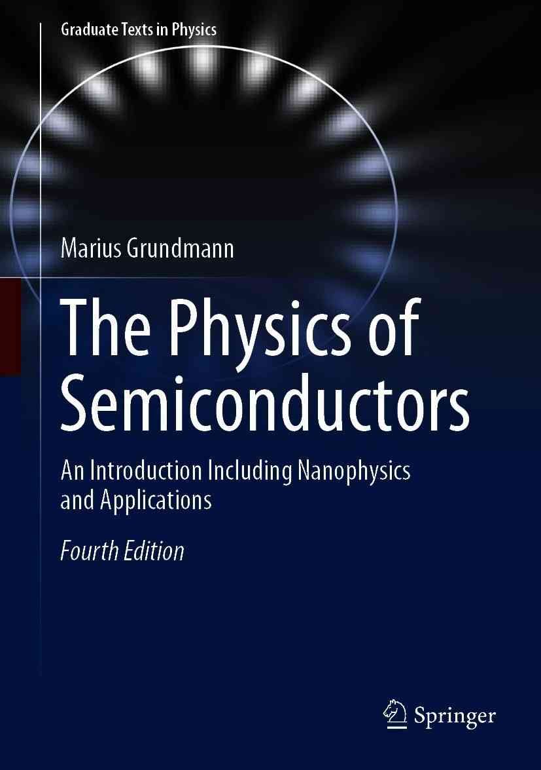

Book cover of The Physics of Semiconductors

Graduate Texts in Physics

Series Editors

Kurt H. Becker

NYU Polytechnic School of Engineering, Brooklyn, NY, USA

Jean-Marc Di Meglio

Matière et Systèmes Complexes, Bâtiment Condorcet, Université Paris Diderot, Paris, France

Morten Hjorth-Jensen

Department of Physics, Blindern, University of Oslo, Oslo, Norway

Bill Munro

NTT Basic Research Laboratories, Atsugi, Japan

William T. Rhodes

Department of Computer and Electrical Engineering and Computer Science, Florida Atlantic University, Boca Raton, FL, USA

Susan Scott

Australian National University, Acton, Australia

H. Eugene Stanley

Center for Polymer Studies, Physics Department, Boston University, Boston, MA, USA

Martin Stutzmann

Walter Schottky Institute, Technical University of Munich, Garching, Germany

Andreas Wipf

Institute of Theoretical Physics, Friedrich-Schiller-University Jena, Jena, Germany

*Graduate Texts in Physics* publishes core learning/teaching material for graduate- and advanced-level undergraduate courses on topics of current and emerging fields within physics, both pure and applied. These textbooks serve students at the MS- or PhD-level and their instructors as comprehensive sources of principles, definitions, derivations, experiments and applications (as relevant) for their mastery and teaching, respectively. International in scope and relevance, the textbooks correspond to course syllabi sufficiently to serve as required reading. Their didactic style, comprehensiveness and coverage of fundamental material also make them suitable as introductions or references for scientists entering, or requiring timely knowledge of, a research field. publishes core learning/teaching material for graduate- and advanced-level undergraduate courses on topics of current and emerging fields within physics, both pure and applied. These textbooks serve students at the MS- or PhD-level and their instructors as comprehensive sources of principles, definitions, derivations, experiments and applications (as relevant) for their mastery and teaching, respectively. International in scope and relevance, the textbooks correspond to course syllabi sufficiently to serve as required reading. Their didactic style, comprehensiveness and coverage of fundamental material also make them suitable as introductions or references for scientists entering, or requiring timely knowledge of, a research field.

More information about this series at [http://​www.​springer.​com/​series/​8431](http://www.springer.com/series/8431)

Marius Grundmann

### The Physics of Semiconductors

#### An Introduction Including Nanophysics and Applications

4th ed. 2021



Logo of the publisher

Marius Grundmann

Felix Bloch Institute for Solid State Physics, Universität Leipzig, Leipzig, Germany

ISSN 1868-4513e-ISSN 1868-4521

Graduate Texts in Physics

ISBN 978-3-030-51568-3e-ISBN 978-3-030-51569-0

<https://doi.org/10.1007/978-3-030-51569-0>

© Springer Nature Switzerland AG 2016, 2021

This work is subject to copyright. All rights are reserved by the Publisher, whether the whole or part of the material is concerned, specifically the rights of translation, reprinting, reuse of illustrations, recitation, broadcasting, reproduction on microfilms or in any other physical way, and transmission or information storage and retrieval, electronic adaptation, computer software, or by similar or dissimilar methodology now known or hereafter developed.

The use of general descriptive names, registered names, trademarks, service marks, etc. in this publication does not imply, even in the absence of a specific statement, that such names are exempt from the relevant protective laws and regulations and therefore free for general use.

The publisher, the authors and the editors are safe to assume that the advice and information in this book are believed to be true and accurate at the date of publication. Neither the publisher nor the authors or the editors give a warranty, expressed or implied, with respect to the material contained herein or for any errors or omissions that may have been made. The publisher remains neutral with regard to jurisdictional claims in published maps and institutional affiliations.

Cover Credit line: “Whispering gallery mode in circular cavity. Image: Th. Nobis, M. Grundmann, Universität Leipzig”

This Springer imprint is published by the registered company Springer Nature Switzerland AG

The registered company address is: Gewerbestrasse 11, 6330 Cham, Switzerland

*To Michelle,*

*Sophia Charlotte*

*and Isabella Rose*

Preface

Semiconductor electronics is commonplace in every household. Semiconductor devices have enabled economically reasonable fiber-based optical communication, optical storage and high-frequency amplification and have recently revolutionized photography, display technology and lighting. By now solar energy harvesting with photovoltaics contributes a significant portion to the energy mix. Along with these tremendous technological developments, semiconductors have changed the way we work, communicate, entertain and think. The technological progress of semiconductor materials and devices is evolving continuously with a large worldwide effort in human and monetary capital. For students, semiconductors offer a rich and exciting field with a great tradition, offering diverse fundamental and applied topics [1] and a bright future.

This book introduces students to semiconductor physics and semiconductor devices. It brings them to the point where they can specialize and enter supervised laboratory research. It is based on the two semester semiconductor physics course taught at Universität Leipzig in its Master of Science physics curriculum. Since the book can be followed with little or no pre-existing knowledge in solid-state physics and quantum mechanics, it is also suitable for undergraduate students. For the interested reader many additional topics are included in the book that can be covered in subsequent, more specialized courses. The material is selected to provide a balance between aspects of solid-state and semiconductor physics, the concepts of various semiconductor devices and modern applications in electronics and photonics.

The first semester contains the fundamentals of semiconductor physics (Part I, Chaps. [1](#u116076_4_En_1_Chapter)–[10](The_Physics_of_Semiconductors00005.docx#u116076_4_En_10_Chapter)) and selected topics from Part II (Chaps. [11](The_Physics_of_Semiconductors00005.docx#u116076_4_En_11_Chapter)–[20](The_Physics_of_Semiconductors00007.docx#u116076_4_En_20_Chapter)). Besides important aspects of solid-state physics such as crystal structure, lattice vibrations and band structure, semiconductor specifics such as technologically relevant materials and their properties, doping and electronic defects, recombination, surfaces, hetero- and nanostructures are discussed. Semiconductors with electric polarization and magnetization are introduced. The emphasis is put on inorganic semiconductors, but a brief introduction to organic semiconductors is given in Chap. [18](The_Physics_of_Semiconductors00006.docx#u116076_4_En_18_Chapter). Dielectric structures (Chap. [19](The_Physics_of_Semiconductors00007.docx#u116076_4_En_19_Chapter)) serve as mirrors, cavities and microcavities and are a vital part of many semiconductor devices. Other sections give introductions to 2D materials (Chap. [13](The_Physics_of_Semiconductors00006.docx#u116076_4_En_13_Chapter)) and transparent conductive oxides (TCOs) (Chap. [20](The_Physics_of_Semiconductors00007.docx#u116076_4_En_20_Chapter)). The third part (Part III—Chaps. [21](The_Physics_of_Semiconductors00007.docx#u116076_4_En_21_Chapter)–[24](The_Physics_of_Semiconductors00009.docx#u116076_4_En_24_Chapter)) is dedicated to semiconductor applications and devices that are taught in the second semester of the course. After a general and detailed discussion of various diode types and their physical mechanisms, their applications in electrical circuits, photodetectors, solar cells, light-emitting diodes and lasers are treated. Finally, bipolar and field-effect transistors including thin film transistors are discussed.

In the present text of the fourth edition many passages have been revised and updated, e.g. lead halide perovskites, dipole scattering, anisotropic dielectric function, valley polarization, Dember field, new CMOS image sensors. A new chapter is devoted to 2D semiconductors and an appendix on tight-binding theory has been added. The concept of topological properties now permeates the book; it is introduced for mechanical vibrations in the diatomic linear chain model and appears in chapters on band structure and photonic dielectric structures. Last but not least a few errors and misprints have been corrected. More than 300 additional references, some old and many brand new, have been included (compared to the third edition) and doi's for most of them are provided for easy retrieval. The references have been selected to (i) cover important historical and milestone papers, (ii) direct to reviews and topical books for further reading and (iii) give access to original literature and up-to-date research. In Fig. [1](#u116076_4_En_BookFrontmatter_OnlinePDF-Fig1), a histogram of the references by year is shown. Roughly four phases of semiconductor physics and technology can be seen. Before the realization of the first transistor in 1947, only a few publications are noteworthy. Then an intense phase of understanding the physics of semiconductors and developing semiconductor technology and devices based on bulk semiconductors (mostly Ge, Si, GaAs) followed. At the end of the 1970s, a new era began with the advent of quantum wells and heterostructures, and later nanostructures (nanotubes, nanowires and quantum dots) and new materials (e.g. organic semiconductors, nitrides or graphene). Another peak develops with emerging topics such as 2D materials, topological insulators or novel amorphous semiconductors.

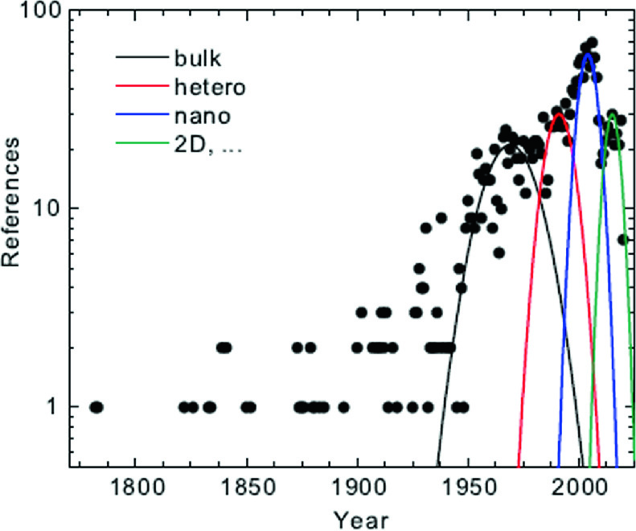

Fig. 1

Histogram of references in this book together with simplified fits visualizing major developments

I would like to thank numerous colleagues for their various contributions to this book, in alphabetical order (if no affiliation is given, at the time at Universität Leipzig): Gabriele Benndorf, Klaus Bente, Rolf Böttcher, Matthias Brandt, Christian Czekalla, Christof Peter Dietrich, Pablo Esquinazi, Heiko Frenzel, Volker Gottschalch, Helena Hilmer, Axel Hoffmann (TU Berlin), Alois Krost



(Otto-von-Guericke Universität Magdeburg), Evgeny Krüger, Michael Lorenz, Stefan Müller, Thomas Nobis, Rainer Pickenhain, Hans-Joachim Queisser (Max-Planck-Institut für Festkörperforschung, Stuttgart), Bernd Rauschenbach, Bernd Rheinländer, Heidemarie Schmidt, Mathias Schmidt, Rüdiger Schmidt-Grund, Matthias Schubert, Jan Sellmann, Oliver Stier (TU Berlin), Chris Sturm, Florian Tendille (CNRS-CRHEA), Gerald Wagner, Eicke Weber (UC Berkeley), Holger von Wenckstern, Michael Ziese and Gregor Zimmermann. This book has benefitted from their comments, proof reading, experimental data and graphic material. Also, numerous helpful comments from my students on my lectures and the previous editions of this book are gratefully acknowledged.

I am also indebted to many other colleagues, in particular to (in alphabetical order) Gerhard Abstreiter, Zhores Alferov



, Martin Allen, Levon Asryan, Günther Bauer, Manfred Bayer, Friedhelm Bechstedt, Dieter Bimberg, Otto Breitenstein, Len Brillson, Fernando Briones, Immanuel Broser



, Jean-Michel Chauveau, Jürgen Christen, Philippe De Mierry, Steve Durbin, Laurence Eaves, Klaus Ellmer, Guy Feuillet, Elvira Fortunato, Ulrich Gösele



, Alfred Forchel, Manus Hayne, Frank Heinrichsdorff, Fritz Henneberger



, Detlev Heitmann, Robert Heitz



, Evamarie Hey-Hawkins, Detlef Hommel, Evgeni Kaidashev, Eli Kapon, Nils Kirstaedter, Claus Klingshirn, Fred Koch



, Jörg Kotthaus, Nikolai Ledentsov, Peter Littlewood, Dave Look, Axel Lorke, Anupam Madhukar, Jan Meijer, Ingrid Mertig, Bruno Meyer



, David Mowbray, Hisao Nakashima, Jörg Neugebauer, Michael Oestreich, Louis Piper, Mats-Erik Pistol, Fred Pollak



, Emil V. Prodan, Volker Riede



, Bernd Rosenow, Hiroyuki Sakaki, Lars Samuelson, Darrell Schlom, Vitali Shchukin, Maurice Skolnick, Robert Suris, Volker Türck, Konrad Unger



, Victor Ustinov, Borge Vinter, Leonid Vorob’jev, Richard Warburton, Alexander Weber, Peter Werner, Wolf Widdra, Ulrike Woggon, Roland Zimmermann, Arthur Zrenner, Alex Zunger and Jesús Zúñiga-Pérez, with whom I have worked closely, had enjoyable discussions with and who have posed questions that stimulated me. It is my distinct privilege and joy that this list becomes longer as I pursue studies in semiconductor physics but sadly the number of



-symbols increases too rapidly from edition to edition.

Marius Grundmann

Leipzig, Germany

May 2020

Physical Constants

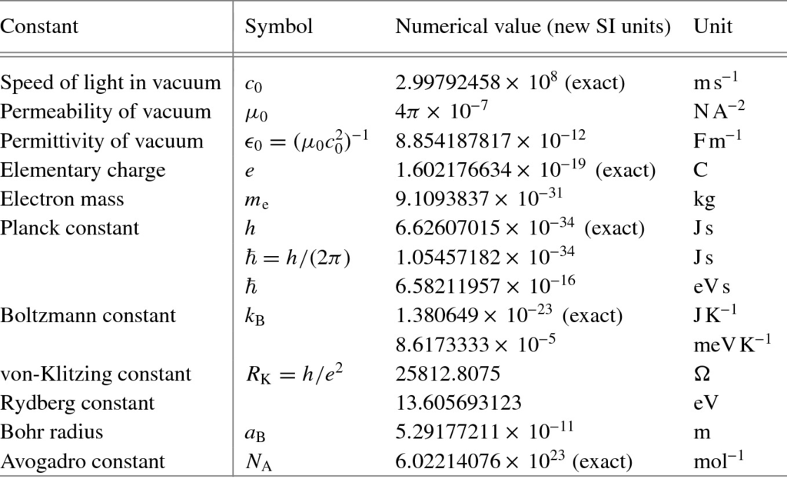

Abbreviations

0D

Zero-dimensional

1D

One-dimensional

2D

Two-dimensional

2DEG

Two-dimensional electron gas

3D

Three-dimensional

AAAS

American Association for the Advancement of Science

AB

Antibonding (position)

ac

Alternating current

ACS

American Chemical Society

ADF

Annular dark field (STEM method)

ADP

Acoustic deformation potential (scattering)

AFM

Atomic force microscopy

AHE

Anomalous Hall effect

AIP

American Institute of Physics

AM

Air mass

APD

Antiphase domain, avalanche photodiode

APS

American Physical Society

AR

Antireflection

ARPES

Angle-resolved photoemission spectroscopy

ASE

Amplified spontaneous emission

AVS

American Vacuum Society (The Science & Technology Society)

bc

Body-centered

BC

Bond center (position)

bcc

Body-centered cubic

BD

Blu-rayTM disc

BEC

Bose–Einstein condensation

BGR

Band gap renormalization

BIA

Bulk inversion asymmetry

BJT

Bipolar junction transistor

BZ

Brillouin zone

CAS

Calorimetric absorption spectroscopy

CCD

Charge coupled device

CD

Compact disc

CEO

Cleaved-edge overgrowth

CIE

Commission Internationale de l’Éclairage

CIGS

Cu(In,Ga)Se



material

CIS

CuInSe



material, CMOS image sensor

CL

Cathodoluminescence

CMOS

Complementary metal–oxide–semiconductor

CMY

Cyan-magenta-yellow (color system)

CNL

Charge neutrality level

CNT

Carbon nanotube

COD

Catastrophical optical damage

CPU

Central processing unit

CRT

Cathode ray tube

CSL

Coincident site lattice

CVD

Chemical vapor deposition

cw

Continuous wave

CZ

Czochralski (growth)

DAP

Donor–acceptor pair

DBR

Distributed Bragg reflector

dc

Direct current

DF

Dielectric function

DFB

Distributed feedback

DH(S)

Double heterostructure

DLTS

Deep level transient spectroscopy

DMS

Diluted magnetic semiconductor

DOS

Density of states

DPSS

Diode-pumped solid-state (laser)

DRAM

Dynamic random access memory

DVD

Digital versatile disc

EA

Electron affinity

EBL

Electron blocking layer

EEPROM

Electrically erasable programmable read-only memory

EHL

Electron–hole liquid

EIL

Electron injection layer

EL

Electroluminescence

ELA

Excimer laser annealing

ELO

Epitaxial lateral overgrowth

EMA

Effective mass approximation

EML

Emission layer

EPR

Electron paramagnetic resonance

EPROM

Erasable programmable read-only memory

ESF

Extrinsic stacking fault

ESR

Electron spin resonance

ETL

Electron transport layer

EXAFS

Extended X-ray absorption fine structure

F



-TCNQ

2,3,5,6-tetrafluoro-7,7,8,8-tetracyano-quinodimethane

FA

Formamidinium, HC(NH



)



fc

Face-centered

fcc

Face-centered cubic

FeRAM

Ferroelectric random access memory

FET

Field-effect transistor

FIB

Focused ion beam

FIR

Far infrared

FKO

Franz–Keldysh oscillation

FLG

Few layer graphene

FPA

Focal plane array

FQHE

Fractional quantum Hall effect

FWHM

Full width at half-maximum

FZ

Float-zone (growth)

Gb

Gigabit

GIZO

GaInZnO

GLAD

Glancing-angle deposition

GRINSCH

Graded-index separate confinement heterostructure

GSMBE

Gas-source molecular beam epitaxy

GST

Ge



Sb



Te



HBL

Hole blocking layer

HBT

Heterobipolar transistor

hcp

Hexagonally close packed

HCSEL

Horizontal cavity surface-emitting laser

HEMT

High electron mobility transistor

HIGFET

Heterojunction insulating gate FET

hh

Heavy hole

HIL

Hole injection layer

HJFET

Heterojunction FET

HMM

Hyperbolic metamaterial

HOMO

Highest occupied molecular orbital

HOPG

Highly ordered pyrolithic graphite

HR

High reflection

HRTEM

High-resolution transmission electron microscopy

HTL

Hole transport layer

HWHM

Half-width at half-maximum

IBM

International Business Machines Corporation

IC

Integrated circuit

IDB

Inversion domain boundary

IE

Ionization energy

IEEE

Institute of Electrical and Electronics Engineers[1](#u116076_4_En_BookFrontmatter_OnlinePDF-Fn1)

IF

Intermediate frequency

IOP

Institute of Physics

IPAP

Institute of Pure and Applied Physics, Tokyo

IQHE

Integral quantum Hall effect

IR

Infrared

ISF

Intrinsic stacking fault

ITO

Indium tin oxide

JDOS

Joint density of states

JFET

Junction field-effect transistor

KKR

Kramers–Kronig relation

KOH

Potassium hydroxide

KTP

KTiOPO



material

LA

Longitudinal acoustic (phonon)

LCD

Liquid crystal display

LDA

Local density approximation

LEC

Liquid encapsulated Czochralski (growth)

LED

Light-emitting diode

lh

Light hole

LO

Longitudinal optical (phonon), local oscillator

LPCVD

Low-pressure chemical vapor deposition

LPE

Liquid phase epitaxy

LPP

Longitudinal phonon plasmon (mode)

LST

Lyddane–Sachs–Teller (relation)

LT

Low temperature

LUMO

Lowest unoccupied molecular orbital

LVM

Local vibrational mode

MA

Methylammonium, methylammonium

MBE

Molecular beam epitaxy

MEMS

Micro-electro-mechanical system

MHEMT

Metamorphic HEMT

MESFET

Metal–semiconductor field-effect transistor

MIGS

Midgap (surface) states

MILC

Metal-induced lateral crystallization

MIOS

Metal–insulator–oxide–semiconductor

MIR

Mid-infrared

MIS

Metal–insulator–semiconductor

MIT

Massachusetts Institute of Technology

ML

Monolayer

MLC

Multi-level cell

MMIC

Millimeter-wave integrated circuit

MO

Master oscillator

MOCVD

Metalorganic chemical vapor deposition

MODFET

Modulation-doped field-effect transistor

MOMBE

Metalorganic molecular beam epitaxy

MOPA

Master oscillator power amplifier

MOS

Metal–oxide–semiconductor

MOSFET

Metal–oxide–semiconductor field-effect transistor

MOVPE

Metalorganic chemical vapor deposition

MQW

Multiple quantum well

MRAM

Magnetic random access memory

MRS

Materials Research Society

MS

Metal–semiconductor (diode)

MSA

Mobility spectral analysis

MSM

Metal–semiconductor–metal (diode)

MTJ

Magneto-tunneling junction

MWNT

Multi-walled (carbon) nanotube

NDR

Negative differential resistance

NEP

Noise equivalent power

NIR

Near infrared

NMOS

n-channel metal–oxide–semiconductor (transistor)

NTSC

National television standard colors

OLED

Organic light emitting diode

OMC

Organic molecular crystals

ONO

Oxide/nitride/oxide

OPSL

Optically pumped semiconductor laser

PA

Power amplifier

PBG

Photonic band gap

pc

Primitive cubic

PCM

Phase change memory

PFM

Piezoresponse force microscopy

PHEMT

Pseudomorphic HEMT

PL

Photoluminescence

PLD

Pulsed laser deposition

PLE

Photoluminescence excitation (spectroscopy)

PMC

Programmable metallization cell

PMMA

Poly-methyl methacrylate

PMOS

p-channel metal–oxide–semiconductor (transistor)

PPC

Persistent photoconductivity

PPLN

Perodically poled lithium niobate

PV

Photovoltaic(s)

PWM

Pulsewidth modulation

PZT

PbTi



Zr

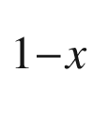

O



material

QCL

Quantum cascade laser

QCSE

Quantum confined Stark effect

QD

Quantum dot

QHE

Quantum Hall effect

QW

Quantum well

QWIP

Quantum-well intersubband photodetector

QWR

Quantum wire

RAM

Random access memory

RAS

Reflection anisotropy spectroscopy

RF

Radio frequency

RFID

Radio frequency identification

RGB

Red-green-blue (color system)

RHEED

Reflection high-energy electron diffraction

RIE

Reactive ion etching

RKKY

Ruderman–Kittel–Kasuya–Yoshida (interaction)

rms

Root mean square

ROM

Read-only memory

RRAM

Resistance random access memory

RSC

The Royal Society of Chemistry

SAGB

Small-angle grain boundary

SAM

Separate absorption and amplification (structure)

sc

Simple cubic

SCH

Separate confinement heterostructure

SCLC

Space-charge limited current

SdH

Shubnikov-de Haas (oscillation)

SEL

Surface-emitting laser

SEM

Scanning electron microscopy

SET

Single-electron transistor, single electron tunneling

SGDBR

Sampled grating distributed Bragg reflector

SHG

Second-harmonic generation

si

Semi-insulating

SIA

Semiconductor Industry Association

SIA

Structural inversion asymmetry

SIMS

Secondary ion mass spectrometry

SL

Superlattice

SLC

Single-level cell

SLG

Single layer graphene

SNR

Signal-to-noise ratio

s-o

Spin-orbit (or split-off)

SOA

Semiconductor optical amplifier

SOFC

Solid-oxide fuel cells

SPD

Spectral power distribution

SPICE

Simulation Program with Integrated Circuit Emphasis

SPIE

Society of Photographic Instrumentation Engineers

SPP

Surface plasmon polariton

SPS

Short-period superlattice

sRGB

Standard RGB

SRH

Shockley–Read–Hall (kinetics)

SSH

Su–Schrieffer–Heeger (model)

SSR

Side-mode suppression ratio

STEM

Scanning transmission electron microscopy

STEM-ADF

Scanning transmission electron microscopy with annular dark field imaging

STM

Scanning tunneling microscopy

SWNT

Single-walled (carbon) nanotube

TA

Transverse acoustic (phonon)

TAS

Thermal admittance spectroscopy

TCO

Transparent conductive oxide

TE

transverse electric (polarization)

TED

transferred electron device

TEGFET

Two-dimensional electron gas field-effect transistor

TEM

Transmission electron microscopy

TES

Two-electron satellite

TF

Thermionic field emission

TFET

Transparent FET, tunneling FET

TFT

Thin-film transistor

TM

Transverse magnetic (polarization)

TMAH

Tetramethyl-ammonium-hydroxide

TMDC

Transition metal dichalcogenide

TMR

Tunnel-magnetoresistance

TO

Transverse optical (phonon)

TOD

Turn-on delay (time)

TPA

Two-photon absorption

TSO

Transparent semiconducting oxide

UHV

Ultrahigh vacuum

UV

Ultraviolet

VCA

Virtual crystal approximation

VCO

Voltage-controlled oscillator

VCSEL

Vertical-cavity surface-emitting laser

VFF

Valence force field

VGF

Vertical gradient freeze (growth)

VIS

Visible

VLSI

Very large scale integration

WGM

Whispering gallery mode

WKB

Wentzel–Kramer–Brillouin (approximation or method)

WS

Wigner–Seitz (cell)

X

Exciton

XPS

X-ray photoelectron spectroscopy

XSTM

Cross-sectional STM

XX

Biexciton

YSZ

Yttria-stabilized zirconia (ZrO



)

ZnPc

Zinc-phthalocyanine

Symbols

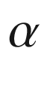

Madelung constant, disorder parameter, linewidth enhancement factor

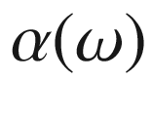

absorption coefficient

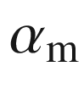

mirror loss

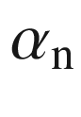

electron ionization coefficient

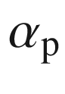

hole ionization coefficient

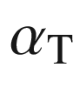

base transport factor

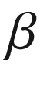

used as abbreviation for

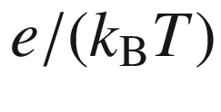

, spontaneous emission coefficient, two-photon absorption coefficient



broadening parameter, Berry phase, Grüneisen parameter, emitter efficiency, tight-binding nearest-neighbor coupling parameter



broadening parameter

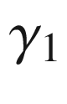

,

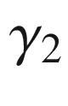

,

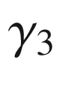

Luttinger parameters

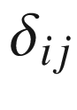

Kronecker symbol

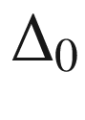

spin-orbit splitting

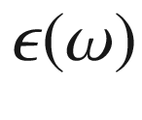

dielectric function

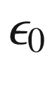

permittivity of vacuum

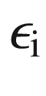

dielectric constant of insulator

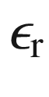

relative dielectric function

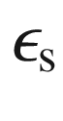

dielectric function of semiconductor (

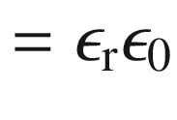

)

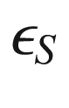

gain compression coefficient

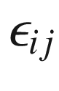

components of strain tensor

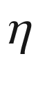

quantum efficiency

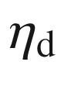

differential quantum efficiency

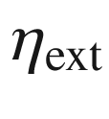

external quantum efficiency

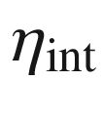

internal quantum efficiency

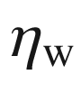

wall-plug efficiency



angle

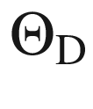

Debye temperature

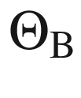

typical phonon energy parameter



imaginary part of index of refraction, heat conductivity



wavelength

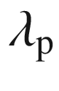

plasma wavelength



mobility

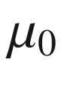

magnetic susceptibility of vacuum

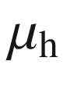

hole mobility

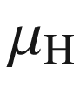

Hall mobility

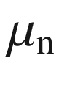

electron mobility



frequency, filling factor (QHE), winding number

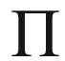

Peltier coefficient

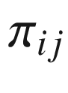

components of piezoresistivity tensor



mass density, charge density, resistivity



components of resistivity tensor

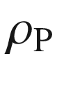

polarization charge density (per volume)

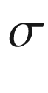

standard deviation, conductivity, stress, effective mass ratio

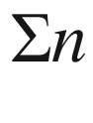

grain boundary type

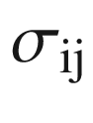

components of stress tensor, conductivity tensor

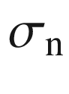

electron capture cross section

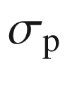

hole capture cross section

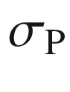

polarization charge density (per area)



lifetime, time constant

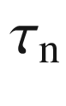

electron (minority carrier) lifetime

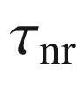

non-radiative lifetime

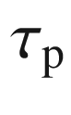

hole (minority carrier) lifetime

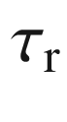

radiative lifetime

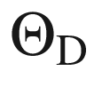

Debye temperature

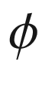

phase

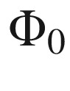

photon flux

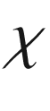

electron affinity, electric susceptibility

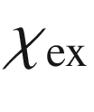

light extraction efficiency

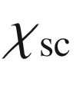

electron affinity (of semiconductor)

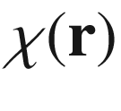

envelope wavefunction

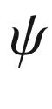

angle

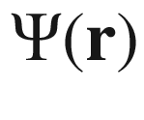

wavefunction

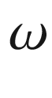

angular frequency

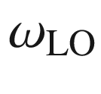

longitudinal optical phonon frequency

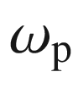

plasma frequency

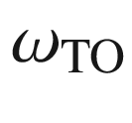

transverse optical phonon frequency

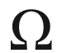

interaction parameter



hydrostatic deformation potential, lattice constant



accelaration

A

atomic mass (

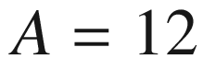

for

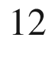

C)



area, band-impurity recombination coefficient



, A

vector potential

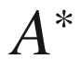

Richardson constant

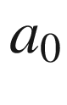

(cubic) lattice constant



bowing parameter, deformation potential



Burger's vector



bimolecular recombination coefficient, bandwidth



, B

magnetic induction field



velocity of light in vacuum, lattice constant (along



-axis)



capacitance, spring constant, Auger recombination coefficient

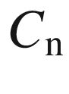

,

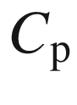

Auger recombination coefficient



,

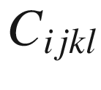

elastic constants

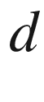

distance, shear deformation potential

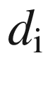

insulator thickness



density of states, diffusion coefficient



,



electric displacement field

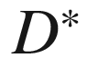

detectivity

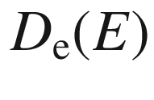

electron density of states

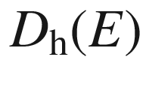

hole density of states

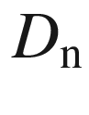

electron diffusion coefficient

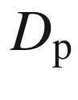

hole diffusion coefficient



elementary charge

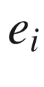

strain components (Voigt notation)



energy



, E

electric field

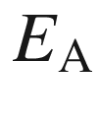

energy of acceptor level

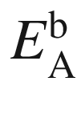

acceptor ionization energy

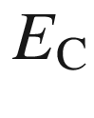

energy of conduction-band edge

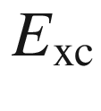

exchange interaction energy

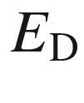

energy of donor level, Dirac energy (in graphene)

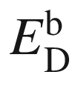

donor ionization energy

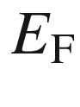

Fermi energy

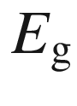

band gap

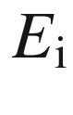

intrinsic Fermi level

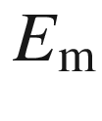

maximum electric field

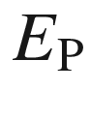

energy parameter

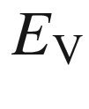

energy of valence-band edge

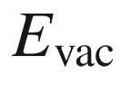

energy of vacuum level

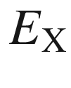

exciton energy

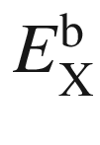

exciton binding energy

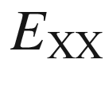

biexciton energy

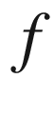

oscillator strength

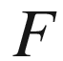

free energy



,

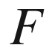

force

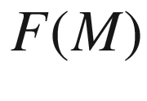

excess noise factor

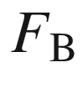

Schottky barrier height

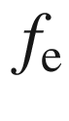

Fermi–Dirac distribution function (for electrons)

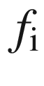

ionicity

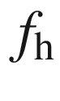

Fermi–Dirac distribution function for holes (

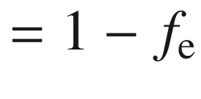

)

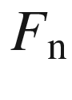

electron quasi-Fermi energy

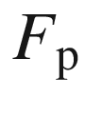

hole quasi-Fermi energy

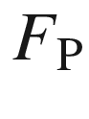

Purcell factor

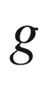

degeneracy, g-factor, gain



free enthalpy, generation rate



,



reciprocal lattice vector

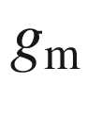

transconductance

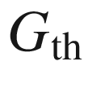

thermal generation rate



Planck constant



enthalpy, Hamiltonian



,



magnetic field



*h/(2π)*



imaginary number

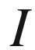

current, light intensity

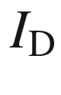

drain current

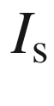

saturation current

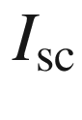

short circuit current

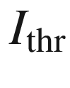

threshold current

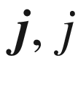

current density



total orbital momentum



saturation current density

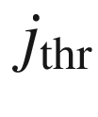

threshold current density



wavenumber, Boltzmann constant



wavevector

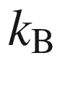

Boltzmann constant

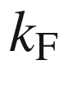

Fermi wavevector



angular orbital momentum

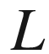

length of line element



line vector (of dislocation)

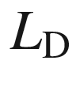

diffusion length

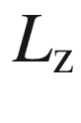

quantum-well thickness

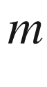

mass

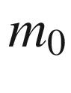

free electron mass

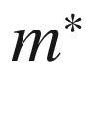

effective mass



effective mass tensor

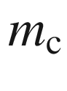

cyclotron mass



mass, multiplication factor



,



magnetization

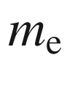

effective electron mass

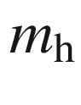

effective hole mass



magnetic quantum number

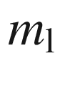

longitudinal mass

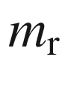

reduced mass

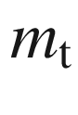

transverse mass



electron concentration (in conduction band), ideality factor



normal vector

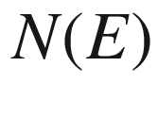

number of states

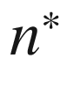

complex index of refraction (

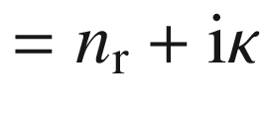

)

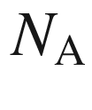

acceptor concentration

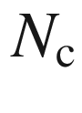

critical doping concentration

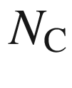

conduction-band edge density of states

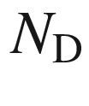

donor concentration

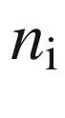

intrinsic electron concentration

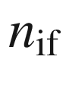

ideality factor due to image force effect

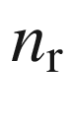

index of refraction (real part)

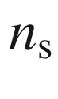

sheet electron density

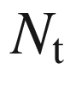

trap concentration

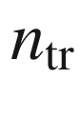

transparency electron concentration



threshold electron concentration

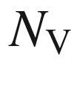

valence-band edge density of states

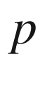

pressure, free hole density



,

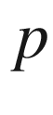

momentum



power



,



electric polarization

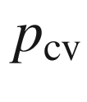

momentum matrix element

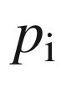

intrinsic hole concentration

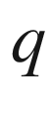

charge



,

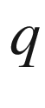

heat flow

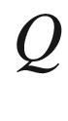

charge, quality factor, impurity-bound exciton localization energy

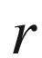

radius



spatial coordinate



resistance, radius, recombination rate

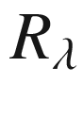

responsivity



vector of direct lattice

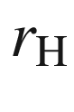

Hall factor

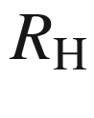

Hall coefficient



spin



entropy, Seebeck coefficient, total spin, surface index, surface recombination velocity



,

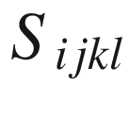

stiffness coefficients



time

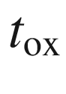

(gate) oxide thickness



temperature



displacement, cell-internal parameter



energy



Bloch function



,

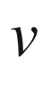

velocity

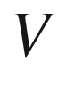

volume, voltage, potential

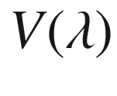

(standardized) sensitivity of human eye

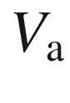

unit-cell volume

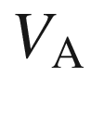

Early voltage

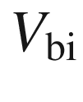

built-in voltage

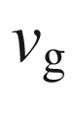

group velocity

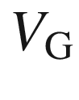

gate voltage

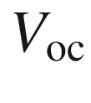

open circuit voltage

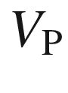

pinch-off voltage

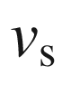

velocity of sound, drift-saturation velocity



source-drain voltage

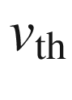

thermal velocity

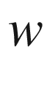

depletion-layer width, width



base width (bipolar transistor)

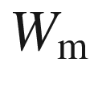

(metal) work function



electronegativity

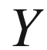

Young's module, CIE brightness parameter



partition sum, atomic order number

Contents

[1 Introduction](#u116076_4_En_1_Chapter) 1

[1.​1 Timetable and Key Achievements](#u116076_4_En_1_Chapter-Sec2) 1

[1.​2 Nobel Prize Winners](#u116076_4_En_1_Chapter-Sec3) 12

[1.​3 General Information](#u116076_4_En_1_Chapter-Sec4) 14

Part I Fundamentals

[2 Bonds](#u116076_4_En_2_Chapter) 21

[2.​1 Introduction](#u116076_4_En_2_Chapter-Sec1) 21

[2.​2 Covalent Bonds](#u116076_4_En_2_Chapter-Sec2) 21

[2.​2.​1 Electron-Pair Bond](#u116076_4_En_2_Chapter-Sec3) 21

[2.2.2 sp](#u116076_4_En_2_Chapter-Sec4)

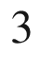

Bonds 22

[2.2.3 sp](#u116076_4_En_2_Chapter-Sec5)

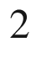

Bonds 25

[2.​3 Ionic Bonds](#u116076_4_En_2_Chapter-Sec6) 27

[2.​4 Mixed Bonds](#u116076_4_En_2_Chapter-Sec7) 28

[2.​5 Metallic Bonding](#u116076_4_En_2_Chapter-Sec8) 31

[2.​6 Van-der-Waals Bonds](#u116076_4_En_2_Chapter-Sec9) 31

[2.​7 Hamilton Operator of the Solid](#u116076_4_En_2_Chapter-Sec10) 32

[3 Crystals](#u116076_4_En_3_Chapter) 35

[3.​1 Introduction](#u116076_4_En_3_Chapter-Sec1) 35

[3.​2 Crystal Structure](#u116076_4_En_3_Chapter-Sec2) 35

[3.​3 Lattice](#u116076_4_En_3_Chapter-Sec3) 36

[3.​3.​1 2D Bravais Lattices](#u116076_4_En_3_Chapter-Sec4) 36

[3.​3.​2 3D Bravais Lattices](#u116076_4_En_3_Chapter-Sec5) 37

[3.​3.​3 Unit Cell](The_Physics_of_Semiconductors00002.docx#u116076_4_En_3_Chapter-Sec8) 40

[3.​3.​4 Point Group](The_Physics_of_Semiconductors00002.docx#u116076_4_En_3_Chapter-Sec9) 41

[3.​3.​5 Space Group](The_Physics_of_Semiconductors00002.docx#u116076_4_En_3_Chapter-Sec10) 42

[3.​3.​6 Polycrystalline Semiconductors](The_Physics_of_Semiconductors00002.docx#u116076_4_En_3_Chapter-Sec11) 43

[3.​3.​7 Amorphous Semiconductors](The_Physics_of_Semiconductors00002.docx#u116076_4_En_3_Chapter-Sec12) 43

[3.​4 Important Crystal Structures](The_Physics_of_Semiconductors00002.docx#u116076_4_En_3_Chapter-Sec13) 44

[3.​4.​1 Rocksalt Structure](The_Physics_of_Semiconductors00002.docx#u116076_4_En_3_Chapter-Sec14) 45

[3.​4.​2 CsCl Structure](The_Physics_of_Semiconductors00002.docx#u116076_4_En_3_Chapter-Sec15) 45

[3.​4.​3 Diamond Structure](The_Physics_of_Semiconductors00002.docx#u116076_4_En_3_Chapter-Sec16) 45

[3.​4.​4 Zincblende Structure](The_Physics_of_Semiconductors00002.docx#u116076_4_En_3_Chapter-Sec17) 46

[3.​4.​5 Wurtzite Structure](The_Physics_of_Semiconductors00002.docx#u116076_4_En_3_Chapter-Sec18) 47

[3.​4.​6 Chalcopyrite Structure](The_Physics_of_Semiconductors00002.docx#u116076_4_En_3_Chapter-Sec19) 48

[3.​4.​7 Spinel Structure](The_Physics_of_Semiconductors00002.docx#u116076_4_En_3_Chapter-Sec20) 49

[3.​4.​8 Fluorite Structure](The_Physics_of_Semiconductors00002.docx#u116076_4_En_3_Chapter-Sec21) 51

[3.​4.​9 Delafossite Structure](The_Physics_of_Semiconductors00002.docx#u116076_4_En_3_Chapter-Sec22) 51

[3.​4.​10 Perovskite Structure](The_Physics_of_Semiconductors00002.docx#u116076_4_En_3_Chapter-Sec23) 52

[3.​4.​11 NiAs Structure](The_Physics_of_Semiconductors00002.docx#u116076_4_En_3_Chapter-Sec24) 53

[3.​4.​12 Further Structures](The_Physics_of_Semiconductors00002.docx#u116076_4_En_3_Chapter-Sec25) 53

[3.​5 Polytypism and Polymorphism](The_Physics_of_Semiconductors00002.docx#u116076_4_En_3_Chapter-Sec26) 54

[3.​6 Reciprocal Lattice](The_Physics_of_Semiconductors00002.docx#u116076_4_En_3_Chapter-Sec27) 56

[3.​6.​1 Reciprocal Lattice Vectors](The_Physics_of_Semiconductors00002.docx#u116076_4_En_3_Chapter-Sec28) 56

[3.​6.​2 Miller Indices](The_Physics_of_Semiconductors00002.docx#u116076_4_En_3_Chapter-Sec29) 57

[3.​6.​3 Brillouin Zone](The_Physics_of_Semiconductors00002.docx#u116076_4_En_3_Chapter-Sec30) 60

[3.​7 Alloys](The_Physics_of_Semiconductors00002.docx#u116076_4_En_3_Chapter-Sec31) 60

[3.​7.​1 Random Alloys](The_Physics_of_Semiconductors00002.docx#u116076_4_En_3_Chapter-Sec32) 61

[3.​7.​2 Phase Diagram](The_Physics_of_Semiconductors00002.docx#u116076_4_En_3_Chapter-Sec33) 63

[3.​7.​3 Virtual Crystal Approximation](The_Physics_of_Semiconductors00002.docx#u116076_4_En_3_Chapter-Sec34) 65

[3.​7.​4 Lattice Parameter](The_Physics_of_Semiconductors00002.docx#u116076_4_En_3_Chapter-Sec35) 65

[3.​7.​5 Ordering](The_Physics_of_Semiconductors00002.docx#u116076_4_En_3_Chapter-Sec36) 67

[4 Structural Defects](The_Physics_of_Semiconductors00002.docx#u116076_4_En_4_Chapter) 69

[4.​1 Introduction](The_Physics_of_Semiconductors00002.docx#u116076_4_En_4_Chapter-Sec1) 69

[4.​2 Point Defects](The_Physics_of_Semiconductors00002.docx#u116076_4_En_4_Chapter-Sec2) 69

[4.​2.​1 Point Defect Types](The_Physics_of_Semiconductors00002.docx#u116076_4_En_4_Chapter-Sec3) 69

[4.​2.​2 Thermodynamics](The_Physics_of_Semiconductors00002.docx#u116076_4_En_4_Chapter-Sec4) 70

[4.​2.​3 Diffusion](The_Physics_of_Semiconductors00002.docx#u116076_4_En_4_Chapter-Sec5) 73

[4.​2.​4 Dopant Distribution](The_Physics_of_Semiconductors00002.docx#u116076_4_En_4_Chapter-Sec6) 75

[4.​2.​5 Large Concentration Effects](The_Physics_of_Semiconductors00002.docx#u116076_4_En_4_Chapter-Sec7) 78

[4.​3 Dislocations](The_Physics_of_Semiconductors00002.docx#u116076_4_En_4_Chapter-Sec11) 81

[4.​3.​1 Dislocation Types](The_Physics_of_Semiconductors00002.docx#u116076_4_En_4_Chapter-Sec12) 82

[4.​3.​2 Visualization of Dislocations by Etching](The_Physics_of_Semiconductors00002.docx#u116076_4_En_4_Chapter-Sec18) 85

[4.​3.​3 Impurity Hardening](The_Physics_of_Semiconductors00002.docx#u116076_4_En_4_Chapter-Sec19) 88

[4.​4 Extended Defects](The_Physics_of_Semiconductors00002.docx#u116076_4_En_4_Chapter-Sec20) 88

[4.​4.​1 Micro-cracks](The_Physics_of_Semiconductors00002.docx#u116076_4_En_4_Chapter-Sec21) 88

[4.​4.​2 Stacking Faults](The_Physics_of_Semiconductors00002.docx#u116076_4_En_4_Chapter-Sec22) 89

[4.​4.​3 Grain Boundaries](The_Physics_of_Semiconductors00002.docx#u116076_4_En_4_Chapter-Sec23) 90

[4.​4.​4 Antiphase and Inversion Domains](The_Physics_of_Semiconductors00002.docx#u116076_4_En_4_Chapter-Sec24) 93

[4.​5 Disorder](The_Physics_of_Semiconductors00002.docx#u116076_4_En_4_Chapter-Sec25) 94

[5 Mechanical Properties](The_Physics_of_Semiconductors00002.docx#u116076_4_En_5_Chapter) 95

[5.​1 Introduction](The_Physics_of_Semiconductors00002.docx#u116076_4_En_5_Chapter-Sec1) 95

[5.​2 Lattice Vibrations](The_Physics_of_Semiconductors00002.docx#u116076_4_En_5_Chapter-Sec2) 95

[5.​2.​1 Monoatomic Linear Chain](The_Physics_of_Semiconductors00002.docx#u116076_4_En_5_Chapter-Sec3) 96

[5.​2.​2 Diatomic Linear Chain](The_Physics_of_Semiconductors00002.docx#u116076_4_En_5_Chapter-Sec4) 99

[5.​2.​3 Mode Patterns and Topological States](The_Physics_of_Semiconductors00002.docx#u116076_4_En_5_Chapter-Sec5) 101

[5.​2.​4 Lattice Vibrations of a Three-Dimensional Crystal](The_Physics_of_Semiconductors00002.docx#u116076_4_En_5_Chapter-Sec6) 104

[5.​2.​5 Density of States](The_Physics_of_Semiconductors00002.docx#u116076_4_En_5_Chapter-Sec7) 107

[5.​2.​6 Phonons](The_Physics_of_Semiconductors00002.docx#u116076_4_En_5_Chapter-Sec8) 109

[5.​2.​7 Localized Vibrational Modes](The_Physics_of_Semiconductors00002.docx#u116076_4_En_5_Chapter-Sec9) 110

[5.​2.​8 Phonons in Alloys](The_Physics_of_Semiconductors00002.docx#u116076_4_En_5_Chapter-Sec10) 112

[5.​2.​9 Disorder](The_Physics_of_Semiconductors00002.docx#u116076_4_En_5_Chapter-Sec11) 114

[5.​2.​10 Topological Edge States of the Diatomic Linear Chain](The_Physics_of_Semiconductors00002.docx#u116076_4_En_5_Chapter-Sec12) 115

[5.​3 Elasticity](The_Physics_of_Semiconductors00002.docx#u116076_4_En_5_Chapter-Sec13) 118

[5.​3.​1 Thermal Expansion](The_Physics_of_Semiconductors00002.docx#u116076_4_En_5_Chapter-Sec14) 118

[5.​3.​2 Stress–Strain Relation](The_Physics_of_Semiconductors00003.docx#u116076_4_En_5_Chapter-Sec15) 118

[5.​3.​3 Biaxial Stress](The_Physics_of_Semiconductors00003.docx#u116076_4_En_5_Chapter-Sec16) 122

[5.​3.​4 Three-Dimensional Stress](The_Physics_of_Semiconductors00003.docx#u116076_4_En_5_Chapter-Sec17) 123

[5.​3.​5 Substrate Bending](The_Physics_of_Semiconductors00003.docx#u116076_4_En_5_Chapter-Sec18) 126

[5.​3.​6 Scrolling](The_Physics_of_Semiconductors00003.docx#u116076_4_En_5_Chapter-Sec19) 127

[5.​4 Plasticity](The_Physics_of_Semiconductors00003.docx#u116076_4_En_5_Chapter-Sec20) 129

[5.​4.​1 Critical Thickness](The_Physics_of_Semiconductors00003.docx#u116076_4_En_5_Chapter-Sec21) 129

[5.​4.​2 Cleaving](The_Physics_of_Semiconductors00003.docx#u116076_4_En_5_Chapter-Sec22) 133

[5.​4.​3 Wafer Breakage](The_Physics_of_Semiconductors00003.docx#u116076_4_En_5_Chapter-Sec23) 133

[6 Band Structure](The_Physics_of_Semiconductors00003.docx#u116076_4_En_6_Chapter) 135

[6.​1 Introduction](The_Physics_of_Semiconductors00003.docx#u116076_4_En_6_Chapter-Sec1) 135

[6.​2 Electrons in a Periodic Potential](The_Physics_of_Semiconductors00003.docx#u116076_4_En_6_Chapter-Sec2) 135

[6.​2.​1 Bloch’s Theorem](The_Physics_of_Semiconductors00003.docx#u116076_4_En_6_Chapter-Sec3) 135

[6.​2.​2 Free-Electron Dispersion](The_Physics_of_Semiconductors00003.docx#u116076_4_En_6_Chapter-Sec4) 136

[6.​2.​3 Non-Vanishing Potential](The_Physics_of_Semiconductors00003.docx#u116076_4_En_6_Chapter-Sec5) 137

[6.​2.​4 Kramer’s Degeneracy](The_Physics_of_Semiconductors00003.docx#u116076_4_En_6_Chapter-Sec11) 140

[6.​2.​5 Symmetry Considerations](The_Physics_of_Semiconductors00003.docx#u116076_4_En_6_Chapter-Sec12) 141

[6.​2.​6 Topological Considerations](The_Physics_of_Semiconductors00003.docx#u116076_4_En_6_Chapter-Sec13) 142

[6.​3 Band Structures of Selected Semiconductors](The_Physics_of_Semiconductors00003.docx#u116076_4_En_6_Chapter-Sec14) 144

[6.​3.​1 Silicon](The_Physics_of_Semiconductors00003.docx#u116076_4_En_6_Chapter-Sec15) 144

[6.​3.​2 Germanium](The_Physics_of_Semiconductors00003.docx#u116076_4_En_6_Chapter-Sec16) 145

[6.​3.​3 GaAs](The_Physics_of_Semiconductors00003.docx#u116076_4_En_6_Chapter-Sec17) 145

[6.​3.​4 GaP](The_Physics_of_Semiconductors00003.docx#u116076_4_En_6_Chapter-Sec18) 146

[6.​3.​5 GaN](The_Physics_of_Semiconductors00003.docx#u116076_4_En_6_Chapter-Sec19) 146

[6.​3.​6 Lead Salts](The_Physics_of_Semiconductors00003.docx#u116076_4_En_6_Chapter-Sec20) 146

[6.​3.​7 MgO, ZnO, CdO](The_Physics_of_Semiconductors00003.docx#u116076_4_En_6_Chapter-Sec21)  147

[6.​3.​8 Chalcopyrites](The_Physics_of_Semiconductors00003.docx#u116076_4_En_6_Chapter-Sec22)  147

[6.​3.​9 Spinels](The_Physics_of_Semiconductors00003.docx#u116076_4_En_6_Chapter-Sec23)  149

[6.​3.​10 Delafossites](The_Physics_of_Semiconductors00003.docx#u116076_4_En_6_Chapter-Sec24)  149

[6.​3.​11 Perovskites](The_Physics_of_Semiconductors00003.docx#u116076_4_En_6_Chapter-Sec25) 149

[6.​4 Systematics of Semiconductor Band Gaps](The_Physics_of_Semiconductors00003.docx#u116076_4_En_6_Chapter-Sec26) 150

[6.​5 Alloy Semiconductors](The_Physics_of_Semiconductors00003.docx#u116076_4_En_6_Chapter-Sec27) 152

[6.​6 Amorphous Semiconductors](The_Physics_of_Semiconductors00003.docx#u116076_4_En_6_Chapter-Sec28)  153

[6.​7 Temperature Dependence of the Band Gap](The_Physics_of_Semiconductors00003.docx#u116076_4_En_6_Chapter-Sec29) 154

[6.​8 Isotope Dependence of the Band Gap](The_Physics_of_Semiconductors00003.docx#u116076_4_En_6_Chapter-Sec30) 158

[6.​9 Electron Dispersion](The_Physics_of_Semiconductors00003.docx#u116076_4_En_6_Chapter-Sec31)  158

[6.​9.​1 Equation of Electron Motion](The_Physics_of_Semiconductors00003.docx#u116076_4_En_6_Chapter-Sec32)  158

[6.​9.​2 Effective Mass of Electrons](The_Physics_of_Semiconductors00003.docx#u116076_4_En_6_Chapter-Sec33) 159

[6.​9.​3 Nonparabolicity of Electron Mass](The_Physics_of_Semiconductors00003.docx#u116076_4_En_6_Chapter-Sec34)  162

[6.​10 Holes](The_Physics_of_Semiconductors00003.docx#u116076_4_En_6_Chapter-Sec35)  163

[6.​10.​1 Hole Concept](The_Physics_of_Semiconductors00003.docx#u116076_4_En_6_Chapter-Sec36) 163

[6.​10.​2 Hole Dispersion Relation](The_Physics_of_Semiconductors00003.docx#u116076_4_En_6_Chapter-Sec37) 164

[6.​10.​3 Valence-Band Fine Structure](The_Physics_of_Semiconductors00003.docx#u116076_4_En_6_Chapter-Sec38) 168

[6.​11 Band Inversion](The_Physics_of_Semiconductors00003.docx#u116076_4_En_6_Chapter-Sec39) 169

[6.​12 Strain Effects on the Band Structure](The_Physics_of_Semiconductors00003.docx#u116076_4_En_6_Chapter-Sec40) 170

[6.​12.​1 Strain Effect on Band Edges](The_Physics_of_Semiconductors00003.docx#u116076_4_En_6_Chapter-Sec41) 170

[6.​12.​2 Strain Effect on Effective Masses](The_Physics_of_Semiconductors00003.docx#u116076_4_En_6_Chapter-Sec42) 172

[6.​12.​3 Interaction With a Localized Level](The_Physics_of_Semiconductors00003.docx#u116076_4_En_6_Chapter-Sec43) 173

[6.​13 Density of States](The_Physics_of_Semiconductors00003.docx#u116076_4_En_6_Chapter-Sec44) 173

[6.​13.​1 General Band Structure](The_Physics_of_Semiconductors00003.docx#u116076_4_En_6_Chapter-Sec45) 173

[6.​13.​2 Amorphous Semiconductors](The_Physics_of_Semiconductors00003.docx#u116076_4_En_6_Chapter-Sec46) 174

[6.​13.​3 Free-Electron Gas](The_Physics_of_Semiconductors00003.docx#u116076_4_En_6_Chapter-Sec47)  175

[7 Electronic Defect States](The_Physics_of_Semiconductors00003.docx#u116076_4_En_7_Chapter) 179

[7.​1 Introduction](The_Physics_of_Semiconductors00003.docx#u116076_4_En_7_Chapter-Sec1) 179

[7.​2 Carrier Concentration](The_Physics_of_Semiconductors00003.docx#u116076_4_En_7_Chapter-Sec2) 179

[7.​3 Intrinsic Conduction](The_Physics_of_Semiconductors00003.docx#u116076_4_En_7_Chapter-Sec3) 182

[7.​4 Doping](The_Physics_of_Semiconductors00003.docx#u116076_4_En_7_Chapter-Sec4) 184

[7.​4.​1 Concept](The_Physics_of_Semiconductors00003.docx#u116076_4_En_7_Chapter-Sec5) 184

[7.​4.​2 Doping Principles](The_Physics_of_Semiconductors00003.docx#u116076_4_En_7_Chapter-Sec6) 185

[7.​5 Shallow Defects](The_Physics_of_Semiconductors00003.docx#u116076_4_En_7_Chapter-Sec7) 186

[7.​5.​1 Donors](The_Physics_of_Semiconductors00003.docx#u116076_4_En_7_Chapter-Sec8) 187

[7.​5.​2 Acceptors](The_Physics_of_Semiconductors00003.docx#u116076_4_En_7_Chapter-Sec9) 192

[7.​5.​3 Compensation](The_Physics_of_Semiconductors00003.docx#u116076_4_En_7_Chapter-Sec10) 195

[7.​5.​4 Multiple Impurities](The_Physics_of_Semiconductors00003.docx#u116076_4_En_7_Chapter-Sec11) 199

[7.​5.​5 Amphoteric Impurities](The_Physics_of_Semiconductors00004.docx#u116076_4_En_7_Chapter-Sec12) 199

[7.​5.​6 Autodoping](The_Physics_of_Semiconductors00004.docx#u116076_4_En_7_Chapter-Sec13) 200

[7.​5.​7 High Doping](The_Physics_of_Semiconductors00004.docx#u116076_4_En_7_Chapter-Sec14) 201

[7.​6 Quasi-fermi Levels](The_Physics_of_Semiconductors00004.docx#u116076_4_En_7_Chapter-Sec15) 204

[7.​7 Deep Levels](The_Physics_of_Semiconductors00004.docx#u116076_4_En_7_Chapter-Sec16) 205

[7.​7.​1 Charge States](The_Physics_of_Semiconductors00004.docx#u116076_4_En_7_Chapter-Sec17)  206

[7.​7.​2 Double Donors](The_Physics_of_Semiconductors00004.docx#u116076_4_En_7_Chapter-Sec18) 208

[7.​7.​3 Double Acceptors](The_Physics_of_Semiconductors00004.docx#u116076_4_En_7_Chapter-Sec19)  209

[7.​7.​4 Jahn–Teller Effect](The_Physics_of_Semiconductors00004.docx#u116076_4_En_7_Chapter-Sec20) 210

[7.7.5 Negative-](The_Physics_of_Semiconductors00004.docx#u116076_4_En_7_Chapter-Sec21)



Center 211

[7.​7.​6 DX Center](The_Physics_of_Semiconductors00004.docx#u116076_4_En_7_Chapter-Sec22) 213

[7.​7.​7 EL2 Defect](The_Physics_of_Semiconductors00004.docx#u116076_4_En_7_Chapter-Sec23) 214

[7.​7.​8 Semi-insulating Semiconductors](The_Physics_of_Semiconductors00004.docx#u116076_4_En_7_Chapter-Sec24) 215

[7.​7.​9 Isoelectronic Impurities](The_Physics_of_Semiconductors00004.docx#u116076_4_En_7_Chapter-Sec25) 216

[7.​7.​10 Surface States](The_Physics_of_Semiconductors00004.docx#u116076_4_En_7_Chapter-Sec26) 217

[7.​8 The Charge Neutrality Level](The_Physics_of_Semiconductors00004.docx#u116076_4_En_7_Chapter-Sec27) 219

[7.​9 Hydrogen in Semiconductors](The_Physics_of_Semiconductors00004.docx#u116076_4_En_7_Chapter-Sec28) 219

[8 Transport](The_Physics_of_Semiconductors00004.docx#u116076_4_En_8_Chapter) 223

[8.​1 Introduction](The_Physics_of_Semiconductors00004.docx#u116076_4_En_8_Chapter-Sec1) 223

[8.​2 Conductivity](The_Physics_of_Semiconductors00004.docx#u116076_4_En_8_Chapter-Sec2) 224

[8.​3 Low-Field Transport](The_Physics_of_Semiconductors00004.docx#u116076_4_En_8_Chapter-Sec3) 225

[8.​3.​1 Mobility](The_Physics_of_Semiconductors00004.docx#u116076_4_En_8_Chapter-Sec4) 226

[8.​3.​2 Microscopic Scattering Processes](The_Physics_of_Semiconductors00004.docx#u116076_4_En_8_Chapter-Sec5) 227

[8.​3.​3 Ionized Impurity Scattering](The_Physics_of_Semiconductors00004.docx#u116076_4_En_8_Chapter-Sec6) 227

[8.​3.​4 Deformation Potential Scattering](The_Physics_of_Semiconductors00004.docx#u116076_4_En_8_Chapter-Sec7) 229

[8.​3.​5 Piezoelectric Potential Scattering](The_Physics_of_Semiconductors00004.docx#u116076_4_En_8_Chapter-Sec8) 230

[8.​3.​6 Polar Optical Scattering](The_Physics_of_Semiconductors00004.docx#u116076_4_En_8_Chapter-Sec9) 230

[8.​3.​7 Dislocation Scattering](The_Physics_of_Semiconductors00004.docx#u116076_4_En_8_Chapter-Sec10) 230

[8.​3.​8 Grain Boundary Scattering](The_Physics_of_Semiconductors00004.docx#u116076_4_En_8_Chapter-Sec11) 231

[8.​3.​9 Alloy Scattering](The_Physics_of_Semiconductors00004.docx#u116076_4_En_8_Chapter-Sec12) 231

[8.​3.​10 Dipole Scattering](The_Physics_of_Semiconductors00004.docx#u116076_4_En_8_Chapter-Sec13) 232

[8.​3.​11 Temperature Dependence](The_Physics_of_Semiconductors00004.docx#u116076_4_En_8_Chapter-Sec14) 232

[8.​3.​12 Doping Dependence](The_Physics_of_Semiconductors00004.docx#u116076_4_En_8_Chapter-Sec15) 233

[8.​3.​13 Superconductivit​y](The_Physics_of_Semiconductors00004.docx#u116076_4_En_8_Chapter-Sec16) 235

[8.​3.​14 Piezoresistivity​](The_Physics_of_Semiconductors00004.docx#u116076_4_En_8_Chapter-Sec17) 235

[8.​4 High-Field Transport](The_Physics_of_Semiconductors00004.docx#u116076_4_En_8_Chapter-Sec18) 236

[8.​4.​1 Drift-Saturation Velocity](The_Physics_of_Semiconductors00004.docx#u116076_4_En_8_Chapter-Sec19) 237

[8.​4.​2 Negative Differential Resistivity](The_Physics_of_Semiconductors00004.docx#u116076_4_En_8_Chapter-Sec20) 237

[8.​4.​3 Velocity Overshoot](The_Physics_of_Semiconductors00004.docx#u116076_4_En_8_Chapter-Sec21) 238

[8.​4.​4 Impact Ionization](The_Physics_of_Semiconductors00004.docx#u116076_4_En_8_Chapter-Sec22) 239

[8.​5 High-Frequency Transport](The_Physics_of_Semiconductors00004.docx#u116076_4_En_8_Chapter-Sec23) 241

[8.​6 Impurity Band Transport](The_Physics_of_Semiconductors00004.docx#u116076_4_En_8_Chapter-Sec24) 243

[8.​7 Polarons](The_Physics_of_Semiconductors00004.docx#u116076_4_En_8_Chapter-Sec25) 243

[8.​7.​1 Large Polarons](The_Physics_of_Semiconductors00004.docx#u116076_4_En_8_Chapter-Sec26) 243

[8.​7.​2 Small Polarons](The_Physics_of_Semiconductors00004.docx#u116076_4_En_8_Chapter-Sec27) 244

[8.​8 Hopping Transport](The_Physics_of_Semiconductors00004.docx#u116076_4_En_8_Chapter-Sec28) 245

[8.​9 Transport in Amorphous Semiconductors](The_Physics_of_Semiconductors00004.docx#u116076_4_En_8_Chapter-Sec29) 247

[8.​10 Ionic Transport](The_Physics_of_Semiconductors00004.docx#u116076_4_En_8_Chapter-Sec30) 248

[8.​11 Diffusion](The_Physics_of_Semiconductors00004.docx#u116076_4_En_8_Chapter-Sec31) 248

[8.​12 Continuity Equation](The_Physics_of_Semiconductors00004.docx#u116076_4_En_8_Chapter-Sec32) 250

[8.​13 Heat Conduction](The_Physics_of_Semiconductors00004.docx#u116076_4_En_8_Chapter-Sec33) 251

[8.​14 Coupled Heat and Charge Transport](The_Physics_of_Semiconductors00004.docx#u116076_4_En_8_Chapter-Sec34) 251

[8.​14.​1 Thermopower and Seebeck Effect](The_Physics_of_Semiconductors00004.docx#u116076_4_En_8_Chapter-Sec35) 252

[8.​14.​2 Peltier Effect](The_Physics_of_Semiconductors00004.docx#u116076_4_En_8_Chapter-Sec36) 254

[9 Optical Properties](The_Physics_of_Semiconductors00004.docx#u116076_4_En_9_Chapter) 257

[9.​1 Spectral Regions and Overview](The_Physics_of_Semiconductors00004.docx#u116076_4_En_9_Chapter-Sec1) 257

[9.​2 Complex Dielectric Function](The_Physics_of_Semiconductors00004.docx#u116076_4_En_9_Chapter-Sec2) 258

[9.​3 Reflection and Diffraction](The_Physics_of_Semiconductors00004.docx#u116076_4_En_9_Chapter-Sec3) 260

[9.​4 Absorption](The_Physics_of_Semiconductors00004.docx#u116076_4_En_9_Chapter-Sec4) 262

[9.​5 Dielectric Function due to Optical Phonons](The_Physics_of_Semiconductors00004.docx#u116076_4_En_9_Chapter-Sec5) 263

[9.​6 Electron–Photon Interaction](The_Physics_of_Semiconductors00004.docx#u116076_4_En_9_Chapter-Sec6) 265

[9.​7 Band–Band Transitions](The_Physics_of_Semiconductors00004.docx#u116076_4_En_9_Chapter-Sec7) 267

[9.​7.​1 Joint Density of States](The_Physics_of_Semiconductors00004.docx#u116076_4_En_9_Chapter-Sec8) 267

[9.​7.​2 Direct Transitions](The_Physics_of_Semiconductors00004.docx#u116076_4_En_9_Chapter-Sec9) 268

[9.​7.​3 Indirect Transitions](The_Physics_of_Semiconductors00004.docx#u116076_4_En_9_Chapter-Sec10) 271

[9.​7.​4 Urbach Tail](The_Physics_of_Semiconductors00004.docx#u116076_4_En_9_Chapter-Sec11) 273

[9.​7.​5 Amorphous Semiconductors](The_Physics_of_Semiconductors00004.docx#u116076_4_En_9_Chapter-Sec12) 274

[9.​7.​6 Excitons](The_Physics_of_Semiconductors00004.docx#u116076_4_En_9_Chapter-Sec13) 274

[9.​7.​7 Phonon Broadening](The_Physics_of_Semiconductors00004.docx#u116076_4_En_9_Chapter-Sec14) 277

[9.​7.​8 Exciton Polariton](The_Physics_of_Semiconductors00004.docx#u116076_4_En_9_Chapter-Sec15) 279

[9.​7.​9 Bound-Exciton Absorption](The_Physics_of_Semiconductors00004.docx#u116076_4_En_9_Chapter-Sec16) 281

[9.​7.​10 Biexcitons](The_Physics_of_Semiconductors00004.docx#u116076_4_En_9_Chapter-Sec17) 283

[9.​7.​11 Trions](The_Physics_of_Semiconductors00004.docx#u116076_4_En_9_Chapter-Sec18) 283

[9.​7.​12 Band Gap Renormalization](The_Physics_of_Semiconductors00005.docx#u116076_4_En_9_Chapter-Sec19) 284

[9.​7.​13 Electron–Hole Droplets](The_Physics_of_Semiconductors00005.docx#u116076_4_En_9_Chapter-Sec20) 285

[9.​7.​14 Two-Photon Absorption](The_Physics_of_Semiconductors00005.docx#u116076_4_En_9_Chapter-Sec21) 286

[9.​8 Impurity Absorption](The_Physics_of_Semiconductors00005.docx#u116076_4_En_9_Chapter-Sec22) 287

[9.​8.​1 Shallow Levels](The_Physics_of_Semiconductors00005.docx#u116076_4_En_9_Chapter-Sec23) 287

[9.​8.​2 Deep Levels](The_Physics_of_Semiconductors00005.docx#u116076_4_En_9_Chapter-Sec24) 289

[9.​9 Absorption in the Presence of Free Charge Carriers](The_Physics_of_Semiconductors00005.docx#u116076_4_En_9_Chapter-Sec25) 291

[9.​9.​1 Absorption Coefficient, Plasma Frequency](The_Physics_of_Semiconductors00005.docx#u116076_4_En_9_Chapter-Sec26) 291

[9.​9.​2 Burstein–Moss Shift](The_Physics_of_Semiconductors00005.docx#u116076_4_En_9_Chapter-Sec27) 294

[9.​9.​3 Inter-Valenceband Transitions](The_Physics_of_Semiconductors00005.docx#u116076_4_En_9_Chapter-Sec28) 295

[9.​9.​4 Inter-Valley Transitions](The_Physics_of_Semiconductors00005.docx#u116076_4_En_9_Chapter-Sec29) 297

[9.​9.​5 Intra-Band Transitions](The_Physics_of_Semiconductors00005.docx#u116076_4_En_9_Chapter-Sec30) 297

[9.​10 Lattice Absorption](The_Physics_of_Semiconductors00005.docx#u116076_4_En_9_Chapter-Sec31) 298

[9.​10.​1 Dielectric Constant](The_Physics_of_Semiconductors00005.docx#u116076_4_En_9_Chapter-Sec32) 298

[9.​10.​2 Reststrahlenband​e](The_Physics_of_Semiconductors00005.docx#u116076_4_En_9_Chapter-Sec33) 299

[9.​10.​3 Polaritons](The_Physics_of_Semiconductors00005.docx#u116076_4_En_9_Chapter-Sec34) 300

[9.​10.​4 Phonon–Plasmon Coupling](The_Physics_of_Semiconductors00005.docx#u116076_4_En_9_Chapter-Sec35) 300

[10 Recombination](The_Physics_of_Semiconductors00005.docx#u116076_4_En_10_Chapter) 303

[10.​1 Introduction](The_Physics_of_Semiconductors00005.docx#u116076_4_En_10_Chapter-Sec1) 303

[10.​2 Band–Band Recombination](The_Physics_of_Semiconductors00005.docx#u116076_4_En_10_Chapter-Sec2) 304

[10.​2.​1 Spontaneous Emission](The_Physics_of_Semiconductors00005.docx#u116076_4_En_10_Chapter-Sec3) 304

[10.​2.​2 Absorption](The_Physics_of_Semiconductors00005.docx#u116076_4_En_10_Chapter-Sec4) 306

[10.​2.​3 Stimulated Emission](The_Physics_of_Semiconductors00005.docx#u116076_4_En_10_Chapter-Sec5) 306

[10.​2.​4 Net Recombination Rate](The_Physics_of_Semiconductors00005.docx#u116076_4_En_10_Chapter-Sec6) 306

[10.​2.​5 Recombination Dynamics](The_Physics_of_Semiconductors00005.docx#u116076_4_En_10_Chapter-Sec7) 308

[10.​2.​6 Lasing](The_Physics_of_Semiconductors00005.docx#u116076_4_En_10_Chapter-Sec8) 309

[10.​3 Exciton Recombination](The_Physics_of_Semiconductors00005.docx#u116076_4_En_10_Chapter-Sec9) 309

[10.​3.​1 Free Excitons](The_Physics_of_Semiconductors00005.docx#u116076_4_En_10_Chapter-Sec10) 309

[10.​3.​2 Bound Excitons](The_Physics_of_Semiconductors00005.docx#u116076_4_En_10_Chapter-Sec11) 310

[10.​3.​3 Alloy Broadening](The_Physics_of_Semiconductors00005.docx#u116076_4_En_10_Chapter-Sec12) 315

[10.​4 Phonon Replica](The_Physics_of_Semiconductors00005.docx#u116076_4_En_10_Chapter-Sec13) 318

[10.​5 Self-Absorption](The_Physics_of_Semiconductors00005.docx#u116076_4_En_10_Chapter-Sec14) 321

[10.​6 Donor–Acceptor Pair Transitions](The_Physics_of_Semiconductors00005.docx#u116076_4_En_10_Chapter-Sec15) 321

[10.​7 Inner-Impurity Recombination](The_Physics_of_Semiconductors00005.docx#u116076_4_En_10_Chapter-Sec16) 322

[10.​8 Auger Recombination](The_Physics_of_Semiconductors00005.docx#u116076_4_En_10_Chapter-Sec17) 322

[10.​9 Band–Impurity Recombination](The_Physics_of_Semiconductors00005.docx#u116076_4_En_10_Chapter-Sec18) 325

[10.​9.​1 Shockley–Read–Hall Kinetics](The_Physics_of_Semiconductors00005.docx#u116076_4_En_10_Chapter-Sec19) 325

[10.​9.​2 Multilevel Traps](The_Physics_of_Semiconductors00005.docx#u116076_4_En_10_Chapter-Sec20) 328

[10.​10 ABC Model](The_Physics_of_Semiconductors00005.docx#u116076_4_En_10_Chapter-Sec21) 328

[10.​11 Field Effect](The_Physics_of_Semiconductors00005.docx#u116076_4_En_10_Chapter-Sec22) 329

[10.​11.​1 Thermally Activated Emission](The_Physics_of_Semiconductors00005.docx#u116076_4_En_10_Chapter-Sec23) 329

[10.​11.​2 Direct Tunneling](The_Physics_of_Semiconductors00005.docx#u116076_4_En_10_Chapter-Sec24) 329

[10.​11.​3 Assisted Tunneling](The_Physics_of_Semiconductors00005.docx#u116076_4_En_10_Chapter-Sec25) 330

[10.​12 Recombination at Extended Defects](The_Physics_of_Semiconductors00005.docx#u116076_4_En_10_Chapter-Sec26) 330

[10.​12.​1 Surfaces](The_Physics_of_Semiconductors00005.docx#u116076_4_En_10_Chapter-Sec27) 330

[10.​12.​2 Grain Boundaries](The_Physics_of_Semiconductors00005.docx#u116076_4_En_10_Chapter-Sec28) 331

[10.​12.​3 Dislocations](The_Physics_of_Semiconductors00005.docx#u116076_4_En_10_Chapter-Sec29) 331

[10.​13 Excess-Carrier Profiles](The_Physics_of_Semiconductors00005.docx#u116076_4_En_10_Chapter-Sec30) 332

[10.​13.​1 Generation at Surface](The_Physics_of_Semiconductors00005.docx#u116076_4_En_10_Chapter-Sec31) 333

[10.​13.​2 Generation in the Bulk](The_Physics_of_Semiconductors00005.docx#u116076_4_En_10_Chapter-Sec32) 334

Part II Selected Topics

[11 Surfaces](The_Physics_of_Semiconductors00005.docx#u116076_4_En_11_Chapter) 339

[11.​1 Introduction](The_Physics_of_Semiconductors00005.docx#u116076_4_En_11_Chapter-Sec1) 339

[11.​2 Surface Crystallography](The_Physics_of_Semiconductors00005.docx#u116076_4_En_11_Chapter-Sec2) 340

[11.​3 Surface Energy](The_Physics_of_Semiconductors00005.docx#u116076_4_En_11_Chapter-Sec3) 341

[11.​4 Surface Reconstruction](The_Physics_of_Semiconductors00005.docx#u116076_4_En_11_Chapter-Sec4) 341

[11.​5 Surface Morphology](The_Physics_of_Semiconductors00005.docx#u116076_4_En_11_Chapter-Sec5) 343

[11.​6 Surface Physical Properties](The_Physics_of_Semiconductors00005.docx#u116076_4_En_11_Chapter-Sec6) 345

[11.​6.​1 Surface Phonons](The_Physics_of_Semiconductors00005.docx#u116076_4_En_11_Chapter-Sec7) 345

[11.​6.​2 Surface Plasmons](The_Physics_of_Semiconductors00005.docx#u116076_4_En_11_Chapter-Sec8) 346

[11.​6.​3 Electronic Surface States](The_Physics_of_Semiconductors00005.docx#u116076_4_En_11_Chapter-Sec9) 347

[12 Heterostructures​](The_Physics_of_Semiconductors00005.docx#u116076_4_En_12_Chapter) 351

[12.​1 Introduction](The_Physics_of_Semiconductors00005.docx#u116076_4_En_12_Chapter-Sec1) 351

[12.​2 Heteroepitaxy](The_Physics_of_Semiconductors00005.docx#u116076_4_En_12_Chapter-Sec2) 352

[12.​2.​1 Growth Methods](The_Physics_of_Semiconductors00005.docx#u116076_4_En_12_Chapter-Sec3) 352

[12.​2.​2 Substrates](The_Physics_of_Semiconductors00005.docx#u116076_4_En_12_Chapter-Sec4) 352

[12.​2.​3 Growth Modes](The_Physics_of_Semiconductors00005.docx#u116076_4_En_12_Chapter-Sec5) 355

[12.​2.​4 Heterosubstrates​](The_Physics_of_Semiconductors00005.docx#u116076_4_En_12_Chapter-Sec6) 356

[12.​2.​5 Patterned Substrates](The_Physics_of_Semiconductors00005.docx#u116076_4_En_12_Chapter-Sec7) 359

[12.​2.​6 Pseudomorphic Structures](The_Physics_of_Semiconductors00005.docx#u116076_4_En_12_Chapter-Sec8) 362

[12.​2.​7 Plastic Relaxation](The_Physics_of_Semiconductors00005.docx#u116076_4_En_12_Chapter-Sec9) 363

[12.​2.​8 Surfactants](The_Physics_of_Semiconductors00005.docx#u116076_4_En_12_Chapter-Sec10) 363

[12.​3 Energy Levels in Heterostructures​](The_Physics_of_Semiconductors00005.docx#u116076_4_En_12_Chapter-Sec11) 365

[12.​3.​1 Band Lineup in Heterostructures​](The_Physics_of_Semiconductors00005.docx#u116076_4_En_12_Chapter-Sec12) 365

[12.​3.​2 Quantum Wells](The_Physics_of_Semiconductors00005.docx#u116076_4_En_12_Chapter-Sec13) 368

[12.​3.​3 Superlattices](The_Physics_of_Semiconductors00005.docx#u116076_4_En_12_Chapter-Sec14) 372

[12.​3.​4 Heterointerface Between Doped Materials](The_Physics_of_Semiconductors00005.docx#u116076_4_En_12_Chapter-Sec15) 373

[12.​3.​5 Heterointerface Between Semiconductors with Band Structures of Different Topology](The_Physics_of_Semiconductors00005.docx#u116076_4_En_12_Chapter-Sec16) 374

[12.​4 Recombination in Quantum Wells](The_Physics_of_Semiconductors00005.docx#u116076_4_En_12_Chapter-Sec17) 375

[12.​4.​1 Thickness Dependence](The_Physics_of_Semiconductors00005.docx#u116076_4_En_12_Chapter-Sec18) 375

[12.​4.​2 Broadening Effects](The_Physics_of_Semiconductors00005.docx#u116076_4_En_12_Chapter-Sec19) 375

[12.​4.​3 Quantum Confined Stark Effect](The_Physics_of_Semiconductors00006.docx#u116076_4_En_12_Chapter-Sec20) 379

[12.​5 Isotope Superlattices](The_Physics_of_Semiconductors00006.docx#u116076_4_En_12_Chapter-Sec21) 380

[12.​6 Wafer Bonding](The_Physics_of_Semiconductors00006.docx#u116076_4_En_12_Chapter-Sec22) 381

[13 Two-Dimensional Semiconductors](The_Physics_of_Semiconductors00006.docx#u116076_4_En_13_Chapter) 383

[13.​1 Graphene and Related Materials](The_Physics_of_Semiconductors00006.docx#u116076_4_En_13_Chapter-Sec2) 383

[13.​1.​1 Structural Properties](The_Physics_of_Semiconductors00006.docx#u116076_4_En_13_Chapter-Sec3) 384

[13.​1.​2 Band Structures](The_Physics_of_Semiconductors00006.docx#u116076_4_En_13_Chapter-Sec4) 385

[13.​1.​3 Electrical Properties](The_Physics_of_Semiconductors00006.docx#u116076_4_En_13_Chapter-Sec5) 387

[13.​1.​4 Optical Properties](The_Physics_of_Semiconductors00006.docx#u116076_4_En_13_Chapter-Sec6) 390

[13.​2 Two-Dimensional Compound Semiconductors](The_Physics_of_Semiconductors00006.docx#u116076_4_En_13_Chapter-Sec7) 390

[13.​2.​1 Structural Properties](The_Physics_of_Semiconductors00006.docx#u116076_4_En_13_Chapter-Sec8) 391

[13.​2.​2 Band Structures](The_Physics_of_Semiconductors00006.docx#u116076_4_En_13_Chapter-Sec9) 392

[13.​2.​3 Optical Properties and Valley Polarization](The_Physics_of_Semiconductors00006.docx#u116076_4_En_13_Chapter-Sec10) 395

[13.​2.​4 Excitons](The_Physics_of_Semiconductors00006.docx#u116076_4_En_13_Chapter-Sec11) 396

[13.​3 Van-der-Waals Heterostructures​](The_Physics_of_Semiconductors00006.docx#u116076_4_En_13_Chapter-Sec12) 398

[14 Nanostructures](The_Physics_of_Semiconductors00006.docx#u116076_4_En_14_Chapter) 401

[14.​1 Introduction](The_Physics_of_Semiconductors00006.docx#u116076_4_En_14_Chapter-Sec1) 401

[14.​2 Quantum Wires](The_Physics_of_Semiconductors00006.docx#u116076_4_En_14_Chapter-Sec2) 401

[14.​2.​1 V-Groove Quantum Wires](The_Physics_of_Semiconductors00006.docx#u116076_4_En_14_Chapter-Sec3) 401

[14.​2.​2 Cleaved-Edge Overgrowth Quantum Wires](The_Physics_of_Semiconductors00006.docx#u116076_4_En_14_Chapter-Sec4) 403

[14.​2.​3 Nanowhiskers](The_Physics_of_Semiconductors00006.docx#u116076_4_En_14_Chapter-Sec5) 404

[14.​2.​4 Nanobelts](The_Physics_of_Semiconductors00006.docx#u116076_4_En_14_Chapter-Sec6) 406

[14.​2.​5 Quantization in Two-Dimensional Potential Wells](The_Physics_of_Semiconductors00006.docx#u116076_4_En_14_Chapter-Sec7) 407

[14.​3 Carbon Nanotubes](The_Physics_of_Semiconductors00006.docx#u116076_4_En_14_Chapter-Sec8) 408

[14.​3.​1 Structure](The_Physics_of_Semiconductors00006.docx#u116076_4_En_14_Chapter-Sec9) 408

[14.​3.​2 Band Structure](The_Physics_of_Semiconductors00006.docx#u116076_4_En_14_Chapter-Sec10) 410

[14.​3.​3 Optical Properties](The_Physics_of_Semiconductors00006.docx#u116076_4_En_14_Chapter-Sec11) 411

[14.​3.​4 Other Anorganic Nanotubes](The_Physics_of_Semiconductors00006.docx#u116076_4_En_14_Chapter-Sec12) 412

[14.​4 Quantum Dots](The_Physics_of_Semiconductors00006.docx#u116076_4_En_14_Chapter-Sec13) 413

[14.​4.​1 Quantization in Three-Dimensional Potential Wells](The_Physics_of_Semiconductors00006.docx#u116076_4_En_14_Chapter-Sec14) 413

[14.​4.​2 Electrical and Transport Properties](The_Physics_of_Semiconductors00006.docx#u116076_4_En_14_Chapter-Sec15) 416

[14.​4.​3 Self-Assembled Preparation](The_Physics_of_Semiconductors00006.docx#u116076_4_En_14_Chapter-Sec16) 420

[14.​4.​4 Optical Properties](The_Physics_of_Semiconductors00006.docx#u116076_4_En_14_Chapter-Sec17) 425

[15 External Fields](The_Physics_of_Semiconductors00006.docx#u116076_4_En_15_Chapter) 429

[15.​1 Electric Fields](The_Physics_of_Semiconductors00006.docx#u116076_4_En_15_Chapter-Sec1) 429

[15.​1.​1 Bulk Material](The_Physics_of_Semiconductors00006.docx#u116076_4_En_15_Chapter-Sec2) 429

[15.​1.​2 Quantum Wells](The_Physics_of_Semiconductors00006.docx#u116076_4_En_15_Chapter-Sec3) 431

[15.​2 Magnetic Fields](The_Physics_of_Semiconductors00006.docx#u116076_4_En_15_Chapter-Sec4) 432

[15.​2.​1 Classical Hall Effect](The_Physics_of_Semiconductors00006.docx#u116076_4_En_15_Chapter-Sec5) 432

[15.​2.​2 Free-Carrier Absorption](The_Physics_of_Semiconductors00006.docx#u116076_4_En_15_Chapter-Sec6) 438

[15.​2.​3 Energy Levels in Bulk Crystals](The_Physics_of_Semiconductors00006.docx#u116076_4_En_15_Chapter-Sec7) 439

[15.​2.​4 Magnetic Field Effect on Impurities](The_Physics_of_Semiconductors00006.docx#u116076_4_En_15_Chapter-Sec8) 440

[15.​2.​5 Magnetic Field Effect on Excitons](The_Physics_of_Semiconductors00006.docx#u116076_4_En_15_Chapter-Sec9) 441

[15.​2.​6 Energy Levels in a 2DEG](The_Physics_of_Semiconductors00006.docx#u116076_4_En_15_Chapter-Sec10) 441

[15.​2.​7 Shubnikov-De Haas Oscillations](The_Physics_of_Semiconductors00006.docx#u116076_4_En_15_Chapter-Sec11) 442

[15.​2.​8 Quantum Hall Effect](The_Physics_of_Semiconductors00006.docx#u116076_4_En_15_Chapter-Sec12) 444

[16 Polarized Semiconductors](The_Physics_of_Semiconductors00006.docx#u116076_4_En_16_Chapter) 451

[16.​1 Introduction](The_Physics_of_Semiconductors00006.docx#u116076_4_En_16_Chapter-Sec1) 451

[16.​2 Spontaneous Polarization](The_Physics_of_Semiconductors00006.docx#u116076_4_En_16_Chapter-Sec2) 451

[16.​3 Ferroelectricity​](The_Physics_of_Semiconductors00006.docx#u116076_4_En_16_Chapter-Sec3) 453

[16.​3.​1 Materials](The_Physics_of_Semiconductors00006.docx#u116076_4_En_16_Chapter-Sec4) 453

[16.​3.​2 Soft Phonon Mode](The_Physics_of_Semiconductors00006.docx#u116076_4_En_16_Chapter-Sec5) 454

[16.​3.​3 Phase Transition](The_Physics_of_Semiconductors00006.docx#u116076_4_En_16_Chapter-Sec6) 455

[16.​3.​4 Domains](The_Physics_of_Semiconductors00006.docx#u116076_4_En_16_Chapter-Sec9) 457

[16.​3.​5 Optical Properties](The_Physics_of_Semiconductors00006.docx#u116076_4_En_16_Chapter-Sec10) 458

[16.​4 Piezoelectricity​](The_Physics_of_Semiconductors00006.docx#u116076_4_En_16_Chapter-Sec11) 459

[16.​4.​1 Piezoelectric Effect](The_Physics_of_Semiconductors00006.docx#u116076_4_En_16_Chapter-Sec12) 459

[16.​4.​2 Zincblende Crystals](The_Physics_of_Semiconductors00006.docx#u116076_4_En_16_Chapter-Sec13) 459

[16.​4.​3 Wurtzite Crystals](The_Physics_of_Semiconductors00006.docx#u116076_4_En_16_Chapter-Sec14) 460

[16.​4.​4 Piezoelectric Effects in Nanostructures](The_Physics_of_Semiconductors00006.docx#u116076_4_En_16_Chapter-Sec15) 462

[17 Magnetic Semiconductors](The_Physics_of_Semiconductors00006.docx#u116076_4_En_17_Chapter) 465

[17.​1 Introduction](The_Physics_of_Semiconductors00006.docx#u116076_4_En_17_Chapter-Sec1) 465

[17.​2 Magnetic Semiconductors](The_Physics_of_Semiconductors00006.docx#u116076_4_En_17_Chapter-Sec2) 465

[17.​3 Diluted Magnetic Semiconductors](The_Physics_of_Semiconductors00006.docx#u116076_4_En_17_Chapter-Sec3) 466

[17.​4 Spintronics](The_Physics_of_Semiconductors00006.docx#u116076_4_En_17_Chapter-Sec4) 470

[17.​4.​1 Spin Transistor](The_Physics_of_Semiconductors00006.docx#u116076_4_En_17_Chapter-Sec5) 470

[17.​4.​2 Spin LED](The_Physics_of_Semiconductors00006.docx#u116076_4_En_17_Chapter-Sec6) 471

[18 Organic Semiconductors](The_Physics_of_Semiconductors00006.docx#u116076_4_En_18_Chapter) 473

[18.​1 Introduction](The_Physics_of_Semiconductors00006.docx#u116076_4_En_18_Chapter-Sec1) 473

[18.​2 Materials](The_Physics_of_Semiconductors00006.docx#u116076_4_En_18_Chapter-Sec2) 473

[18.​2.​1 Small Organic Molecules, Polymers](The_Physics_of_Semiconductors00006.docx#u116076_4_En_18_Chapter-Sec3) 473

[18.​2.​2 Organic Semiconductor Crystals](The_Physics_of_Semiconductors00006.docx#u116076_4_En_18_Chapter-Sec4) 474

[18.​3 Electronic Structure](The_Physics_of_Semiconductors00007.docx#u116076_4_En_18_Chapter-Sec5) 476

[18.​4 Doping](The_Physics_of_Semiconductors00007.docx#u116076_4_En_18_Chapter-Sec6) 476

[18.​5 Transport Properties](The_Physics_of_Semiconductors00007.docx#u116076_4_En_18_Chapter-Sec7) 478

[18.​6 Optical Properties](The_Physics_of_Semiconductors00007.docx#u116076_4_En_18_Chapter-Sec8) 479

[19 Dielectric Structures](The_Physics_of_Semiconductors00007.docx#u116076_4_En_19_Chapter) 485

[19.​1 Photonic Band Gap Materials](The_Physics_of_Semiconductors00007.docx#u116076_4_En_19_Chapter-Sec1) 485

[19.​1.​1 Introduction](The_Physics_of_Semiconductors00007.docx#u116076_4_En_19_Chapter-Sec2) 485

[19.​1.​2 General 1D Scattering Theory](The_Physics_of_Semiconductors00007.docx#u116076_4_En_19_Chapter-Sec3) 486

[19.1.3 Transmission of an](The_Physics_of_Semiconductors00007.docx#u116076_4_En_19_Chapter-Sec4)

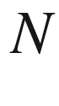

-Period Potential 487

[19.​1.​4 The Quarter-Wave Stack](The_Physics_of_Semiconductors00007.docx#u116076_4_En_19_Chapter-Sec5) 489

[19.​1.​5 Formation of a 3D Band Structure](The_Physics_of_Semiconductors00007.docx#u116076_4_En_19_Chapter-Sec6) 492

[19.​1.​6 Disorder](The_Physics_of_Semiconductors00007.docx#u116076_4_En_19_Chapter-Sec7) 494

[19.​1.​7 Defect Modes](The_Physics_of_Semiconductors00007.docx#u116076_4_En_19_Chapter-Sec8) 494

[19.​1.​8 Topological Photonic Band Structures](The_Physics_of_Semiconductors00007.docx#u116076_4_En_19_Chapter-Sec9) 497

[19.​1.​9 Coupling to an Electronic Resonance](The_Physics_of_Semiconductors00007.docx#u116076_4_En_19_Chapter-Sec10) 499

[19.​1.​10 Hyperbolic Optical Metamaterials](The_Physics_of_Semiconductors00007.docx#u116076_4_En_19_Chapter-Sec11) 502

[19.​2 Microscopic Resonators](The_Physics_of_Semiconductors00007.docx#u116076_4_En_19_Chapter-Sec12) 504

[19.​2.​1 Microdiscs](The_Physics_of_Semiconductors00007.docx#u116076_4_En_19_Chapter-Sec13) 504

[19.​2.​2 Purcell Effect](The_Physics_of_Semiconductors00007.docx#u116076_4_En_19_Chapter-Sec14) 506

[19.​2.​3 Deformed Resonators](The_Physics_of_Semiconductors00007.docx#u116076_4_En_19_Chapter-Sec15) 506

[19.​2.​4 Hexagonal Cavities](The_Physics_of_Semiconductors00007.docx#u116076_4_En_19_Chapter-Sec16) 508

[20 Transparent Conductive Oxide Semiconductors](The_Physics_of_Semiconductors00007.docx#u116076_4_En_20_Chapter) 511

[20.​1 Introduction](The_Physics_of_Semiconductors00007.docx#u116076_4_En_20_Chapter-Sec1) 511

[20.​2 Materials](The_Physics_of_Semiconductors00007.docx#u116076_4_En_20_Chapter-Sec2) 511

[20.​3 Properties](The_Physics_of_Semiconductors00007.docx#u116076_4_En_20_Chapter-Sec3) 512

Part III Applications

[21 Diodes](The_Physics_of_Semiconductors00007.docx#u116076_4_En_21_Chapter) 517

[21.​1 Introduction](The_Physics_of_Semiconductors00007.docx#u116076_4_En_21_Chapter-Sec1) 517

[21.​2 Metal-Semiconductor Contacts](The_Physics_of_Semiconductors00007.docx#u116076_4_En_21_Chapter-Sec2) 518

[21.​2.​1 Band Diagram in Equilibrium](The_Physics_of_Semiconductors00007.docx#u116076_4_En_21_Chapter-Sec3) 518

[21.​2.​2 Space-Charge Region](The_Physics_of_Semiconductors00007.docx#u116076_4_En_21_Chapter-Sec4) 523

[21.​2.​3 Schottky Effect](The_Physics_of_Semiconductors00007.docx#u116076_4_En_21_Chapter-Sec5) 526

[21.​2.​4 Capacitance](The_Physics_of_Semiconductors00007.docx#u116076_4_En_21_Chapter-Sec6) 527

[21.​2.​5 Current-Voltage Characteristic](The_Physics_of_Semiconductors00007.docx#u116076_4_En_21_Chapter-Sec7) 529

[21.​2.​6 Ohmic Contacts](The_Physics_of_Semiconductors00007.docx#u116076_4_En_21_Chapter-Sec8) 540

[21.​2.​7 Metal Contacts to Organic Semiconductors](The_Physics_of_Semiconductors00007.docx#u116076_4_En_21_Chapter-Sec9) 543

[21.​3 Metal-Insulator-Semiconductor Diodes](The_Physics_of_Semiconductors00007.docx#u116076_4_En_21_Chapter-Sec10) 544

[21.​3.​1 Band Diagram for Ideal MIS Diode](The_Physics_of_Semiconductors00007.docx#u116076_4_En_21_Chapter-Sec11) 545

[21.​3.​2 Space-Charge Region](The_Physics_of_Semiconductors00007.docx#u116076_4_En_21_Chapter-Sec12) 548

[21.​3.​3 Capacitance](The_Physics_of_Semiconductors00007.docx#u116076_4_En_21_Chapter-Sec13) 551

[21.​3.​4 Nonideal MIS Diode](The_Physics_of_Semiconductors00007.docx#u116076_4_En_21_Chapter-Sec14) 553

[21.​4 Bipolar Diodes](The_Physics_of_Semiconductors00007.docx#u116076_4_En_21_Chapter-Sec15) 553

[21.​4.​1 Band Diagram](The_Physics_of_Semiconductors00007.docx#u116076_4_En_21_Chapter-Sec16) 554

[21.​4.​2 Space-Charge Region](The_Physics_of_Semiconductors00007.docx#u116076_4_En_21_Chapter-Sec17) 555

[21.​4.​3 Capacitance](The_Physics_of_Semiconductors00007.docx#u116076_4_En_21_Chapter-Sec18) 559

[21.​4.​4 Current-Voltage Characteristics](The_Physics_of_Semiconductors00008.docx#u116076_4_En_21_Chapter-Sec19) 560

[21.​4.​5 Breakdown](The_Physics_of_Semiconductors00008.docx#u116076_4_En_21_Chapter-Sec20) 569

[21.​4.​6 Heterostructure Diodes](The_Physics_of_Semiconductors00008.docx#u116076_4_En_21_Chapter-Sec21) 573

[21.​4.​7 Organic Semiconductor Diodes](The_Physics_of_Semiconductors00008.docx#u116076_4_En_21_Chapter-Sec22) 573

[21.​5 Applications and Special Diode Devices](The_Physics_of_Semiconductors00008.docx#u116076_4_En_21_Chapter-Sec23) 576

[21.​5.​1 Rectification](The_Physics_of_Semiconductors00008.docx#u116076_4_En_21_Chapter-Sec24) 576

[21.​5.​2 Frequency Mixing](The_Physics_of_Semiconductors00008.docx#u116076_4_En_21_Chapter-Sec25) 578

[21.​5.​3 Voltage Regulator](The_Physics_of_Semiconductors00008.docx#u116076_4_En_21_Chapter-Sec26) 578

[21.​5.​4 Zener Diodes](The_Physics_of_Semiconductors00008.docx#u116076_4_En_21_Chapter-Sec27) 580

[21.​5.​5 Varactors](The_Physics_of_Semiconductors00008.docx#u116076_4_En_21_Chapter-Sec28) 581

[21.​5.​6 Fast-Recovery Diodes](The_Physics_of_Semiconductors00008.docx#u116076_4_En_21_Chapter-Sec29) 582

[21.​5.​7 Step-Recovery Diodes](The_Physics_of_Semiconductors00008.docx#u116076_4_En_21_Chapter-Sec30) 583

[21.​5.​8 Pin-Diodes](The_Physics_of_Semiconductors00008.docx#u116076_4_En_21_Chapter-Sec31) 583

[21.​5.​9 Tunneling Diodes](The_Physics_of_Semiconductors00008.docx#u116076_4_En_21_Chapter-Sec32) 584

[21.​5.​10 Backward Diodes](The_Physics_of_Semiconductors00008.docx#u116076_4_En_21_Chapter-Sec33) 587

[21.​5.​11 Gunn Diodes](The_Physics_of_Semiconductors00008.docx#u116076_4_En_21_Chapter-Sec34) 588

[22 Light-to-Electricity Conversion](The_Physics_of_Semiconductors00008.docx#u116076_4_En_22_Chapter) 589

[22.​1 Photocatalysis](The_Physics_of_Semiconductors00008.docx#u116076_4_En_22_Chapter-Sec1)  589

[22.​2 Photoconductors](The_Physics_of_Semiconductors00008.docx#u116076_4_En_22_Chapter-Sec2)  591

[22.​2.​1 Introduction](The_Physics_of_Semiconductors00008.docx#u116076_4_En_22_Chapter-Sec3) 591

[22.​2.​2 Photoconductivit​y Detectors](The_Physics_of_Semiconductors00008.docx#u116076_4_En_22_Chapter-Sec4) 591

[22.​2.​3 Electrophotograp​hy](The_Physics_of_Semiconductors00008.docx#u116076_4_En_22_Chapter-Sec5)  593

[22.​2.​4 QWIPs](The_Physics_of_Semiconductors00008.docx#u116076_4_En_22_Chapter-Sec6) 593

[22.​2.​5 Blocked Impurity-Band Detectors](The_Physics_of_Semiconductors00008.docx#u116076_4_En_22_Chapter-Sec7) 597

[22.​3 Photodiodes](The_Physics_of_Semiconductors00008.docx#u116076_4_En_22_Chapter-Sec8)  599

[22.​3.​1 Introduction](The_Physics_of_Semiconductors00008.docx#u116076_4_En_22_Chapter-Sec9) 599

[22.​3.​2 Pn Photodiodes](The_Physics_of_Semiconductors00008.docx#u116076_4_En_22_Chapter-Sec10)  600

[22.​3.​3 Pin Photodiodes](The_Physics_of_Semiconductors00008.docx#u116076_4_En_22_Chapter-Sec11)  602

[22.​3.​4 Position-Sensing Detector](The_Physics_of_Semiconductors00008.docx#u116076_4_En_22_Chapter-Sec12) 603

[22.​3.​5 MSM Photodiodes](The_Physics_of_Semiconductors00008.docx#u116076_4_En_22_Chapter-Sec13)  604

[22.​3.​6 Avalanche Photodiodes](The_Physics_of_Semiconductors00008.docx#u116076_4_En_22_Chapter-Sec14)  609

[22.​3.​7 Traveling-Wave Photodetectors](The_Physics_of_Semiconductors00008.docx#u116076_4_En_22_Chapter-Sec15) 613

[22.​3.​8 Charge Coupled Devices](The_Physics_of_Semiconductors00008.docx#u116076_4_En_22_Chapter-Sec16)  614

[22.​3.​9 Photodiode Arrays](The_Physics_of_Semiconductors00008.docx#u116076_4_En_22_Chapter-Sec17) 618

[22.​4 Solar Cells](The_Physics_of_Semiconductors00008.docx#u116076_4_En_22_Chapter-Sec18) 623

[22.​4.​1 Solar Radiation](The_Physics_of_Semiconductors00008.docx#u116076_4_En_22_Chapter-Sec19) 623

[22.​4.​2 Ideal Solar Cells](The_Physics_of_Semiconductors00008.docx#u116076_4_En_22_Chapter-Sec20) 624

[22.​4.​3 Real Solar Cells](The_Physics_of_Semiconductors00008.docx#u116076_4_En_22_Chapter-Sec21) 629

[22.​4.​4 Design Refinements](The_Physics_of_Semiconductors00008.docx#u116076_4_En_22_Chapter-Sec22) 630

[22.​4.​5 Modules](The_Physics_of_Semiconductors00008.docx#u116076_4_En_22_Chapter-Sec23) 630

[22.​4.​6 Solar-Cell Types](The_Physics_of_Semiconductors00008.docx#u116076_4_En_22_Chapter-Sec24) 632

[22.​4.​7 Economic Issues](The_Physics_of_Semiconductors00008.docx#u116076_4_En_22_Chapter-Sec28) 635

[23 Electricity-to-Light Conversion](The_Physics_of_Semiconductors00008.docx#u116076_4_En_23_Chapter) 639

[23.​1 Radiometric and Photometric Quantities](The_Physics_of_Semiconductors00008.docx#u116076_4_En_23_Chapter-Sec1) 639

[23.​1.​1 Radiometric Quantities](The_Physics_of_Semiconductors00008.docx#u116076_4_En_23_Chapter-Sec2) 639

[23.​1.​2 Photometric Quantities](The_Physics_of_Semiconductors00008.docx#u116076_4_En_23_Chapter-Sec3) 639

[23.​2 Scintillators](The_Physics_of_Semiconductors00008.docx#u116076_4_En_23_Chapter-Sec4) 641

[23.​2.​1 CIE Chromaticity Diagram](The_Physics_of_Semiconductors00008.docx#u116076_4_En_23_Chapter-Sec5) 641

[23.​2.​2 Display Applications](The_Physics_of_Semiconductors00008.docx#u116076_4_En_23_Chapter-Sec6) 644

[23.​2.​3 Radiation Detection](The_Physics_of_Semiconductors00008.docx#u116076_4_En_23_Chapter-Sec7) 644

[23.​2.​4 Luminescence Mechanisms](The_Physics_of_Semiconductors00008.docx#u116076_4_En_23_Chapter-Sec8)  645

[23.​3 Light-Emitting Diodes](The_Physics_of_Semiconductors00008.docx#u116076_4_En_23_Chapter-Sec9)  646

[23.​3.​1 Introduction](The_Physics_of_Semiconductors00008.docx#u116076_4_En_23_Chapter-Sec10) 646

[23.​3.​2 Spectral Ranges](The_Physics_of_Semiconductors00008.docx#u116076_4_En_23_Chapter-Sec11) 646

[23.​3.​3 Efficiencies](The_Physics_of_Semiconductors00008.docx#u116076_4_En_23_Chapter-Sec12) 647

[23.​3.​4 Device Design](The_Physics_of_Semiconductors00008.docx#u116076_4_En_23_Chapter-Sec13) 648

[23.​3.​5 White LEDs](The_Physics_of_Semiconductors00008.docx#u116076_4_En_23_Chapter-Sec14) 653

[23.​3.​6 Quantum Dot LEDs](The_Physics_of_Semiconductors00008.docx#u116076_4_En_23_Chapter-Sec15) 656

[23.​3.​7 Organic LEDs](The_Physics_of_Semiconductors00008.docx#u116076_4_En_23_Chapter-Sec16) 657

[23.​4 Lasers](The_Physics_of_Semiconductors00008.docx#u116076_4_En_23_Chapter-Sec17)  659

[23.​4.​1 Introduction](The_Physics_of_Semiconductors00008.docx#u116076_4_En_23_Chapter-Sec18) 659

[23.​4.​2 Applications](The_Physics_of_Semiconductors00009.docx#u116076_4_En_23_Chapter-Sec19) 660

[23.​4.​3 Gain](The_Physics_of_Semiconductors00009.docx#u116076_4_En_23_Chapter-Sec20) 661

[23.​4.​4 Optical Mode](The_Physics_of_Semiconductors00009.docx#u116076_4_En_23_Chapter-Sec21) 664

[23.​4.​5 Loss Mechanisms](The_Physics_of_Semiconductors00009.docx#u116076_4_En_23_Chapter-Sec22)  669

[23.​4.​6 Threshold](The_Physics_of_Semiconductors00009.docx#u116076_4_En_23_Chapter-Sec23)  670

[23.​4.​7 Spontaneous Emission Factor](The_Physics_of_Semiconductors00009.docx#u116076_4_En_23_Chapter-Sec24)  671

[23.​4.​8 Output Power](The_Physics_of_Semiconductors00009.docx#u116076_4_En_23_Chapter-Sec25)  672

[23.​4.​9 Temperature Dependence](The_Physics_of_Semiconductors00009.docx#u116076_4_En_23_Chapter-Sec26) 675

[23.​4.​10 Mode Spectrum](The_Physics_of_Semiconductors00009.docx#u116076_4_En_23_Chapter-Sec27)  676

[23.​4.​11 Longitudinal Single-Mode Lasers](The_Physics_of_Semiconductors00009.docx#u116076_4_En_23_Chapter-Sec28) 677

[23.​4.​12 Tunability](The_Physics_of_Semiconductors00009.docx#u116076_4_En_23_Chapter-Sec29)  678

[23.​4.​13 Dynamics and Modulation](The_Physics_of_Semiconductors00009.docx#u116076_4_En_23_Chapter-Sec30)  679

[23.​4.​14 Surface-Emitting Lasers](The_Physics_of_Semiconductors00009.docx#u116076_4_En_23_Chapter-Sec31)  684

[23.​4.​15 Optically Pumped Semiconductor Lasers](The_Physics_of_Semiconductors00009.docx#u116076_4_En_23_Chapter-Sec32)  686

[23.​4.​16 Quantum Cascade Lasers](The_Physics_of_Semiconductors00009.docx#u116076_4_En_23_Chapter-Sec33)  688

[23.​4.​17 Hot-Hole Lasers](The_Physics_of_Semiconductors00009.docx#u116076_4_En_23_Chapter-Sec34)  688

[23.​5 Semiconductor Optical Amplifiers](The_Physics_of_Semiconductors00009.docx#u116076_4_En_23_Chapter-Sec35)  689

[24 Transistors](The_Physics_of_Semiconductors00009.docx#u116076_4_En_24_Chapter) 691

[24.​1 Introduction](The_Physics_of_Semiconductors00009.docx#u116076_4_En_24_Chapter-Sec1) 691

[24.​2 Bipolar Transistors](The_Physics_of_Semiconductors00009.docx#u116076_4_En_24_Chapter-Sec2) 691

[24.​2.​1 Carrier Density and Currents](The_Physics_of_Semiconductors00009.docx#u116076_4_En_24_Chapter-Sec3) 693

[24.​2.​2 Current Amplification](The_Physics_of_Semiconductors00009.docx#u116076_4_En_24_Chapter-Sec4) 695

[24.​2.​3 Ebers-Moll Model](The_Physics_of_Semiconductors00009.docx#u116076_4_En_24_Chapter-Sec5) 697

[24.​2.​4 Current–Voltage Characteristics](The_Physics_of_Semiconductors00009.docx#u116076_4_En_24_Chapter-Sec6) 699

[24.​2.​5 Basic Circuits](The_Physics_of_Semiconductors00009.docx#u116076_4_En_24_Chapter-Sec7) 701

[24.​2.​6 High-Frequency Properties](The_Physics_of_Semiconductors00009.docx#u116076_4_En_24_Chapter-Sec11) 702

[24.​2.​7 Heterojunction Bipolar Transistors](The_Physics_of_Semiconductors00009.docx#u116076_4_En_24_Chapter-Sec12) 702

[24.​2.​8 Light-Emitting Transistors](The_Physics_of_Semiconductors00009.docx#u116076_4_En_24_Chapter-Sec13) 703

[24.​3 Field-Effect Transistors](The_Physics_of_Semiconductors00009.docx#u116076_4_En_24_Chapter-Sec14) 703

[24.​4 JFET and MESFET](The_Physics_of_Semiconductors00009.docx#u116076_4_En_24_Chapter-Sec15) 706

[24.​4.​1 General Principle](The_Physics_of_Semiconductors00009.docx#u116076_4_En_24_Chapter-Sec16) 706

[24.​4.​2 Static Characteristics](The_Physics_of_Semiconductors00009.docx#u116076_4_En_24_Chapter-Sec17) 706

[24.​4.​3 Normally On and Normally Off FETs](The_Physics_of_Semiconductors00009.docx#u116076_4_En_24_Chapter-Sec18) 709

[24.​4.​4 Field-Dependent Mobility](The_Physics_of_Semiconductors00009.docx#u116076_4_En_24_Chapter-Sec19) 710

[24.​4.​5 High-Frequency Properties](The_Physics_of_Semiconductors00009.docx#u116076_4_En_24_Chapter-Sec20) 712

[24.​5 MOSFETs](The_Physics_of_Semiconductors00009.docx#u116076_4_En_24_Chapter-Sec21) 712

[24.​5.​1 Operation Principle](The_Physics_of_Semiconductors00009.docx#u116076_4_En_24_Chapter-Sec22) 713

[24.​5.​2 Current–Voltage Characteristics](The_Physics_of_Semiconductors00009.docx#u116076_4_En_24_Chapter-Sec23) 714

[24.​5.​3 MOSFET Types](The_Physics_of_Semiconductors00009.docx#u116076_4_En_24_Chapter-Sec24) 718

[24.​5.​4 Complementary MOS](The_Physics_of_Semiconductors00009.docx#u116076_4_En_24_Chapter-Sec25) 718

[24.​5.​5 Large-Scale Integration](The_Physics_of_Semiconductors00009.docx#u116076_4_En_24_Chapter-Sec26) 721

[24.​5.​6 Tunneling FETs](The_Physics_of_Semiconductors00009.docx#u116076_4_En_24_Chapter-Sec27) 727

[24.​5.​7 Nonvolatile Memories](The_Physics_of_Semiconductors00009.docx#u116076_4_En_24_Chapter-Sec28) 727

[24.​5.​8 Heterojunction FETs](The_Physics_of_Semiconductors00009.docx#u116076_4_En_24_Chapter-Sec29) 731

[24.​6 Thin-Film Transistors](The_Physics_of_Semiconductors00009.docx#u116076_4_En_24_Chapter-Sec30) 733

[24.​6.​1 Annealing of Amorphous Silicon](The_Physics_of_Semiconductors00009.docx#u116076_4_En_24_Chapter-Sec31) 734

[24.​6.​2 TFT Devices](The_Physics_of_Semiconductors00009.docx#u116076_4_En_24_Chapter-Sec32) 736

[24.​6.​3 Transistors with 2D Materials](The_Physics_of_Semiconductors00009.docx#u116076_4_En_24_Chapter-Sec33) 737

[24.​6.​4 OFETs](The_Physics_of_Semiconductors00009.docx#u116076_4_En_24_Chapter-Sec34) 738

[Appendix A:​ Tensors](The_Physics_of_Semiconductors00009.docx#u116076_4_En_BookBackmatter_OnlinePDF-App1) 739 [Appendix B:​ Point and Space Groups](The_Physics_of_Semiconductors00009.docx#u116076_4_En_BookBackmatter_OnlinePDF-App2) 743 [Appendix C:​ Kramers–Kronig Relations](The_Physics_of_Semiconductors00009.docx#u116076_4_En_BookBackmatter_OnlinePDF-App3) 747 [Appendix D:​ Oscillator Strength](The_Physics_of_Semiconductors00010.docx#u116076_4_En_BookBackmatter_OnlinePDF-App4) 749 [Appendix E:​ Quantum Statistics](The_Physics_of_Semiconductors00010.docx#u116076_4_En_BookBackmatter_OnlinePDF-App5) 755 [Appendix F:​ Kronig-Penney Model](The_Physics_of_Semiconductors00010.docx#u116076_4_En_BookBackmatter_OnlinePDF-App6) 761 [Appendix G:​ Tight-Binding Model](The_Physics_of_Semiconductors00010.docx#u116076_4_En_BookBackmatter_OnlinePDF-App7) 765 [Appendix H:](The_Physics_of_Semiconductors00010.docx#u116076_4_En_BookBackmatter_OnlinePDF-App8)

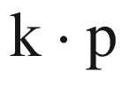

Perturbation Theory 773 [Appendix I:​ Effective-Mass Theory](The_Physics_of_Semiconductors00010.docx#u116076_4_En_BookBackmatter_OnlinePDF-App9) 777 [Appendix J:​ Boltzmann Transport Theory](The_Physics_of_Semiconductors00010.docx#u116076_4_En_BookBackmatter_OnlinePDF-App10) 779 [Appendix K:​ Noise](The_Physics_of_Semiconductors00010.docx#u116076_4_En_BookBackmatter_OnlinePDF-App11) 785 [References](The_Physics_of_Semiconductors00010.docx#u116076_4_En_BookBackmatter_OnlinePDF-Bib1) 793 Index 869

Footnotes

[1](#u116076_4_En_BookFrontmatter_OnlinePDF-Fn1_source)

pronounced Eye-triple-E.

© Springer Nature Switzerland AG 2021

M. Grundmann

The Physics of Semiconductors

Graduate Texts in Physics

<https://doi.org/10.1007/978-3-030-51569-0_1>

## 1. Introduction

Marius Grundmann[1](#u116076_4_En_1_Chapter-Aff11)

(1)

Felix Bloch Institute for Solid State Physics, Universität Leipzig, Leipzig, Germany

Marius Grundmann

Email:

[grundmann@physik.uni-leipzig.de](mailto:grundmann@physik.uni-leipzig.de)

*The proper conduct of science lies in the pursuit of Nature’s puzzles, wherever they may lead.*

*J.M. Bishop* [2]

## Abstract

Important dates and events in the history of semiconductors are chronologically listed, from the early days (Volta, Seebeck and Faraday) to the latest achievements like the blue and white LED. Many known and not so well known scientists are mentioned. Also a list of semiconductor related Nobel prizes and their winners is given.

The historic development of semiconductor physics and technology began in the second half of the 19th century. Interesting discussions of the history of the physics and chemistry of semiconductors can be found in [3–5]. The development of crystal growth is covered in [6]. The history of semiconductor industry can be followed in [7, 8]. In [9] 141 pioneering papers on semiconductor devices are compiled. In 1947, the commercial realization of the transistor was the impetus to a fast-paced development that created the electronics and photonics industries. Products founded on the basis of semiconductor devices such as computers (CPUs, memories), optical-storage media (lasers for CD, DVD), communication infrastructure (lasers and photodetectors for optical-fiber technology, high frequency electronics for mobile communication), displays (thin film transistors, LEDs), projection (laser diodes) and general lighting (LEDs) are commonplace. Thus, fundamental research on semiconductors and semiconductor physics and its offspring in the form of devices has contributed largely to the development of modern civilization and culture.

### 1.1 Timetable and Key Achievements

In this section important milestones in semiconductor physics and technology are listed.

1782

A. Volta—coins the phrase ‘semicoibente’ (semi-insulating) which was translated then into English as ‘semiconducting’ [10].

1821

T.J. Seebeck—discovery of thermopower (electrical phenomena upon temperature difference) in metals and PbS, FeS



, CuFeS



 [11, 12].

1833

M. Faraday—discovery of the temperature dependence of the conductivity of Ag



S (sulphuret of silver, negative d*R*/d*T*) [13].

1839

A.E. Becquerel[1](#u116076_4_En_1_Chapter-Fn1)—photoelectric effect (production of a photocurrent when electrodes covered by copper or silver halides salts (in an electrolyte) were illuminated by solar light) [14–17].

1834

J. Peltier—discovery of the Peltier effect (cooling by current) [18].

1873

W. Smith—discovery of photoconductivity in selenium [19, 20]. Early work on photoconductivity in Se is reviewed in [21, 22].

1874

F. Braun[2](#u116076_4_En_1_Chapter-Fn2)—discovery of rectification in metal–sulfide semiconductor contacts [24], e.g. for CuFeS



and PbS. The current through a metal–semiconductor contact is nonlinear (as compared to that through a metal, Fig. [1.1](#u116076_4_En_1_Chapter-Fig1)), i.e. a deviation from Ohm’s law. Braun’s structure is similar to a MSM diode.

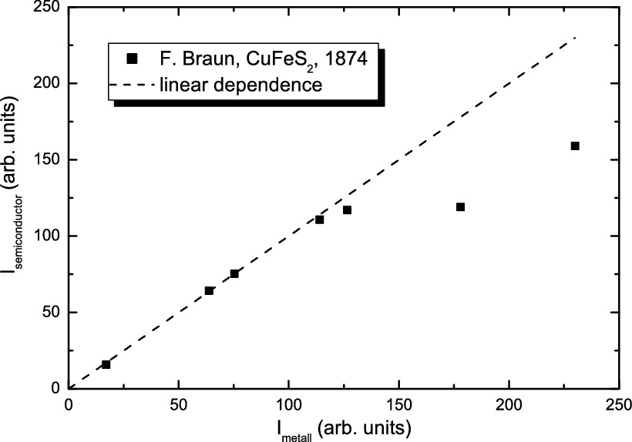

Fig. 1.1

Current through a silver–CuFeS



–silver structure as a function of the current through the metal only, 1874. Data points are for different applied voltages.

Experimental data from [24]

1876

W.G. Adams and R.E. Day—discovery of the photovoltaic effect in selenium [25].

W. Siemens—large response from selenium photoconductor [26], made by winding two thin platinum wires to the surface of a sheet of mica, and then covering the surface with a thin film of molten selenium. Resistance ratio between dark and illuminated by sunlight was larger than ten [26] and measured to 14.8 in [27].

1879

E.H. Hall—measurement of the transverse potential difference in a thin gold leaf on glass [28, 29]. Experiments were continued by his mentor H.A. Rowland [30]. A detailed account of the discovery of the Hall efect is given in [31, 32].

1883

Ch. Fritts—first solar cell, based on an gold/selenium rectifier [27]. The efficiency was below 1%.

1901

J.C. Bose—point contact detector for electromagnetic waves based on galena (PbS) [33]. At the time, the term semiconductor was not introduced yet and Bose speaks about ‘substances of a certain class (...) presenting a decreasing resistance to the passage of the electric current with an increasing impressed electromotive force’.

1906

G.W. Pickard—rectifier based on point contact (cat’s whisker) diode on silicon [34–36]. Erroneously, the rectifying effect was attributed to a thermal effect, however, the drawing of the ‘thermo-junction’ (TJ in Fig. [1.2](#u116076_4_En_1_Chapter-Fig2)) developed into the circuit symbol for a diode (cmp. Fig. [21.​63](The_Physics_of_Semiconductors00008.docx#u116076_4_En_21_Chapter-Fig63)a).

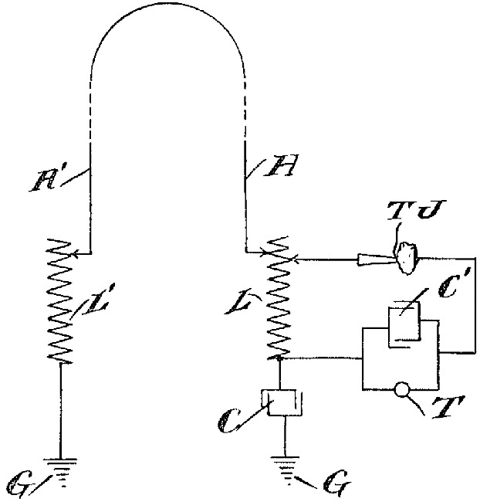

Fig. 1.2

Circuit diagram for a radio receiver with a point-contact diode (TJ).

Adapted from [34]

1907

H.J. Round—discovery of electroluminescence investigating yellow and blue light emission from SiC [37].

K. Bädeker—preparation of metal (e.g. Cd, Cu) oxides and sulfides and also CuI from metal layers using a vapor phase transport method [38][3](#u116076_4_En_1_Chapter-Fn3). CuI is reported transparent (

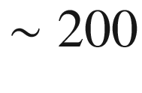

 nm thick films) with a specific resistivity of

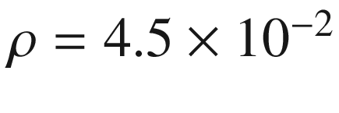

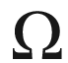

 cm, the first transparent conductor.[4](#u116076_4_En_1_Chapter-Fn4) Also CdO (films of thickness 100–200 nm) is reported to be highly conductive,

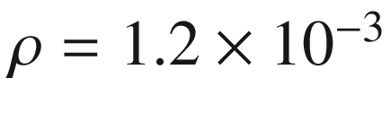

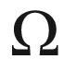

 cm, and orange-yellow in color, the first reported TCO (transparent conductive oxide).

1909

K. Bädeker—discovery of doping. Controlled variation of the conductivity of CuI by dipping into iodine solutions (e.g. in chloroform) of different concentrations [41].

1910

W.H. Eccles—negative differential resistance of contacts with galena (PbS), construction of crystal oscillators[5](#u116076_4_En_1_Chapter-Fn5) [45].

1911

The term ‘Halbleiter’ (semiconductor) is introduced for the first time by J. Weiss [46] and J. Königsberger and J. Weiss [47]. Königsberger preferred the term ‘Variabler Leiter’ (variable conductor).

1912

M. von Laue—X-ray diffraction of bulk crystals including ZnS (Fig. [1.3](#u116076_4_En_1_Chapter-Fig3)) [48, 49].

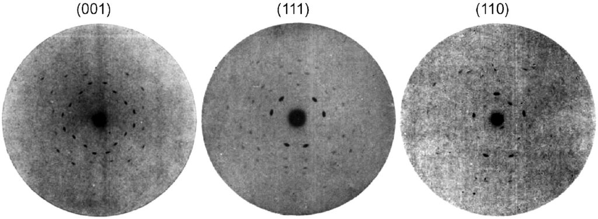

Fig. 1.3

Laue images of ’regular’ (cubic) ZnS along three major crystallographic directions, directly visualizing their 4-, 3- and 2-fold symmetry.

Adapted from [48]

1925

J.E. Lilienfeld[6](#u116076_4_En_1_Chapter-Fn6)—proposal of the metal-semiconductor field-effect transistor (MESFET) [53], with suggested copper sulfide thin film channel and aluminum gate.[7](#u116076_4_En_1_Chapter-Fn7) (Fig. [1.4](#u116076_4_En_1_Chapter-Fig4)). Lilienfeld was also awarded patents for a depletion mode MOSFET [55] with proposed copper sulfide, copper oxide or lead oxide channel and current amplification with nppn- and pnnp-transistors [56]. Due to the lack of other publications of Lilienfeld on transistors, it is under discussion whether Lilienfeld just patented ideas or also build working devices with mounting evidence for the latter [51, 54, 57].

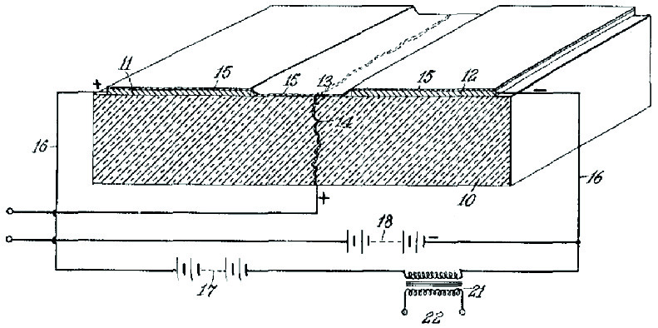

Fig. 1.4

Sketch of a field-effect transistor, 1926.

From [53]

1927

A. Schleede, H. Buggisch—synthesis of pure, stoichiometric PbS, influence of sulphur excess and impurities [58].

A. Schleede, E. Körner—activation of luminescence of ZnS [59, 60].

1928

F. Bloch—quantum mechanics of electrons in a crystal lattice, ‘Bloch functions’ [61].

O.V. Losev—description of the light emitting diode[8](#u116076_4_En_1_Chapter-Fn8) (SiC) [65]; light emission was observed in forward direction and close to breakdown (Fig. [1.5](#u116076_4_En_1_Chapter-Fig5)a). Also current modulation of LED light output was reported (Fig. [1.5](#u116076_4_En_1_Chapter-Fig5)b) [65].

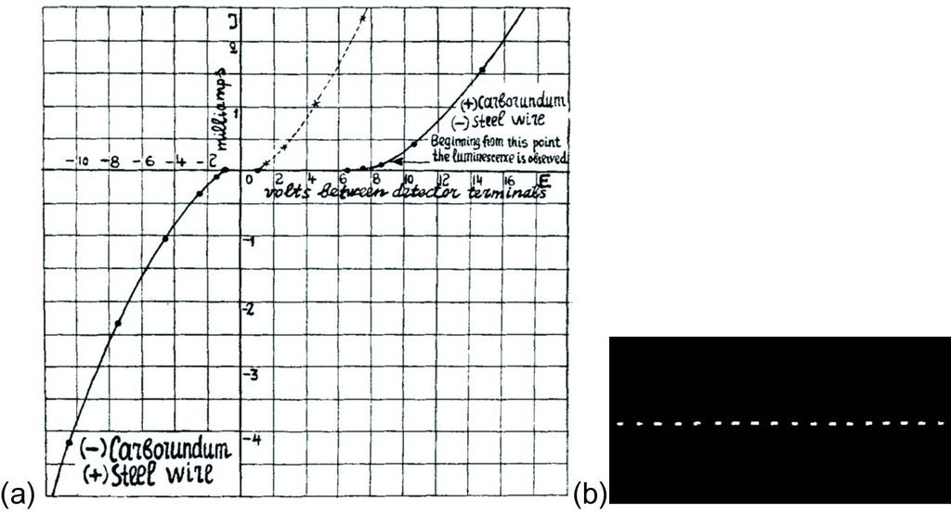

Fig. 1.5

**a** *I*–*V* characteristic of SiC/steel wire light emitting diode. The *dotted curve* is the flipped curve for negative voltage (3rd quadrant). **b** Recording of current modulated (at 500 Hz) LED on moving photographic plate.

Adapted from [65]

1929

R. Peierls—explanation of positive (anomalous) Hall effect with unoccupied electron states [66, 67].

1930

R. Peierls—first calculation of a band structure and band gap[9](#u116076_4_En_1_Chapter-Fn9) (Fig. [1.6](#u116076_4_En_1_Chapter-Fig6)) [69].

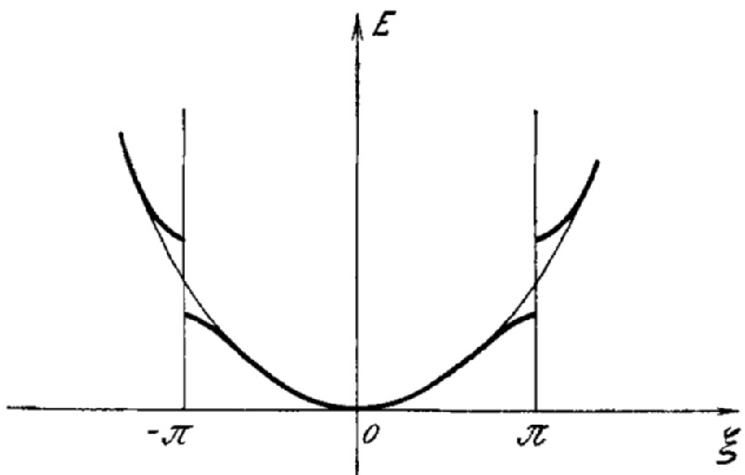

Fig. 1.6

First band structure calculation from Peierls (

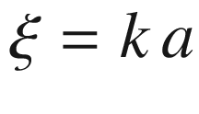

).

Adapted from [69]

1931

W. Heisenberg—theory of hole (‘Löcher’) states [70].

R. de L. Kronig and W.G. Penney—properties of periodic potentials in solids [71].

A.H. Wilson[10](#u116076_4_En_1_Chapter-Fn10)—development of band-structure theory [74, 75].

1933

C. Wagner—excess (‘Elektronenüberschuss-Leitung’, n-type) and defect (‘Elektronen-Defektleitung’, p-type) conduction [76–79]. Anion deficiency in ZnO causes conducting behavior [80].

1934

C. Zener—Zener tunneling [81].

1936

J. Frenkel—description of excitons [82].

1938

B. Davydov—theoretical prediction of rectification at pn-junction [83] and in Cu



O [84].

W. Schottky—theory of the boundary layer in metal–semiconductor contacts [85], being the basis for Schottky contacts and field-effect transistors.

N.F. Mott—metal–semiconductor rectifier theory [86, 87].

R. Hilsch and R.W. Pohl—three-electrode crystal (KBr) [88].

1940

R.S. Ohl—Silicon-based photoeffect (solar cell, Fig. [1.7](#u116076_4_En_1_Chapter-Fig7)) [89] from a pn-junction formed within a slab of polycrystalline Si fabricated with directed solidification due to different distribution coefficients of p- and n-dopants (boron and phosphorus, cmp. Fig. [4.​6](The_Physics_of_Semiconductors00002.docx#u116076_4_En_4_Chapter-Fig6)b) (J. Scaff and H. Theurer) [90, 91].

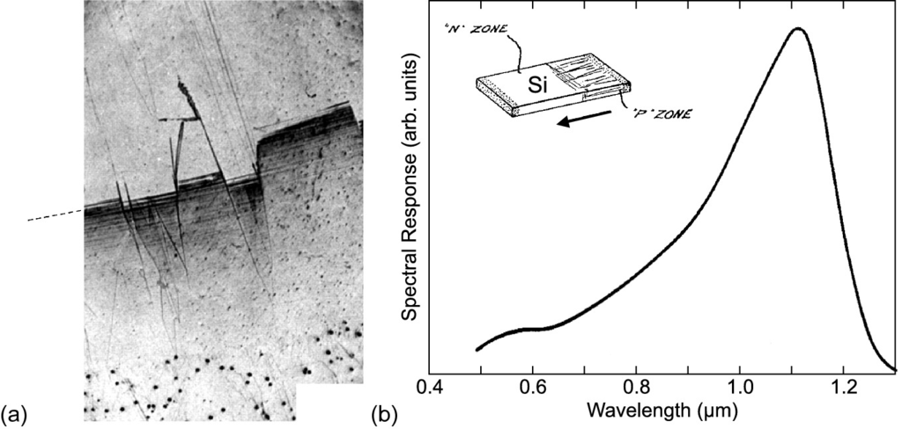

Fig. 1.7

**a** Optical image of directionally solidified silicon. The lower part contains predominantly boron, the upper part contains predominantly phosphorous. First the growth is porous and subsequently columnar. Adapted from [90]. **b** Spectral response of silicon pn-junction photoelement, 1940. The *inset* depicts schematically a Si slab with built-in pn-junction formed during directed solidification as shown in panel (**a**). The *arrow* denotes the direction of solidification (cmp. Fig. [4.​6](The_Physics_of_Semiconductors00002.docx#u116076_4_En_4_Chapter-Fig6)).

Adapted from [89]

1941

R.S. Ohl—Silicon rectifier with point contact [92, 93] (Fig. [1.8](#u116076_4_En_1_Chapter-Fig8)), building on work from G.W. Pickard (1906) and using metallurgically refined and intentionally doped silicon (J. Scaff and H. Theurer) [90].

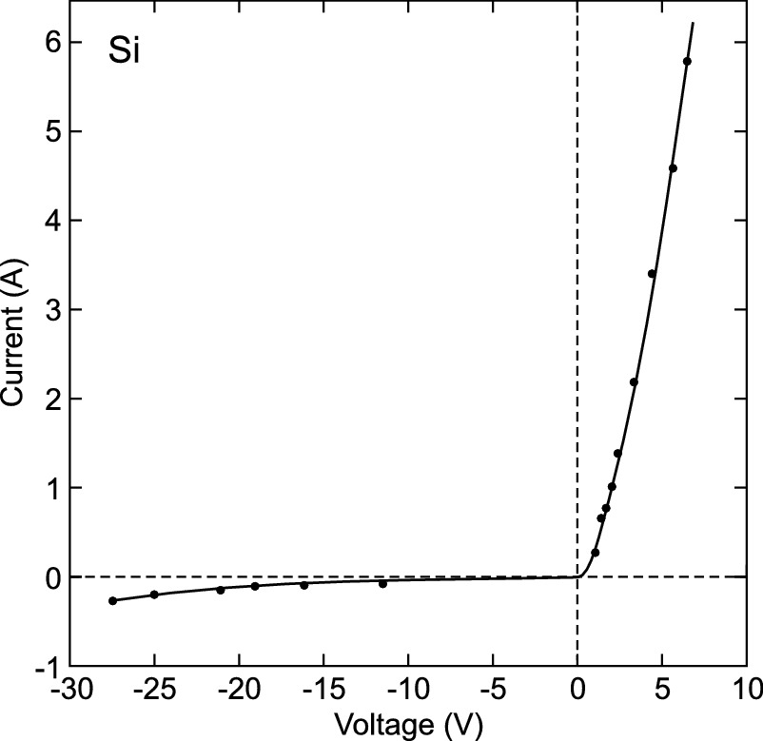

Fig. 1.8

Characteristics of a silicon rectifier, 1941.

Adapted from [92]

1942

K. Clusius, E. Holz and H. Welker—rectification in germanium [94].

1945

H. Welker—patents for JFET and MESFET [95].

1947

W. Shockley, J. Bardeen and W. Brattain fabricate the first transistor in the AT&T Bell Laboratories, Holmdel, NJ in an effort to improve hearing aids [96].[11](#u116076_4_En_1_Chapter-Fn11) Strictly speaking the structure was a point-contact transistor. A 50-

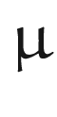

m wide slit was cut with a razor blade into gold foil over a plastic (insulating) triangle and pressed with a spring on n-type germanium (Fig. [1.9](#u116076_4_En_1_Chapter-Fig9)a) [97]. The surface region of the germanium is p-type due to surface states and represents an inversion layer. The two gold contacts form emitter and collector, the large-area back contact of the germanium the base contact [98]. For the first time, amplification was observed [99]. Later models use two close point contacts made from wires with their tips cut into wedge shape (Fig. [1.9](#u116076_4_En_1_Chapter-Fig9)b) [98].[12](#u116076_4_En_1_Chapter-Fn12) More details about the history and development of the semiconductor transistor can be found in [100], written on the occasion of the 50th anniversary of its invention.

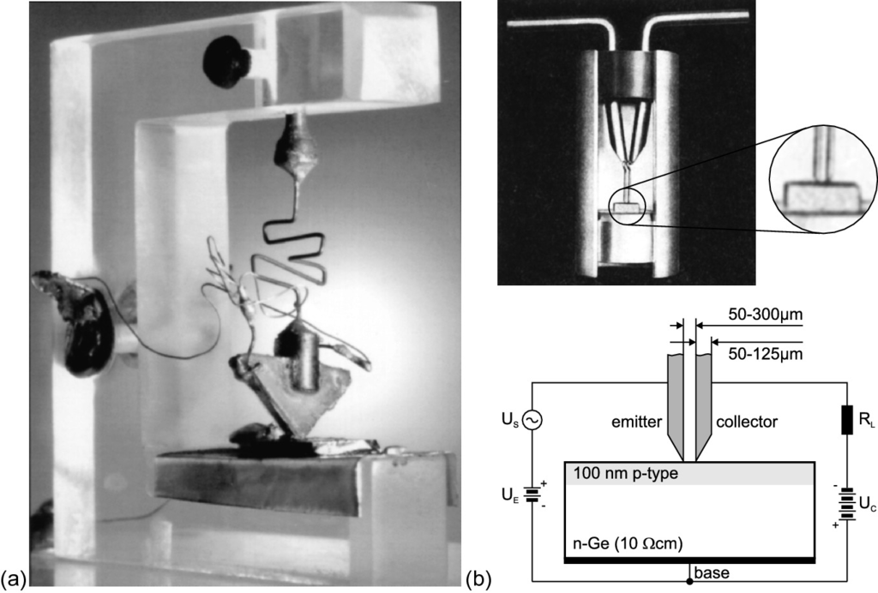

Fig. 1.9

**a** The first transistor, 1947 (length of side of wedge: 32 mm). **b** Cutaway model of a 1948 point contact transistor (‘Type A’) based on n-type bulk Ge (

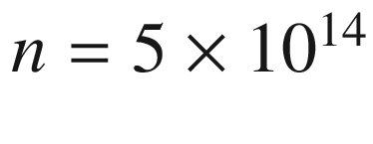

 cm

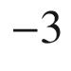

) and common base circuit diagram. The surface region (

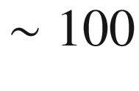

 nm depth) of the Ge is p-type due to surface states and represents an inversion layer. The two wires are made from phosphor bronze.

Adapted from [98]

1948

W. Shockley—invention of the bipolar (junction) transistor [101].

1952

H. Welker—fabrication of III–V compound semiconductors[13](#u116076_4_En_1_Chapter-Fn13) [104–107].

W. Shockley—description of today’s version of the (J)FET [108].

1953

G.C. Dacey and I.M. Ross—first realization of a JFET [109].

D.M. Chapin, C.S. Fuller and G.L. Pearson—invention of the silicon solar cell at Bell Laboratories [110]. A single 2 cm

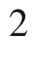

photovoltaic cell from Si, Si:As with an ultrathin layer of Si:B, with about 6% efficiency generated 5 mW of electrical power.[14](#u116076_4_En_1_Chapter-Fn14) Previously existing solar cells based on selenium had very low efficiency (

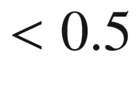

%).

1958

J.S. Kilby made the first integrated circuit at Texas Instruments. The simple 1.3 MHz RC-oscillator consisted of one transistor, three resistors and a capacitor on a

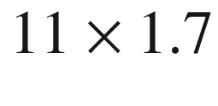

 mm

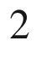

Ge platelet (Fig. [1.10](#u116076_4_En_1_Chapter-Fig10)a). J.S. Kilby filed in 1959 for a US patent for miniaturized electronic circuits [111]. At practically the same time R.N. Noyce from Fairchild Semiconductors, the predecessor of INTEL, invented the integrated circuit on silicon using planar technology [112]. A detailed and (very) critical view on the invention of the integrated circuit can be found in [113].

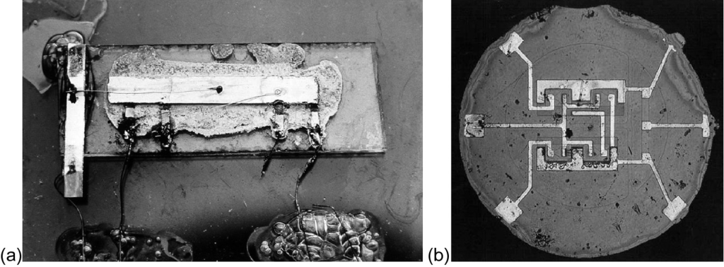

Fig. 1.10

**a** The first integrated circuit, 1958 (germanium,

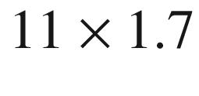

 mm

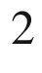

). **b** The first planar integrated circuit, 1959 (silicon, diameter: 1.5 mm)

Figure [1.10](#u116076_4_En_1_Chapter-Fig10)b shows a flip-flop with four bipolar transistors and five resistors. Initially, the invention of the integrated circuit[15](#u116076_4_En_1_Chapter-Fn15) met scepticism because of concerns regarding yield and the achievable quality of the transistors and the other components (such as resistors and capacitors).

1959

J. Hoerni[16](#u116076_4_En_1_Chapter-Fn16) and R. Noyce—first realization of a planar transistor (in silicon) (Fig. [1.11](#u116076_4_En_1_Chapter-Fig11)) [115–119].

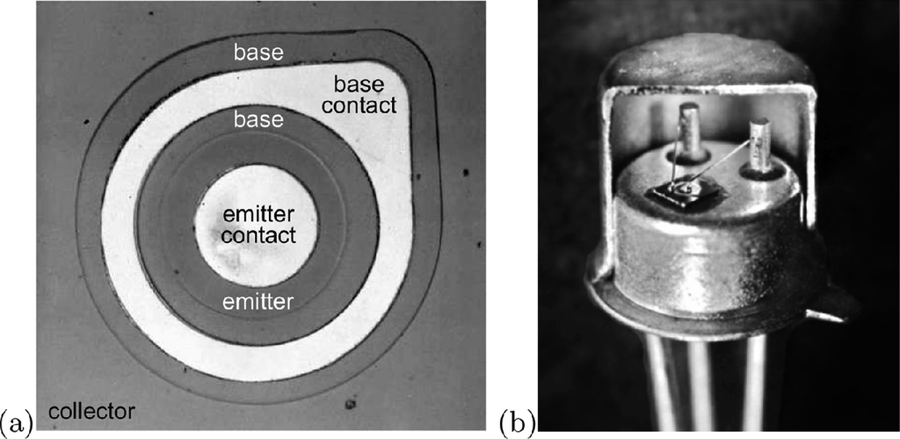

Fig. 1.11

(**a**) Optical image of planar pnp silicon transistor (2N1613 [120]), 1959. The contacts are Al surfaces (not bonded). (**b**) Housing of such transistor cut open

1960

D. Kahng and M.M. Atalla—first realization of a MOSFET [121, 122].

1962

The first semiconductor laser on GaAs basis at 77 K at GE [123, 124] (Fig. [1.12](#u116076_4_En_1_Chapter-Fig12)) and at IBM [125] and MIT [126].

First visible laser diode [127].[17](#u116076_4_En_1_Chapter-Fn17)

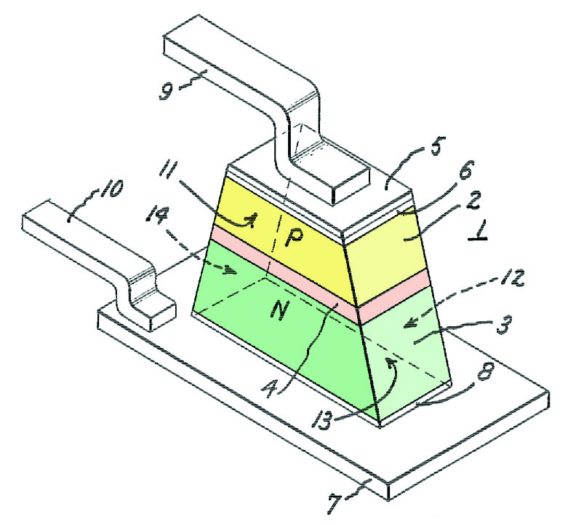

Fig. 1.12

Schematics of GaAs-based laser diode. The active layer is highlighted in *red*.

Adapted from [124]

1963

Proposal of a double heterostructure laser (DH laser) by Zh.I. Alferov [130, 131] and H. Kroemer [132, 133].

J.B. Gunn—discovery of the Gunn effect, the spontaneous microwave oscillations in GaAs and InP at sufficiently large applied electric field (due to negative differential resistance) [134].

1966

C.A. Mead—proposal of the MESFET (‘Schottky Barrier Gate FET’) [135].

1967

Zh.I. Alferov—report of the first DH laser on the basis of Ga(As,P) at 77 K [136, 137].

W.W. Hooper and W.I. Lehrer—first realization of a MESFET [138].

1968

DH laser on the basis of GaAs/(Al,Ga)As at room temperature, independently developed by Zh.I. Alferov [139] and I. Hayashi [140].

GaP:N LEDs with yellow-green emission (550 nm) and 0.3% efficiency [141].

1968

SiC blue LED with efficiency of 0.005% [142].

1970

W.S. Boyle and G.E. Smith—invention of the charge coupled device (CCD) [143, 144].

1971

R.F. Kazarinov and R.A. Suris—proposal of the quantum cascade laser [145].

1975

R.S. Pengelly and J.A. Turner—first monolithic microwave integrated circuit (MMIC) (Fig. [1.13](#u116076_4_En_1_Chapter-Fig13)) [146]

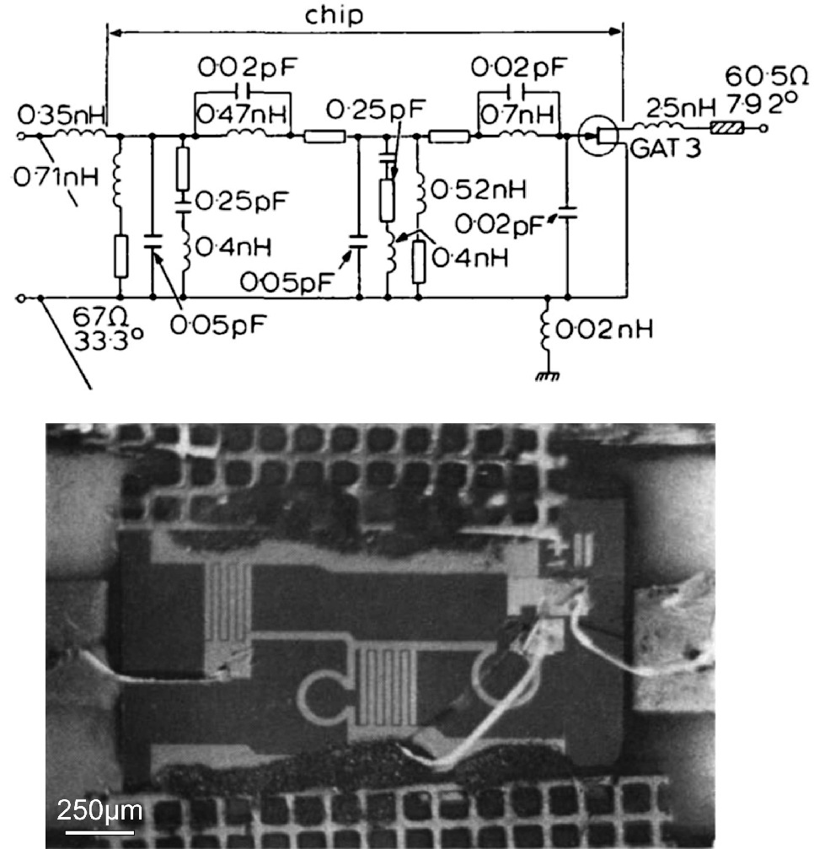

Fig. 1.13

Equivalent circuit and optical image of first monolithic microwave integrated circuit (exhibiting gain (

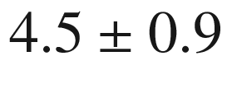

 dB) in the frequency range 7.0–11.7 GHz).

Adapted from [146]

1992

S. Nakamura—growth of high-quality group-III–nitride thin films [147], blue nitride heterostructure LED with efficiency exceeding 10% (1995) [148] (Fig. [1.14](#u116076_4_En_1_Chapter-Fig14)a). Later the white LED was built by combining a blue LED with yellow phosphors (Fig. [1.14](#u116076_4_En_1_Chapter-Fig14)b, c).

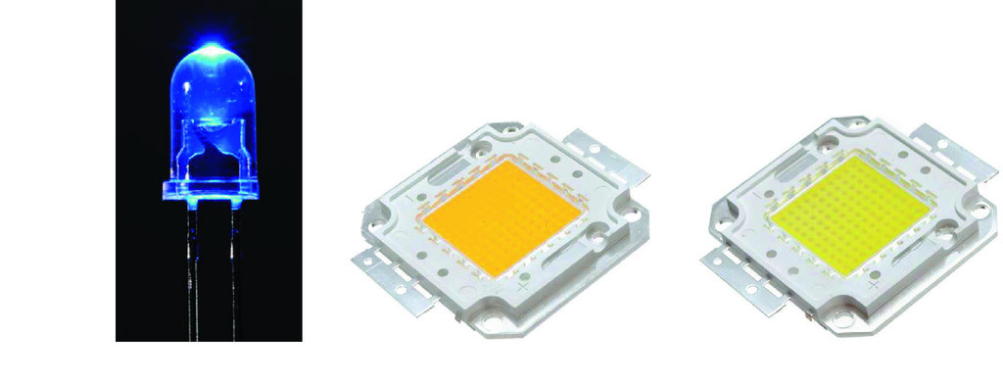

Fig. 1.14

**a** Blue LED (standard housing). 50 W, 4000 lm, **b** warm white and **c** cold white LED (

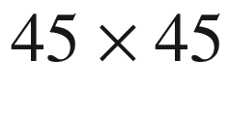

 mm



)

1994

J. Faist and F. Capasso—quantum cascade laser [149].

N. Kirstaedter, N.N. Ledentsov, Zh.I. Alferov and D. Bimberg—quantum dot laser [150].

2004

H. Hosono and T. Kamiya—thin film transistor (TFT) from amorphous oxide semiconductor [151].

### 1.2 Nobel Prize Winners

Several Nobel Prizes[18](#u116076_4_En_1_Chapter-Fn18) have been awarded for discoveries and inventions in the field of semiconductor physics (Fig. [1.15](#u116076_4_En_1_Chapter-Fig15)).

1909

Karl Ferdinand Braun

‘in recognition of his contributions to the development of wireless telegraphy’

1914

Max von Laue ‘for his discovery of the diffraction of X-rays by crystals’

1915

Sir William Henry Bragg

William Lawrence Bragg

‘for their services in the analysis of crystal structure by means of X-rays’

1946

Percy Williams Bridgman

‘for the invention of an apparatus to produce extremely high pressures, and for the discoveries he made therewith in the field of high pressure physics’

1953

William Bradford Shockley

John Bardeen

Walter Houser Brattain

‘for their researches on semiconductors and their discovery of the transistor effect’

1973

Leo Esaki

‘for his experimental discoveries regarding tunneling phenomena in semiconductors’

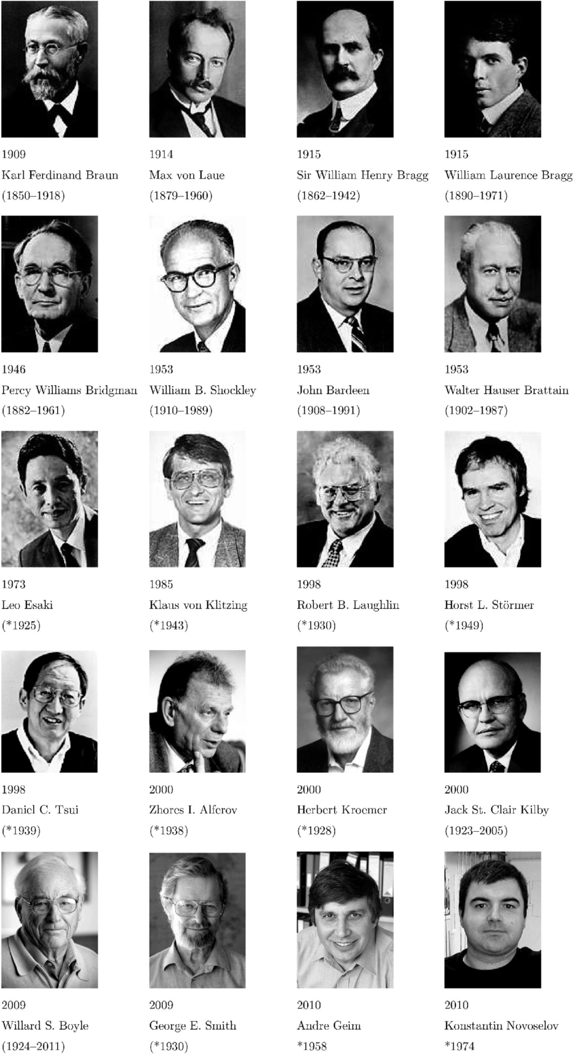

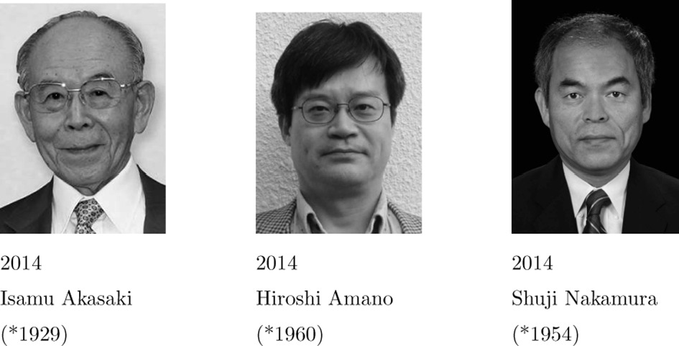

Fig. 1.15

Winners of Nobel Prize in Physics and year of award with great importance for semiconductor physics

1985

Klaus von Klitzing

‘for the discovery of the quantized Hall effect’

1998

Robert B. Laughlin

Horst L. Störmer

Daniel C. Tsui

‘for their discovery of a new form of quantum fluid with fractionally charged excitations’

2000

Zhores I. Alferov

Herbert Kroemer

‘for developing semiconductor heterostructures used in high-speed and optoelectronics’

Jack St. Clair Kilby

‘for his part in the invention of the integrated circuit’

2009

Willard S. Boyle

George E. Smith

‘for the invention of an imaging semiconductor circuit—the CCD sensor’

2010

Andre Geim

Konstantin Novoselov

‘for groundbreaking experiments regarding the two-dimensional material graphene’

2014

Isamu Akasaki

Hiroshi Amano

Shuji Nakamura

‘for the invention of efficient blue light-emitting diodes which has enabled bright and energy-saving white light sources’Table 1.1

Physical properties of various (bulk) semiconductors at room temperature. ‘S’ denotes the crystal structure (d: diamond, w: wurtzite, zb: zincblende, ch: chalcopyrite, rs: rocksalt)

|  | S | $$a_0$$ | $$E_{\mathrm {g}}$$ | $$m_{\mathrm {e}}^*$$ | $$m_{\mathrm {h}}^*$$ | $$\epsilon _0$$ | $$n_{\mathrm {r}}$$ | $$\mu _{\mathrm {e}}$$ | $$\mu _{\mathrm {h}}$$ |
| --- | --- | --- | --- | --- | --- | --- | --- | --- | --- |
|  |  | (nm) | (eV) |  |  |  |  | (cm  $$^2$$  /Vs) | (cm  $$^2$$  /Vs) |
| C | d | 0.3567 | 5.45 (  $$\Gamma $$  ) |  |  | 5.5 | 2.42 | 2200 | 1600 |
| Si | d | 0.5431 | 1.124 (X) | 0.98 (  $$m_{\mathrm {l}}$$  ) | 0.16 (  $$m_{\mathrm {lh}}$$  ) | 11.7 | 3.44 | 1350 | 480 |
|  |  |  |  | 0.19 (  $$m_{\mathrm {t}}$$  ) | 0.5 (  $$m_{\mathrm {hh}}$$  ) |  |  |  |  |
| Ge | d | 0.5658 | 0.67 (L) | 1.58 (  $$m_{\mathrm {l}}$$  ) | 0.04 (  $$m_{\mathrm {lh}}$$  ) | 16.3 | 4.00 | 3900 | 1900 |
|  |  |  |  | 0.08 (  $$m_{\mathrm {t}}$$  ) | 0.3 (  $$m_{\mathrm {hh}}$$  ) |  |  |  |  |
| $$\alpha $$  -Sn | d | 0.64892 | 0.08 (  $$\Gamma $$  ) | 0.02 |  |  |  | 2000 | 1000 |
| 3C-SiC | zb | 0.436 | 2.4 |  |  | 9.7 | 2.7 | 1000 | 50 |
| 4H-SiC | w | 0.3073 (*a*) | 3.26 |  |  | 9.6 | 2.7 |  | 120 |
|  |  | 1.005 (*c*) |  |  |  |  |  |  |  |
| 6H-SiC | w | 0.30806 (*a*) | 3.101 |  |  | 10.2 | 2.7 | 1140 | 850 |
|  |  | 1.5117 (*c*) |  |  |  |  |  |  |  |
| AlN | w | 0.3111 (*a*) | 6.2 |  |  | 8.5 | 3.32 |  |  |
|  |  | 0.4978 (*c*) |  |  |  |  |  |  |  |
| AlP | zb | 0.54625 | 2.43 (X) | 0.13 |  | 9.8 | 3.0 | 80 |  |
| AlAs | zb | 0.56605 | 2.16 (X) | 0.5 | 0.49 (  $$m_{\mathrm {lh}}$$  ) | 12 |  | 1000 | 80 |
|  |  |  |  |  | 1.06 (  $$m_{\mathrm {hh}}$$  ) |  |  |  |  |
| AlSb | zb | 0.61335 | 1.52 X) | 0.11 | 0.39 | 11 | 3.4 | 200 | 300 |
| GaN | w | 0.3189 (*a*) | 3.4 (  $$\Gamma $$  ) | 0.2 | 0.8 | 12 | 2.4 | 1500 |  |
|  |  | 0.5185 (*c*) |  |  |  |  |  |  |  |
| GaP | zb | 0.54506 | 2.26 (  $$\Gamma $$  ) | 0.13 | 0.67 | 10 | 3.37 | 300 | 150 |
| GaAs | zb | 0.56533 | 1.42 (  $$\Gamma $$  ) | 0.067 | 0.12 (  $$m_{\mathrm {lh}}$$  ) | 12.5 | 3.4 | 8500 | 400 |
|  |  |  |  |  | 0.5 (  $$m_{\mathrm {hh}}$$  ) |  |  |  |  |
| GaSb | zb | 0.60954 | 0.72 (  $$\Gamma $$  ) | 0.045 | 0.39 | 15 | 3.9 | 5000 | 1000 |
| InN | w | 0.3533 (*a*) | 0.69 (  $$\Gamma $$  ) |  |  |  |  |  |  |
|  |  | 0.5693 (*c*) |  |  |  |  |  |  |  |
| InP | zb | 0.58686 | 1.35 (  $$\Gamma $$  ) | 0.07 | 0.4 | 12.1 | 3.37 | 4000 | 600 |
| InAs | zb | 0.60584 | 0.36 (  $$\Gamma $$  ) | 0.028 | 0.33 | 12.5 | 3.42 | 22 600 | 200 |
| InSb | zb | 0.64788 | 0.18 (  $$\Gamma $$  ) | 0.013 | 0.18 | 18 | 3.75 | 100 000 | 1700 |
| ZnO | w | 0.325 (*a*) | 3.4 (  $$\Gamma $$  ) | 0.24 | 0.59 | 6.5 | 2.2 | 220 |  |
|  |  | 0.5206 (*c*) |  |  |  |  |  |  |  |
| ZnS | zb | 0.54109 | 3.6 (  $$\Gamma $$  ) | 0.3 |  | 8.3 | 2.4 | 110 |  |
| ZnSe | zb | 0.56686 | 2.58 (  $$\Gamma $$  ) | 0.17 |  | 8.1 | 2.89 | 600 |  |
| ZnTe | zb | 0.61037 | 2.25 (  $$\Gamma $$  ) | 0.15 |  | 9.7 | 3.56 |  |  |
| CdO | rs | 0.47 | 2.16 |  |  |  |  |  |  |
| CdS | w | 0.416 (*a*) | 2.42 (  $$\Gamma $$  ) | 0.2 | 0.7 | 8.9 | 2.5 | 250 |  |
|  |  | 0.6756 (*c*) |  |  |  |  |  |  |  |
| CdSe | zb | 0.650 | 1.73 (  $$\Gamma $$  ) | 0.13 | 0.4 | 10.6 |  | 650 |  |
| CdTe | zb | 0.64816 | 1.50 (  $$\Gamma $$  ) | 0.11 | 0.35 | 10.9 | 2.75 | 1050 | 100 |
|  | S | $$a_0$$ | $$E_{\mathrm {g}}$$ | $$m_{\mathrm {e}}^*$$ | $$m_{\mathrm {h}}^*$$ | $$\epsilon _0$$ | $$n_{\mathrm {r}}$$ | $$\mu _{\mathrm {e}}$$ | $$\mu _{\mathrm {h}}$$ |
|  |  | (nm) | (eV) |  |  |  |  | (cm  $$^2$$  /Vs) | (cm  $$^2$$  /Vs) |
| MgO | rs | 0.421 | 7.3 |  |  |  |  |  |  |
| HgS | zb | 0.5852 | 2.0 (  $$\Gamma $$  ) |  |  |  |  | 50 |  |
| HgSe | zb | 0.6084 | $$-0.15$$  (  $$\Gamma $$  ) | 0.045 |  | 25 |  | 18 500 |  |
| HgTe | zb | 0.64616 | $$-0.15$$  (  $$\Gamma $$  ) | 0.029 | 0.3 | 20 | 3.7 | 22 000 | 100 |
| PbS | rs | 0.5936 | 0.37 (L) | 0.1 | 0.1 | 170 | 3.7 | 500 | 600 |
| PbSe | rs | 0.6147 | 0.26 (L) | 0.07 (  $$m_{\mathrm {lh}}$$  ) | 0.06 (  $$m_{\mathrm {lh}}$$  ) | 250 |  | 1800 | 930 |
|  |  |  |  | 0.039 (  $$m_{\mathrm {hh}}$$  ) | 0.03 (  $$m_{\mathrm {hh}}$$  ) |  |  |  |  |
| PbTe | rs | 0.645 | 0.29 (L) | 0.24 (  $$m_{\mathrm {lh}}$$  ) | 0.3 (  $$m_{\mathrm {lh}}$$  ) | 412 |  | 1400 | 1100 |
|  |  |  |  | 0.02 (  $$m_{\mathrm {hh}}$$  ) | 0.02 (  $$m_{\mathrm {hh}}$$  ) |  |  |  |  |
| ZnSiP  $$_2$$ | ch | 0.54 (*a*) | 2.96 (  $$\Gamma $$  ) | 0.07 |  |  |  |  |  |
|  |  | 1.0441 (*c*) |  |  |  |  |  |  |  |
| ZnGeP  $$_2$$ | ch | 0.5465 (*a*) | 2.34 (  $$\Gamma $$  ) |  | 0.5 |  |  |  |  |
|  |  | 1.0771 (*c*) |  |  |  |  |  |  |  |
| ZnSnP  $$_2$$ | ch | 0.5651 (*a*) | 1.66 (  $$\Gamma $$  ) |  |  |  |  |  |  |
|  |  | 1.1302 (*c*) |  |  |  |  |  |  |  |
| CuInS  $$_2$$ | ch | 0.523 (*a*) | 1.53 (  $$\Gamma $$  ) |  |  |  |  |  |  |
|  |  | 1.113 (*c*) |  |  |  |  |  |  |  |
| CuGaS  $$_2$$ | ch | 0.5347 (*a*) | 2.5 (  $$\Gamma $$  ) |  |  |  |  |  |  |
|  |  | 1.0474 (*c*) |  |  |  |  |  |  |  |
| CuInSe  $$_2$$ | ch | 0.5784 (*a*) | 1.0 (  $$\Gamma $$  ) |  |  |  |  |  |  |
|  |  | 1.162 (*c*) |  |  |  |  |  |  |  |
| CuGaSe  $$_2$$ | ch | 0.5614 (*a*) | 1.7 (  $$\Gamma $$  ) |  |  |  |  |  |  |
|  |  | 1.103 (*c*) |  |  |  |  |  |  |  |

### 1.3 General Information

In Fig. [1.16](#u116076_4_En_1_Chapter-Fig16), the periodic table of elements is shown.

In Table [1.1](#u116076_4_En_1_Chapter-Tab1) the physical properties of various semiconductors are summarized. Data on semiconductors can be found in [152–166].

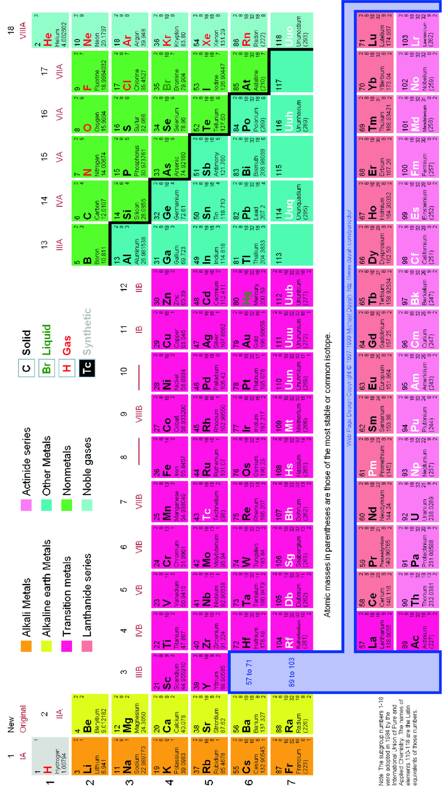

Fig. 1.16

Periodic table of elements.

From [167]

Footnotes

[1](#u116076_4_En_1_Chapter-Fn1_source)

This is Edmond Becquerel; his son Henri Becquerel received the Nobel Prize in Physics for the discovery of radioactivity.

[2](#u116076_4_En_1_Chapter-Fn2_source)

F. Braun made his discoveries on metal–semiconductor contacts in Leipzig while a teacher at the Thomasschule zu Leipzig [23]. He conducted his famous work on vacuum tubes later as a professor in Strasbourg, France.

[3](#u116076_4_En_1_Chapter-Fn3_source)

This work was conducted as Habilitation in the Physics Institute of Universität Leipzig. Bädeker became subsequently professor in Jena and fell in WW I. His scientific contribution to semiconductor physics is discussed in [39, 40]

[4](#u116076_4_En_1_Chapter-Fn4_source)

CuI is actually a p-type transparent conductor; at that time the positive sign of the Hall effect [41, 42] could not be interpreted as hole conduction yet.

[5](#u116076_4_En_1_Chapter-Fn5_source)

Historical remarks on Eccles’ contributions to radio technology can be found in [43, 44]

[6](#u116076_4_En_1_Chapter-Fn6_source)

After obtaining his PhD in 1905 from the Friedrich-Wilhelms-Universität Berlin, Julius Edgar Lilienfeld joined the Physics Department of Universität Leipzig and worked on gas liquefaction and with Lord Zeppelin on hydrogen-filled blimps. In 1910 he became professor at the Universität Leipzig where he mainly researched on X-rays and vacuum tubes [50]. To the surprise of his colleagues he left in 1926 to join a US industrial laboratory [51, 52].

[7](#u116076_4_En_1_Chapter-Fn7_source)

In [51] it is suggested that the device works as a npn transistor, in [54] it is suggested to be a JFET.

[8](#u116076_4_En_1_Chapter-Fn8_source)

The historic role of Losev regarding the invention of the LED and oscillators is discussed in [62–64].

[9](#u116076_4_En_1_Chapter-Fn9_source)

Peierls performed this work at suggestion of W. Pauli at ETH Zürich. The mathematical problem of Schrödinger’s equation with a sinusoidal potential had been already treated by M.J.O Strutt in 1928 [68]

[10](#u116076_4_En_1_Chapter-Fn10_source)

Wilson was theoretical physicist in Cambridge, who spent a sabbatical with Heisenberg in Leipzig and applied the brand new field of quantum mechanics to issues of electrical conduction, first in metals and then in semiconductors. When he returned to Cambridge, Wilson urged that attention be paid to germanium but, as he expressed it long afterward, ’the silence was deafening’ in response. He was told that devoting attention to semiconductors, those messy entities, was likely to blight his career among physicists. He ignored these warnings and in 1939 brought out his famous book ’Semiconductors and Metals’ [72] which explained semiconductor properties, including the much-doubted phenomenon of intrinsic semiconductivity, in terms of electronic energy bands. His academic career seems indeed to have been blighted, because despite his great intellectual distinction, he was not promoted in Cambridge (he remained an assistant professor year after year) [73]. Compare the remark of W. Pauli (p. xx)

[11](#u116076_4_En_1_Chapter-Fn11_source)

Subsequently, AT&T, under pressure from the US Justice Department’s antitrust division, licensed the transistor for $25,000. This action initiated the rise of companies like Texas Instruments, Sony and Fairchild.

[12](#u116076_4_En_1_Chapter-Fn12_source)

The setup of Fig. [1.9](#u116076_4_En_1_Chapter-Fig9)b represents a common base circuit. In a modern bipolar transistor, current amplification in this case is close to unity (Sect. [24.​2.​2](The_Physics_of_Semiconductors00009.docx#u116076_4_En_24_Chapter)). In the 1948 germanium transistor, the reversely biased collector contact is influenced by the emitter current such that current amplification

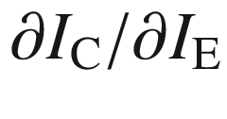

for constant

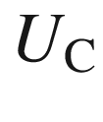

was up to 2–3. Due to the collector voltage being much larger than the emitter voltage, a power gain of

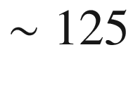

was reported [98].

[13](#u116076_4_En_1_Chapter-Fn13_source)

An early concept for III–V semiconductors was developed in [102, 103].

[14](#u116076_4_En_1_Chapter-Fn14_source)

A solar cell with 1 W power cost $300 in 1956 ($3 in 2004). Initially, ‘solar batteries’ were only used for toys and were looking for an application. H. Ziegler proposed the use in satellites in the ‘space race’ of the late 1950s.

[15](#u116076_4_En_1_Chapter-Fn15_source)

The two patents led to a decade-long legal battle between Fairchild Semiconductors and Texas Instruments. Eventually, the US Court of Customs and Patent Appeals upheld R.N. Noyce’s claims on interconnection techniques but gave J.S. Kilby and Texas Instruments credit for building the first working integrated circuit.

[16](#u116076_4_En_1_Chapter-Fn16_source)

The Swiss born Jean Hoerni also contributed $12 000 for the building of the first school in the Karakoram Mountain area in Pakistan and has continued to build schools in Pakistan and Afghanistan as described in [114].

[17](#u116076_4_En_1_Chapter-Fn17_source)

Remarks on the discovery and further development of the laser diode can be found in [128, 129].

[18](#u116076_4_En_1_Chapter-Fn18_source)

www.nobel.se

# Part IFundamentals

© Springer Nature Switzerland AG 2021

M. Grundmann

The Physics of Semiconductors

Graduate Texts in Physics

<https://doi.org/10.1007/978-3-030-51569-0_2>

## 2. Bonds

Marius Grundmann[1](#u116076_4_En_2_Chapter-Aff11)

(1)

Felix Bloch Institute for Solid State Physics, Universität Leipzig, Leipzig, Germany

Marius Grundmann

Email:

[grundmann@physik.uni-leipzig.de](mailto:grundmann@physik.uni-leipzig.de)

Protons give an atom its identity, electrons its personality.

*B. Bryson [168]*

## Abstract

A little bit of solid state physics... The schemes of covalent, ionic and mixed bonds are explained which are the basis for the atomic arrangement and crystal structures of semiconductors.

### 2.1 Introduction

The positively charged atomic nuclei and the electrons in the atomic shells of the atoms making up the semiconductor (or any other solid) are in a binding state. Several mechanisms can lead to such cohesiveness. First, we will discuss the homopolar, electron-pair or covalent bond, then the ionic bond and subsequently the mixed bond. We will only briefly touch on the metallic bond and the van-der-Waals bond. A classical book on bonds in semiconductors is [169, 170].

### 2.2 Covalent Bonds

Covalent bonds are formed due to quantum-mechanical forces. The prototype covalent bond is the bonding of the hydrogen molecule due to overlapping of the atomic shells. If several electron pairs are involved, directional bonds can be formed in various spatial directions, eventually making up a solid.

#### 2.2.1 Electron-Pair Bond

The covalent bond of two hydrogen atoms in a H



molecule can lead to a reduction of the total energy of the system, compared to two single (distant) atoms (Fig. [2.1](#u116076_4_En_2_Chapter-Fig1)). For fermions (electrons have spin 1/2) the two-particle wavefunction of the two (indistinguishable) electrons *A* and *B* must be antisymmetric, i.e.

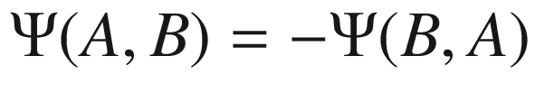

(Pauli principle). The wavefunction of each electron has degrees of freedom in real space (



) and spin (

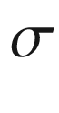

),

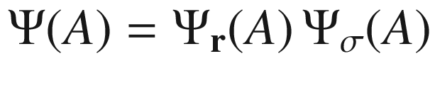

. The two-particle wavefunction of the molecule is nonseparable and has the form

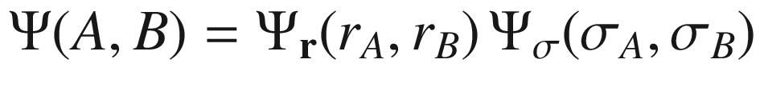

. The binding state has a wavefunction with a symmetric orbital and antiparallel spins, i.e.

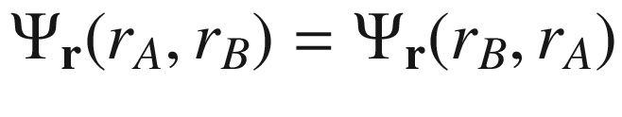

and

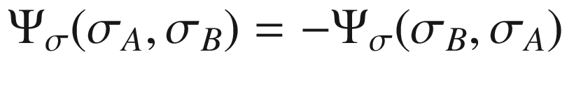

. The antisymmetric orbital with parallel spins is antibinding for all distances of the nuclei (protons).

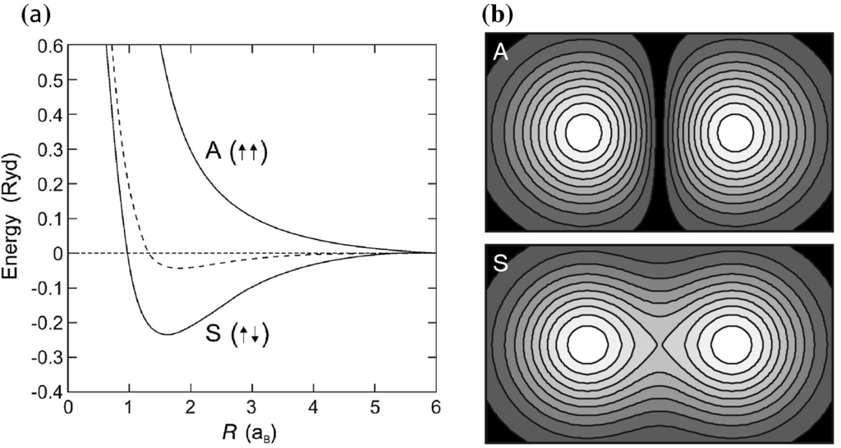

Fig. 2.1

Binding of the hydrogen molecule. **a** *Dashed line*: classical calculation (electrostatics), ‘S’, ‘A’: quantum-mechanical calculation taking into account Pauli’s principle (S: symmetric orbital, antiparallel spins, A: antisymmetric orbital, parallel spins). The distance of the nuclei (protons) is given in units of the Bohr radius

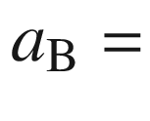

0.053 nm, the energy is given in Rydberg units (13.6 eV). **b** Schematic contour plots of the probability distribution (

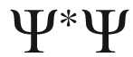

) for the S and A states

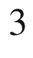

#### 2.2.2 sp Bonds

Elements from group IV of the periodic system (C, Si, Ge,



) have 4 electrons on the outer shell. Carbon has the electron configuration 1s

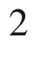

2s



2p



. For an octet configuration bonding to four other electrons would be optimal (Fig. [2.2](#u116076_4_En_2_Chapter-Fig2)). This occurs through the mechanism of  sp



hybridization.[1](#u116076_4_En_2_Chapter-Fn1) First, one electron of the *n*s

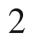



p

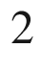

configuration is brought into a p orbital, such that the outermost shell contains one s, p



, p



, and p



orbital each (Fig. [2.3](#u116076_4_En_2_Chapter-Fig3)a–e). The energy necessary for this step is less than regained in the subsequent formation of the covalent bonds. The four orbitals can be reconfigured into four other wavefunctions, the sp



hybrids (Figs. [2.3](#u116076_4_En_2_Chapter-Fig3)f–i), i.e.

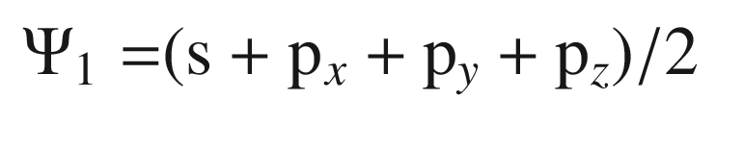

(2.1a)

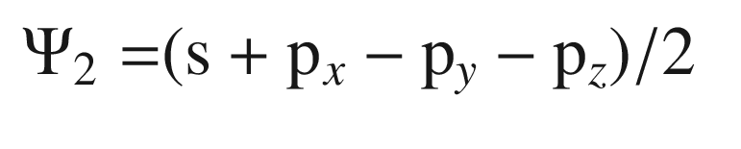

(2.1b)

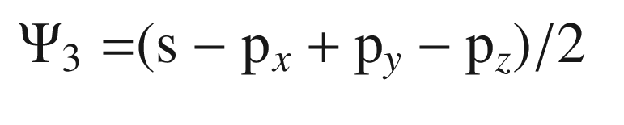

(2.1c)

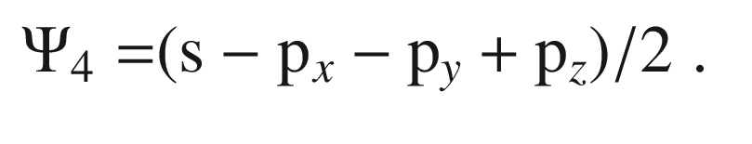

(2.1d)

These orbitals have a directed form along tetrahedral directions. The binding energy (per atom) of the covalent bond is large, for H–H 4.5 eV, for C–C 3.6 eV, for Si–Si 1.8 eV, and for Ge–Ge 1.6 eV. Such energy is, for *neutral* atoms, comparable to the ionic bond, discussed in the next section.

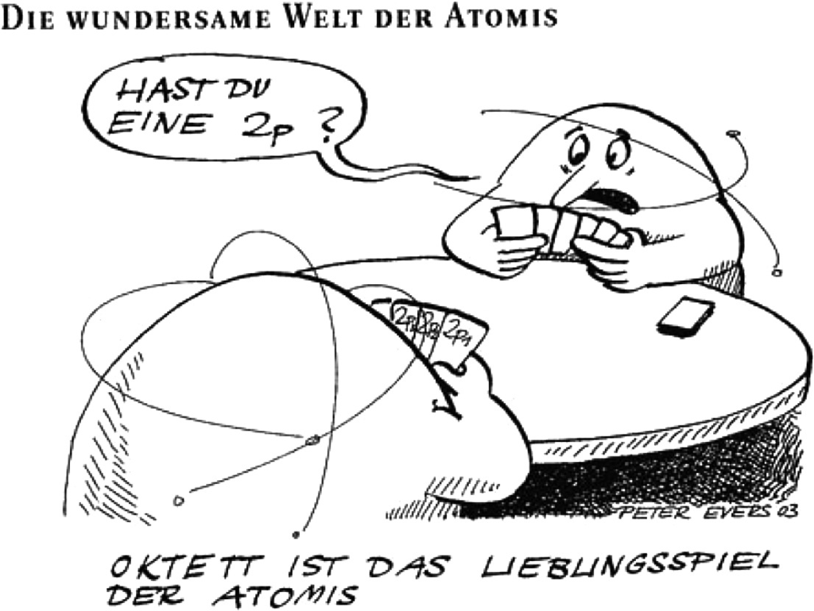

Fig. 2.2

Octet, the favorite card game of the ‘Atomis’ (trying to reach octet configuration in a bond by swapping wavefunctions). The bubble says: ‘Do you have a 2p?’.

Reprinted with permission from [171], ©2002 Wiley-VCH

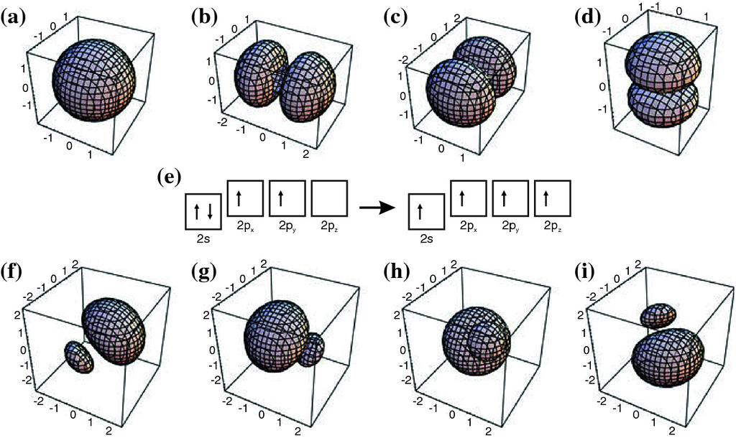

Fig. 2.3

**a** s orbital, **b**, **c**, **d** p



, p



and p



orbital, **e** hybridization, **f**, **g**, **h**, **i** orbitals of the sp

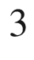

hybridization: **f** (s+p



+p



+p



)/2, **g**) (s+p

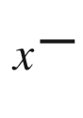

p

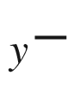

p



)/2, **h** (s−p



+p

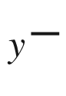

p



)/2, (**i**) (s−p

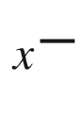

p



+p



)/2

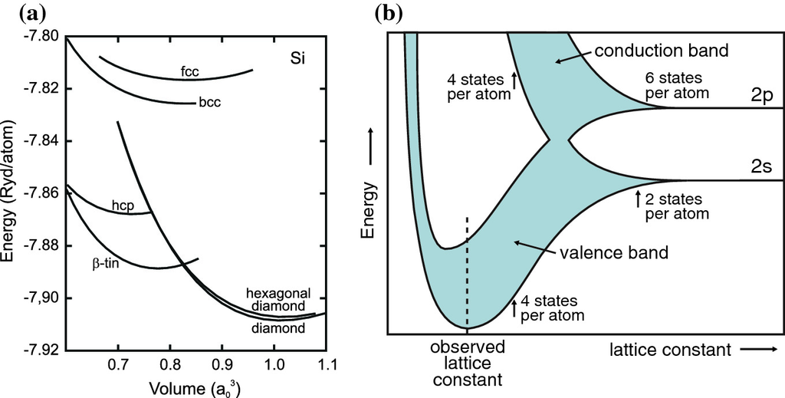

Fig. 2.4

**a** Energy per atom in silicon for various crystal structures. Adapted from [172]. **b** Electron energy levels in (diamond structure) carbon as a function of the distance of the atomic nuclei (schematic).

Adapted from [173, 174]

In Fig. [2.4](#u116076_4_En_2_Chapter-Fig4)a the energy of a crystal made up from silicon atoms is shown for various crystal structures[2](#u116076_4_En_2_Chapter-Fn2) or phases (cf. Chap. [3](#u116076_4_En_3_Chapter)). We note that the crystal energy of further silicon structures are discussed in [175]. The lattice constant with the lowest total energy determines the lattice spacing for each crystal structure. The thermodynamically stable configuration is the phase with the lowest overall energy for given external conditions.

The covalent bond of a group-IV atom to other group-IV atoms has a tetrahedral configuration with electron-pair bonds, similar to the hydrogen molecule bond. In Fig. [2.4](#u116076_4_En_2_Chapter-Fig4)b the energy states of the

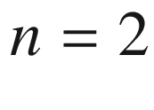

shell for tetrahedrally bonded carbon (diamond, see Chap. [3.​4.​3](#u116076_4_En_3_Chapter)) are shown as a function of the distance from the nuclei. First, the energetically sharp states become a band due to the overlap and coupling of the atomic wavefunctions (cf. Sect. [6](The_Physics_of_Semiconductors00003.docx#u116076_4_En_6_Chapter)). The mixing of the states leads to the formation of the filled lower valence band (binding states) and the empty upper conduction band (antibinding states). This principle is valid for most semiconductors and is shown schematically also in Fig. [2.5](#u116076_4_En_2_Chapter-Fig5). The configuration of bonding and antibinding p orbitals is depicted schematically in Fig. [2.6](#u116076_4_En_2_Chapter-Fig6). The bonding and antibinding sp



orbitals  are depicted in Figs. [2.7](#u116076_4_En_2_Chapter-Fig7)a, b and [2.13](#u116076_4_En_2_Chapter-Fig13). We note that the energy of the crystal does not only depend on the distance from the nuclei but also on their geometric arrangement (crystal structure).

Per carbon atom there are (in the second shell) four electrons and four unoccupied states, altogether eight. These are redistributed into four states (filled) per atoms in the valence band and four states per atom (empty) in the conduction band. Between the top of the valence band and the bottom of the conduction band there is an energy gap, later called the *band gap* (cf. Chap. [6](The_Physics_of_Semiconductors00003.docx#u116076_4_En_6_Chapter)).

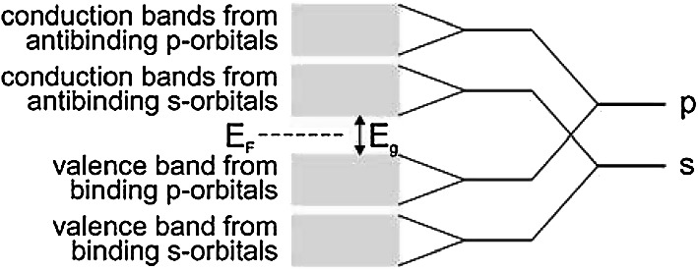

Fig. 2.5

Schematic of the origin of valence and conduction band from the atomic s and p orbitals. The band gap

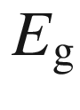

and the position of the Fermi level

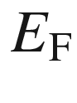

are indicated

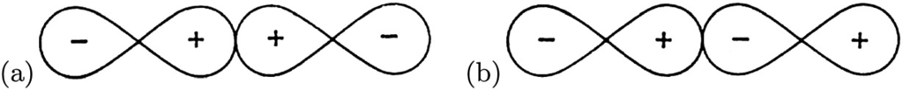

Fig. 2.6

Schematic representation of **a** bonding and **b** antibinding p orbitals. The signs denote the phase of the wavefunction

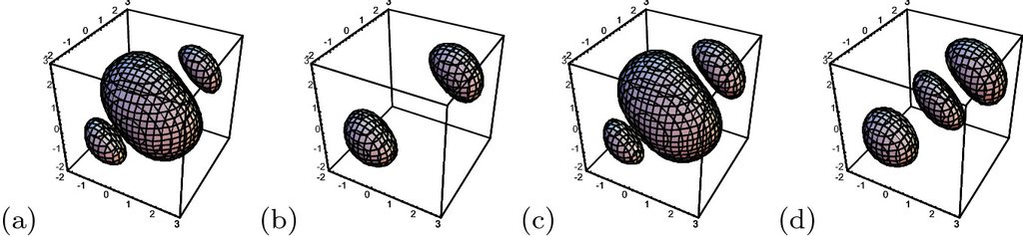

Fig. 2.7

Schematic representation of **a**, **c** bonding and **b**, **d** antibinding symmetric **a**, **b** and nonsymmetric **c**, **d** sp

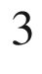

orbitals



#### 2.2.3 sp Bonds

Organic semiconductors (see Chap. [18](The_Physics_of_Semiconductors00006.docx#u116076_4_En_18_Chapter)) are made up from carbon compounds. While for inorganic semiconductors the covalent (or mixed, cf. Sect. [2.4](#u116076_4_En_2_Chapter-Sec7)) bond with sp



hybridization is important, the organic compounds are based on the  sp



hybridization. This bonding mechanism, which is present in graphite, is stronger than the sp



-bond present in diamond. The prototype organic molecule is the benzene ring[3](#u116076_4_En_2_Chapter-Fn3) (C



H



), shown in Fig. [2.8](#u116076_4_En_2_Chapter-Fig8). The benzene ring is the building block for small organic molecules and polymers.

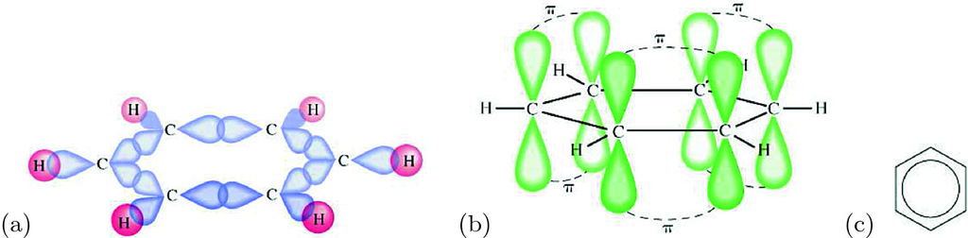

Fig. 2.8

Schematic representation of the **a**

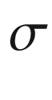

and **b**

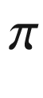

bonds in benzene, **c** schematic symbol for benzene

In the benzene molecule neighboring carbon atoms are bonded within the ring plane via the binding

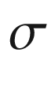

states of the sp



orbitals (Fig. [2.8](#u116076_4_En_2_Chapter-Fig8)a). The wavefunctions (Fig. [2.9](#u116076_4_En_2_Chapter-Fig9)) are given by ([2.2a](#u116076_4_En_2_Chapter-Equ5)c).

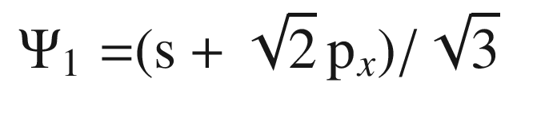

(2.2a)

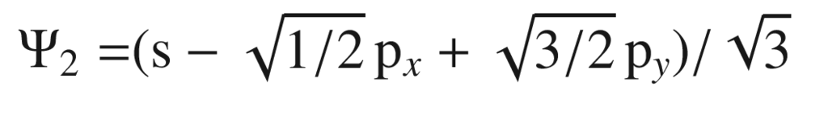

(2.2b)

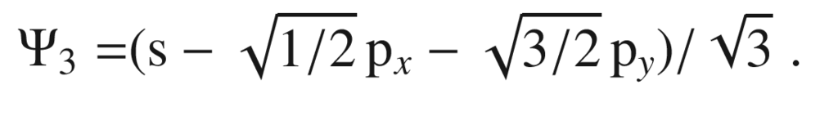

(2.2c)

The ‘remaining’ p



orbitals do not directly take part in the binding (Fig. [2.8](#u116076_4_En_2_Chapter-Fig8)b) and form bonding (

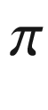

, filled) and antibinding (



\*, empty) orbitals (see Fig. [2.10](#u116076_4_En_2_Chapter-Fig10)). The



and



\* states are delocalized over the ring. A more in-depth view considers the alternating ’staggered’ spin configuration around the ring [177]. Between the highest populated molecular orbital (HOMO)  and the lowest unoccupied molecular orbital (LUMO)  is typically an energy gap (Fig. [2.11](#u116076_4_En_2_Chapter-Fig11)). The antibinding

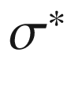

orbitals are energetically above the



\* states.

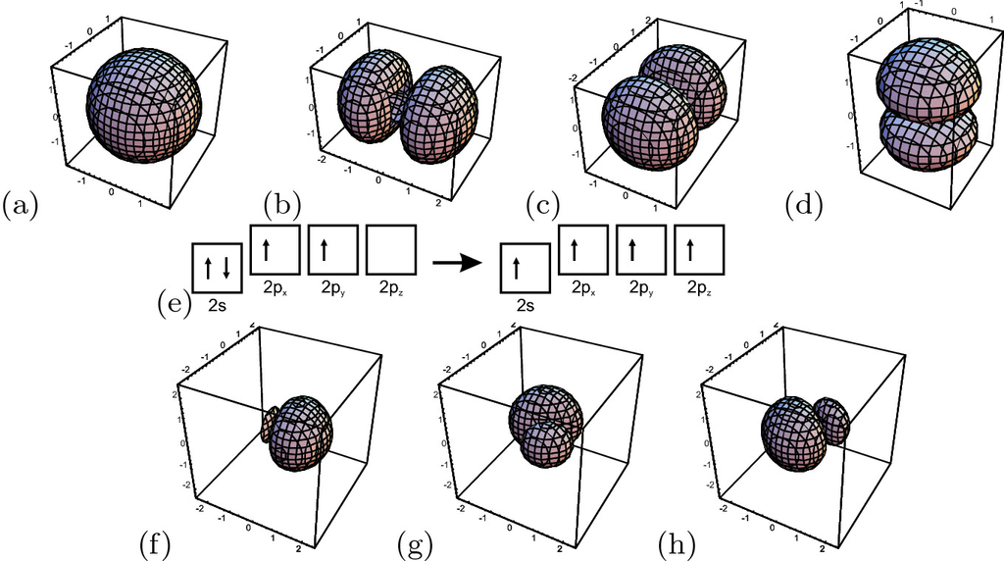

Fig. 2.9

**a** s orbital, **b**,**c**,**d** p



, p



and p



orbital, **e** hybridization, **f**,**g**,**h** orbitals of the sp



hybridization: **f** (s+

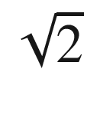

 p



)/

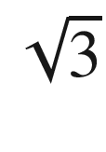

, **g** (s

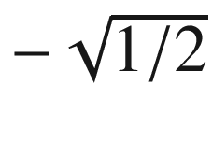

 p

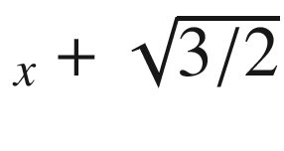

 p



)/

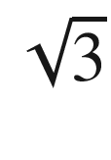

, **h** (s

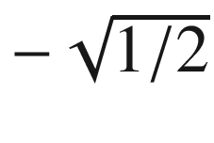

 p

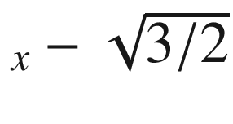

 p



)/



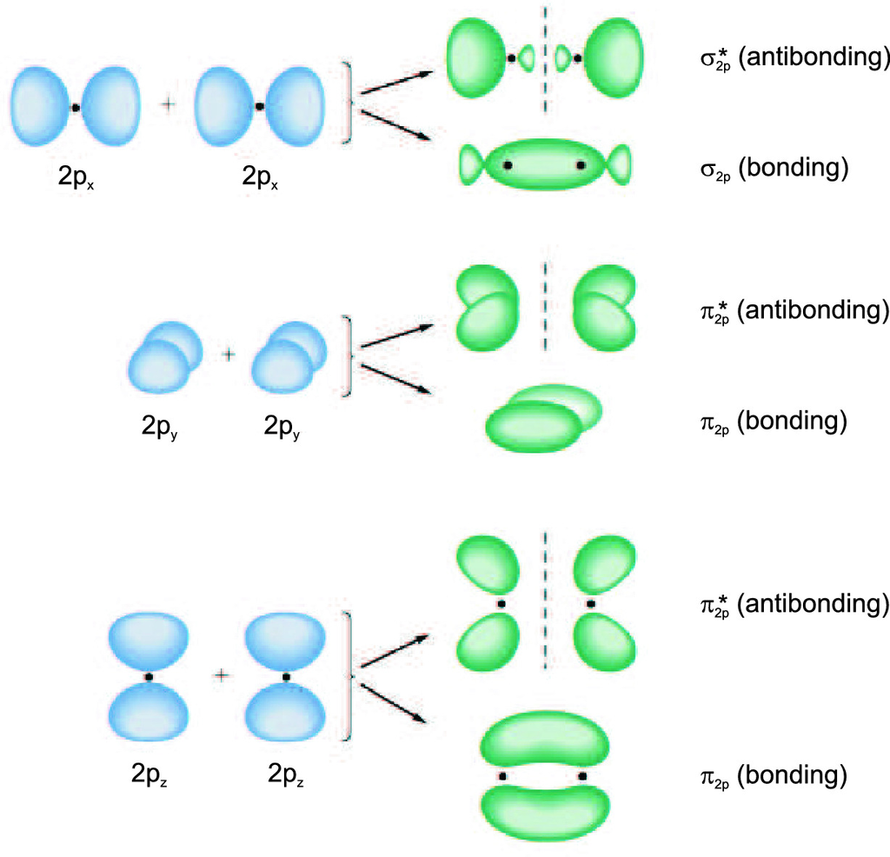

Fig. 2.10

Orbitals due to binding and antibinding configurations of various



orbitals

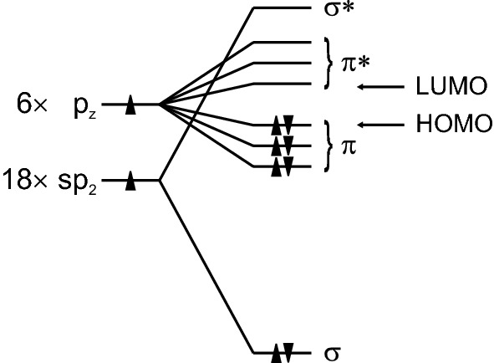

Fig. 2.11

Schematic energy terms of the benzene molecule

### 2.3 Ionic Bonds

Ionic crystals are made up from positively and negatively charged ions. The heteropolar or ionic bond is the consequence of the electrostatic attraction between the ions. However, the possibly repulsive character of next neighbors has to be considered.

For I–VII compounds, e.g. LiF or NaCl, the shells of the singly charged ions are complete: Li: 1s



2s



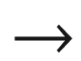

Li

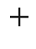

: 1s



, F: 1s



2s



2p

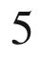

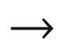

F

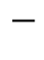

: 1s



2s



2p

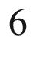

. Compared to ions in a gas, a Na–Cl pair in the crystal has a binding energy of 7.9 eV that mostly stems from the electrostatic energy (Madelung energy). Van-der-Waals forces (cf. Sect. [2.6](#u116076_4_En_2_Chapter-Sec9)) only contribute 1–2%. The ionization energy of Na is 5.14 eV, the electron affinity of Cl is 3.61 eV. Thus the energy of the NaCl pair in the solid is 6.4 (=7.9−5.1+3.6) eV smaller than in a gas of neutral atoms.

The interaction of two ions with distance vector

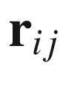

is due to the Coulomb interaction

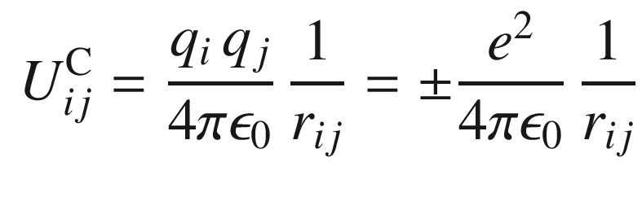

(2.3)

and a repulsive contribution due to the overlap of (complete) shells. This contribution is typically approximated by a radially symmetric core potential

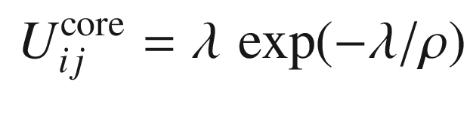

(2.4)

that only acts on next neighbors.



describes the strength of this interaction and



parameterizes its range.

The distance of ions is denoted as

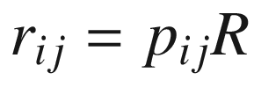

, where *R* denotes the distance of next neighbors and the



are suitable coefficients. The electrostatic interaction of an ion with *all* its neighbors is then written as

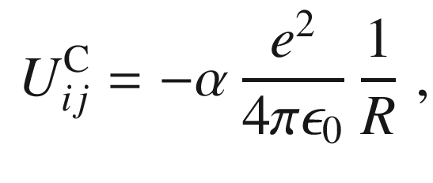

(2.5)

where

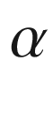

is the Madelung constant. For an attractive interaction (as in a solid),



is positive. It is given (calculated for the *i*-th ion) as

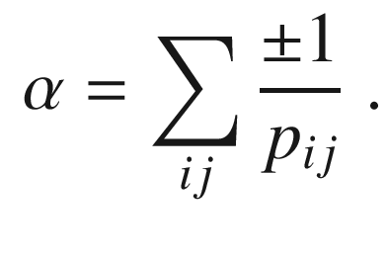

(2.6)

For a one-dimensional chain

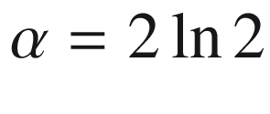

. For the rocksalt (NaCl) structure (cf. Sect. [3.​4.​1](#u116076_4_En_3_Chapter)) it is

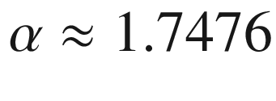

, for the CsCl structure (see Sect. [3.​4.​2](#u116076_4_En_3_Chapter)) it is

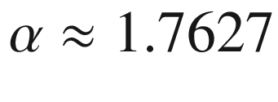

, and for the zincblende structure (see Sect. [3.​4.​4](#u116076_4_En_3_Chapter)) it is

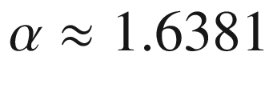

. This shows that ionic compounds prefer the NaCl or CsCl structure. The charge distribution for NaCl is shown in Fig. [2.12](#u116076_4_En_2_Chapter-Fig12). For tetragonal and orthorhombic structures, the Madelung constant has been calculated in [179].

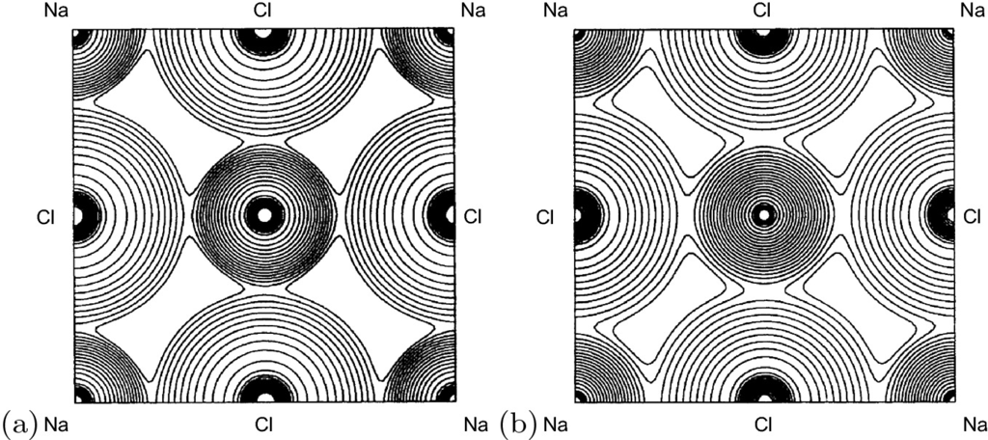

Fig. 2.12

**a** Experimental and **b** theoretical charge distribution in the (100) plane of NaCl. The lowest contour in the interstitial region corresponds to a charge density of 7 e/nm



and adjacent contours differ by

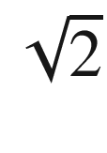

. Differences are mainly due to the fact that the X-ray experiments have been made at room temperature.

Adapted from [178]

### 2.4 Mixed Bonds

The group-IV crystals are of perfectly covalent nature, the I–VII are almost exclusively ionically bonded. For III–V (e.g. GaAs, InP) and II–VI compounds (e.g. CdS, ZnO) we have a mixed case.

The (screened) Coulomb potentials of the *A* and *B* atoms (in the *AB* compound) shall be denoted

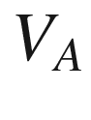

and

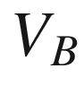

. The origin of the coordinate system is in the center of the *A* and *B* atom (i.e. for the zincblende structure (cf. Sect. [3.​4.​4](#u116076_4_En_3_Chapter)) at (1/8, 1/8, 1/8)*a*. The valence electrons then see the potential

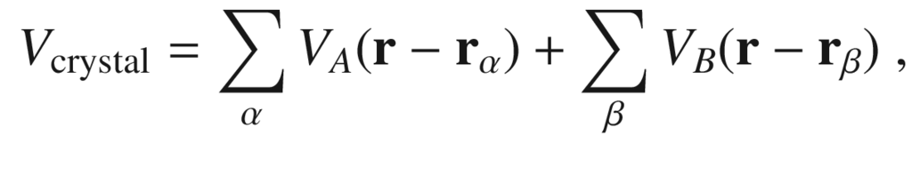

(2.7)

where the sum



(

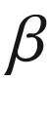

) runs over all *A* (*B*) atoms. This potential can be split into a symmetric (

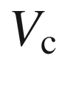

, covalent) and an antisymmetric (

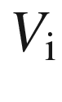

, ionic) part ([2.8b](#u116076_4_En_2_Chapter-Equ14)), i.e.

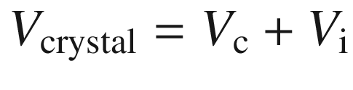

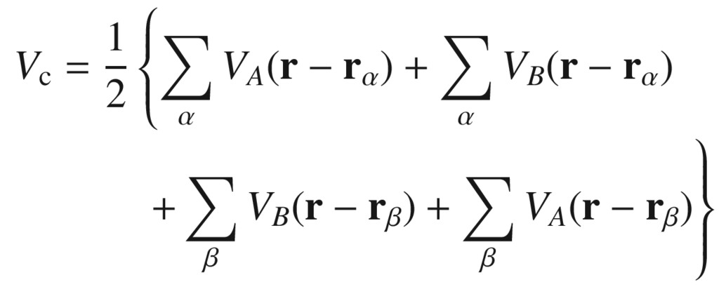

(2.8a)

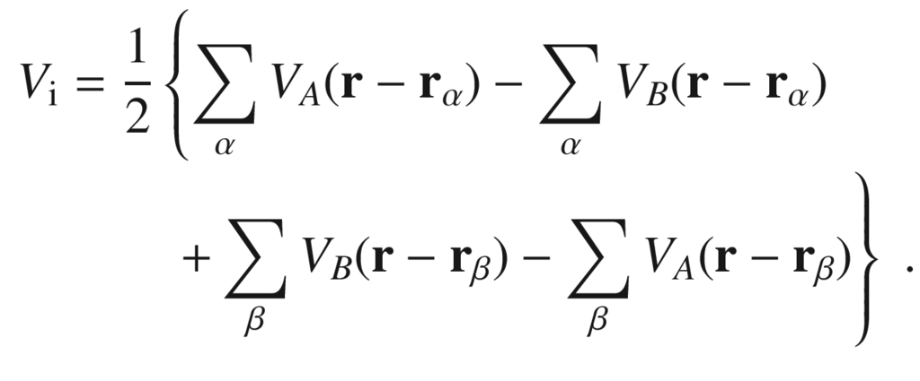

(2.8b)

For homopolar bonds

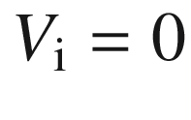

and the splitting between bonding and antibinding states is

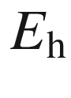

, which mainly depends on the bond length

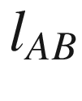

(and the related overlap of atomic wavefunctions). In a partially ionic bond the orbitals are not symmetric along *A*–*B*, but the center is shifted towards the more electronegative material (Figs. [2.7](#u116076_4_En_2_Chapter-Fig7)c, d and [2.13](#u116076_4_En_2_Chapter-Fig13)).

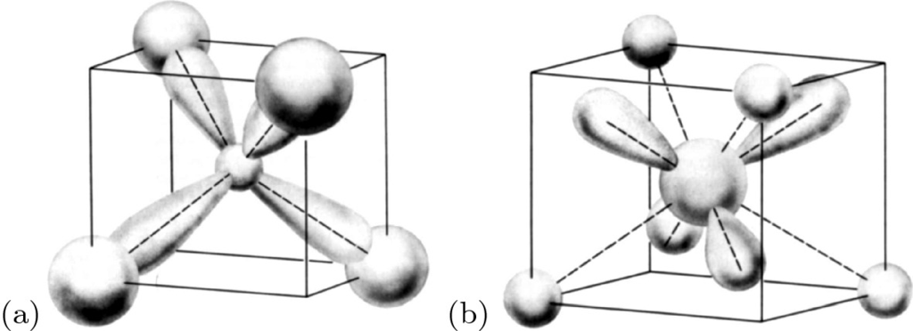

Fig. 2.13

Schematic representation of **a** bonding and **b** antibinding sp



orbitals. From [169]

The band splitting[4](#u116076_4_En_2_Chapter-Fn4) between the (highest) bonding and (lowest) antibinding state

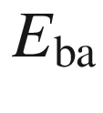

is then written as

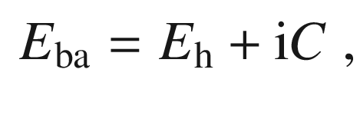

(2.9)

where *C* denotes the band splitting due to the ionic part of the potential and depends only on

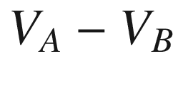

. *C* is proportional to the difference of the electronegativities *X* of the *A* and *B* atoms,

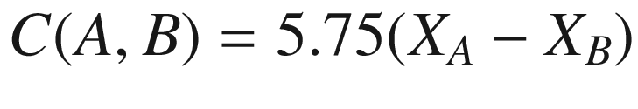

. A material thus takes a point in the (

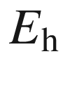

,*C*) plane (Fig. [2.14](#u116076_4_En_2_Chapter-Fig14)). The absolute value for the band splitting is given as

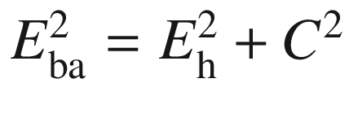

.

The ionicity of the bond is described with the ionicity (after Phillips)

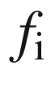

, defined as [181, 182]

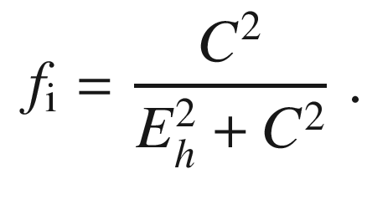

(2.10)

The covalent part is

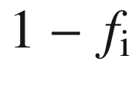

. In Table [2.1](#u116076_4_En_2_Chapter-Tab1) the ionicity is given for a number of binary compounds. The ionicity can also be interpreted as the angle

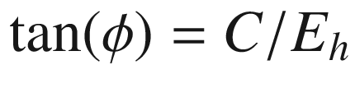

in the (

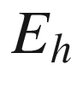

,*C*) diagram. The critical value of

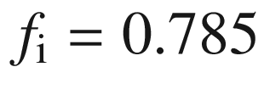

for the ionicity separates quite exactly (for about 70 compounds) the 4-fold (diamond, zincblende and wurtzite) from the 6-fold (rocksalt) coordinated substances (

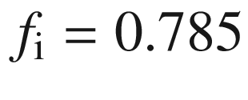

is indicated by a dashed line in Fig. [2.14](#u116076_4_En_2_Chapter-Fig14)).

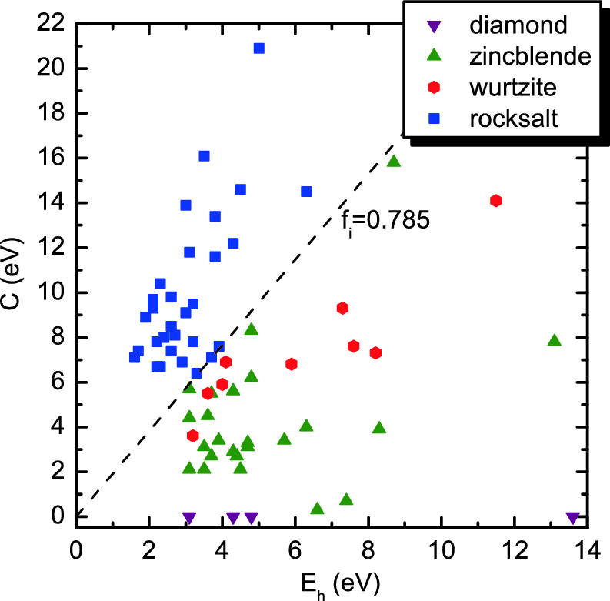

Fig. 2.14

Values of

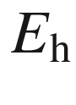

and *C* for various

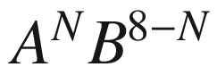

compounds. The *dashed line*

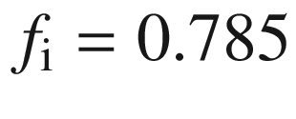

separates 4-fold from 6-fold coordinated structures. Most data taken from [180]

Table 2.1

Ionicity



([2.10](#u116076_4_En_2_Chapter-Equ16)) for various binary compounds

|  |  |  |  |  |  |  |  |
| --- | --- | --- | --- | --- | --- | --- | --- |
| C | 0.0 | AlAs | 0.27 | BeO | 0.60 | CuCl | 0.75 |
| Si | 0.0 | BeS | 0.29 | ZnTe | 0.61 | CuF | 0.77 |
| Ge | 0.0 | AlP | 0.31 | ZnO | 0.62 | AgI | 0.77 |
| Sn | 0.0 | GaAs | 0.31 | ZnS | 0.62 | MgS | 0.79 |
| BAs | 0.002 | InSb | 0.32 | ZnSe | 0.63 | MgSe | 0.79 |
| BP | 0.006 | GaP | 0.33 | HgTe | 0.65 | CdO | 0.79 |
| BeTe | 0.17 | InAs | 0.36 | HgSe | 0.68 | HgS | 0.79 |
| SiC | 0.18 | InP | 0.42 | CdS | 0.69 | MgO | 0.84 |
| AlSb | 0.25 | AlN | 0.45 | CuI | 0.69 | AgBr | 0.85 |
| BN | 0.26 | GaN | 0.50 | CdSe | 0.70 | LiF | 0.92 |
| GaSb | 0.26 | MgTe | 0.55 | CdTe | 0.72 | NaCl | 0.94 |
| BeSe | 0.26 | InN | 0.58 | CuBr | 0.74 | RbF | 0.96 |

For ionic compounds, an effective ionic charge

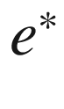

 is defined connecting the displacement



of negative and positive ions and the resulting polarization

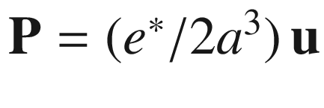

[183]. Connected with the ionicity is the so-called *s*-parameter, describing the change of the charge upon change of bond length *b* from its equilibrium value

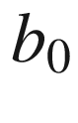

 [184]

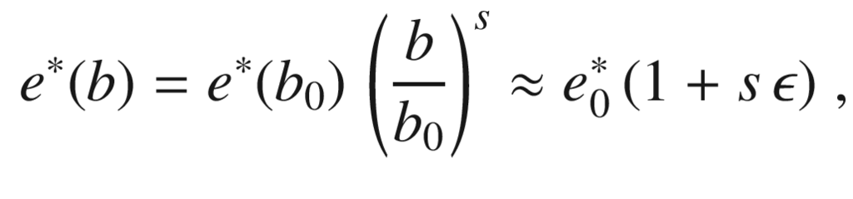

(2.11)



being the strain of the bond length,

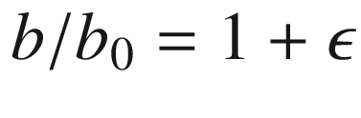

. It seems justified to assume that

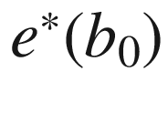

is always positive at the metal atom in III–V and II–VI compounds. The relation of *s* with the ionicity



is shown in Fig. [2.15](#u116076_4_En_2_Chapter-Fig15) for various compound semiconductors.

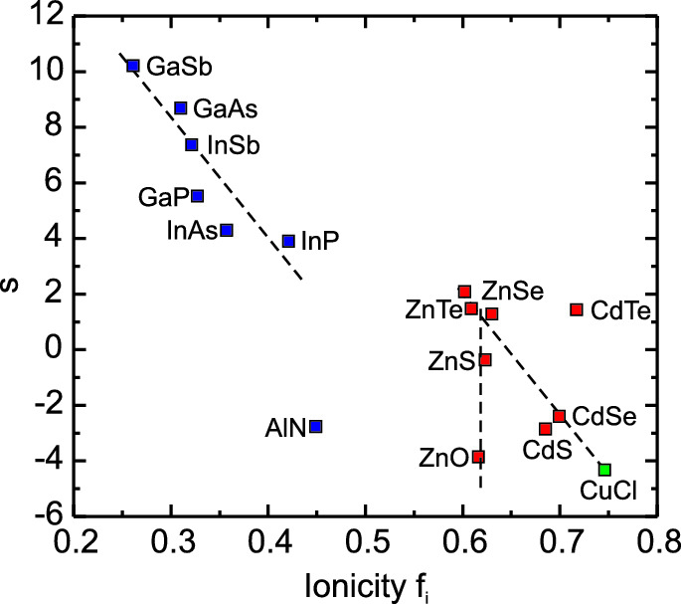

Fig. 2.15

*s*-Parameter as defined in ([2.11](#u116076_4_En_2_Chapter-Equ17)) as a function of the ionicity

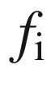

([2.10](#u116076_4_En_2_Chapter-Equ16)) for various compound semiconductors. *Dashed lines* are guides to the eye. Data from [185], value for CuCl from [184]

### 2.5 Metallic Bonding

In a metal, the positively charged atomic cores are embedded in a more or less homogeneous sea of electrons. The valence electrons of the atoms become the conduction electrons of the metal. These are freely moveable and at

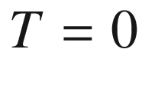

 K there is no energy gap between filled and empty states. The bonding is mediated by the energy reduction for the conduction electrons in the periodic potential of the solid compared to free atoms. This will be clearer when the band structure is discussed (Chap. [6](The_Physics_of_Semiconductors00003.docx#u116076_4_En_6_Chapter)). In transition metals the overlap of inner shells (d or f) can also contribute to the bonding.

### 2.6 Van-der-Waals Bonds

The van-der-Waals bond is a dipole bond that leads to bonding in the noble-gas crystals (at low temperature). Ne, Ar, Kr and Xe crystallize in the densely packed fcc lattice (cf. Sect. [3.​3.​2.​1](#u116076_4_En_3_Chapter)). He



and He

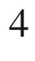

represent an exception. They do not solidify at zero pressure at

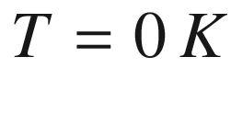

due to the large zero-point energy. This quantum-mechanical effect is especially strong for oscillators with small mass.

When two neutral atoms come near to each other (distance of the nuclei *R*), an attractive dipole–dipole interaction

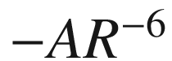

arises (London interaction) the van-der-Waals interaction. The quantum-mechanical overlap of the (filled) shells leads to a strong repulsion

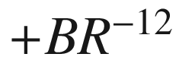

. Altogether, a binding energy minimum results for the Lennard–Jones potential

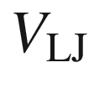

(see Fig. [2.16](#u116076_4_En_2_Chapter-Fig16))

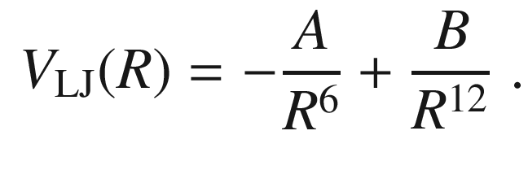

(2.12)

The energy minimum

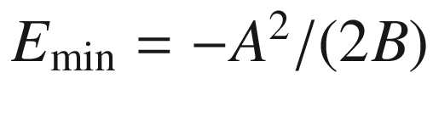

is at

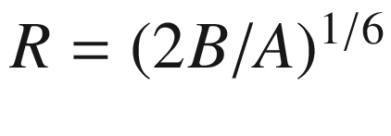

.

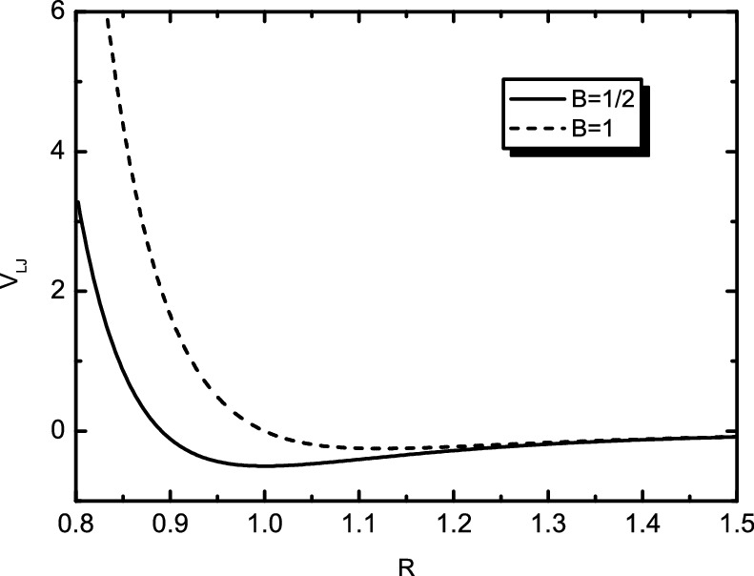

Fig. 2.16

Lennard–Jones potential ([2.12](#u116076_4_En_2_Chapter-Equ18)) for



and two values of *B*

The origin of the attractive dipole–dipole interaction can be understood from a one-dimensional (1D) model as follows: Two atoms are modeled by their fixed positively charged nuclei in a distance *R* and their negatively charged electron shells that are polarizable, i.e. can be displaced along one direction *x*. Additionally, we assume (two identical) 1D harmonic oscillators for the electron motion at the positions 0 and *R*. Then, the Hamilton operator

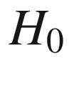

of the system without interaction (*R* is very large)

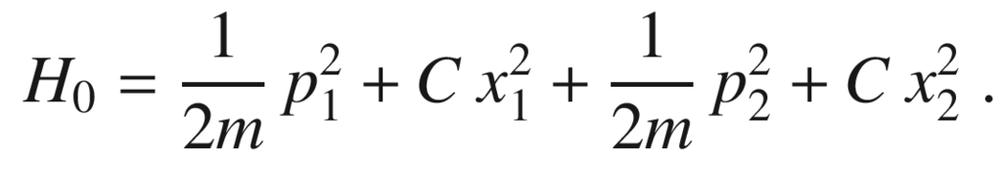

(2.13)

The indices 1 and 2 denote the two electrons of atoms.

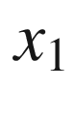

and

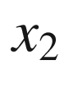

are the displacements of the electrons. Both harmonic oscillators have a resonance frequency

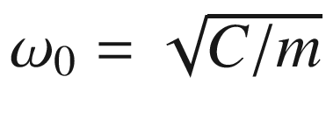

, and the zero-point energy is

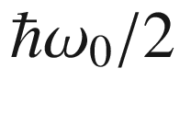

.

Taking into account the Coulomb interaction of the four charges, an additional term

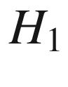

arises

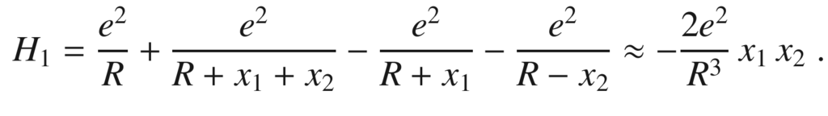

(2.14)

The approximation is valid for small amplitudes

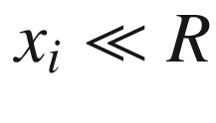

. A separation of variables can be achieved by transformation to the normal modes

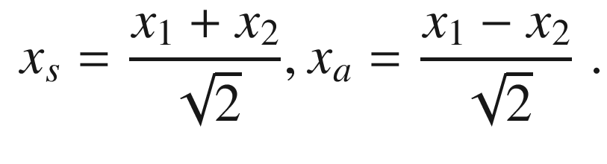

(2.15)

Then we find

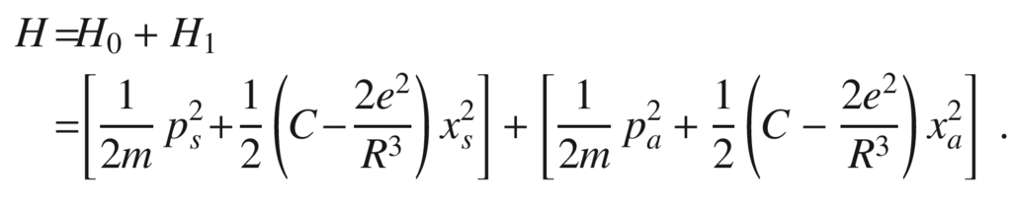

(2.16)

This equation is the Hamiltonian of two decoupled harmonic oscillators with the normal frequencies

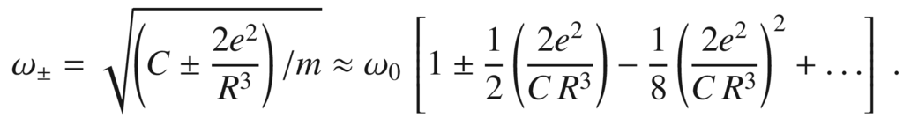

(2.17)

The coupled system thus has a lower (zero-point) energy than the uncoupled. The energy difference per atom is (in lowest order) proportional to

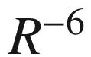

.

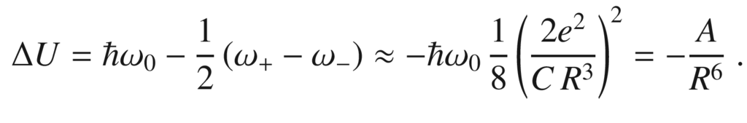

(2.18)

The interaction is a true quantum-mechanical effect, i.e. the reduction of the zero-point energy of coupled oscillators.

### 2.7 Hamilton Operator of the Solid

The total energy of the solid, including kinetic and potential terms, is

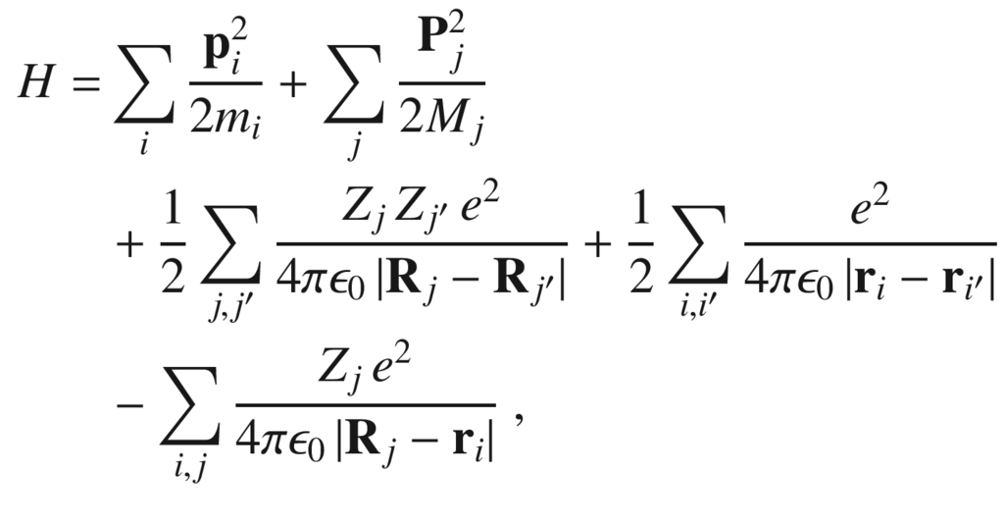

(2.19)

where

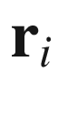

and

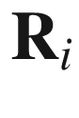

are the position operators and

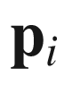

and

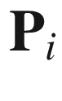

are the momentum operators of the electrons and nuclei, respectively. The first term is the kinetic energy of the electrons, the second term is the kinetic energy of the nuclei. The third term is the electrostatic interaction of the nuclei, the fourth term is the electrostatic interaction of the electrons. In the third and fourth terms the summation over the same indices is left out. The fifth term is the electrostatic interactions of electrons and nuclei.

In the following, the usual approximations in order to treat ([2.19](#u116076_4_En_2_Chapter-Equ25)) are discussed. First, the nuclei and the electrons tightly bound to the nuclei (inner shells) are united with ion cores. The remaining electrons are the valence electrons.

The next approximation is the Born–Oppenheimer (or adiabatic)  approximation. Since the ion cores are much heavier than the electrons (factor

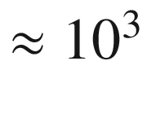

) they move much slower. The frequencies of the ion vibrations are typically in the region of several tens of meV (phonons, cf. Sect. [5.​2](The_Physics_of_Semiconductors00002.docx#u116076_4_En_5_Chapter)), the energy to excite an electron is typically 1 eV. Thus, the electrons always ‘see’ the momentary position of the ions, the ions, however, ‘see’ the electron motions averaged over many periods. Thus, the Hamiltonian ([2.19](#u116076_4_En_2_Chapter-Equ25)) is split into three parts:

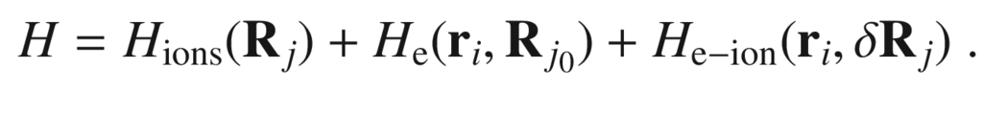

(2.20)

The first term contains the ion cores with their potential and the time-averaged contribution of the electrons. The second term is the electron motion around the ion cores at their averaged positions



. The third term is the Hamiltonian of the electron–phonon interaction that depends on the electron positions and the deviation of the ions from their average position

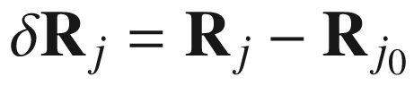

. The electron–phonon interaction is responsible for such effects as electrical resistance and superconductivity.

Footnotes

[1](#u116076_4_En_2_Chapter-Fn1_source)

It is debated in femtosecond chemistry whether the bond *really* forms in this way. However, it is a picture of overwhelming simplicity.

[2](#u116076_4_En_2_Chapter-Fn2_source)

Hexagonal diamond is wurtzite structure with identical atoms in the base.

[3](#u116076_4_En_2_Chapter-Fn3_source)

Supposedly, the chemist Friedrich August Kekulé von Stadonitz had a dream about dancing carbon molecules and thus came up with the ring-like molecule structure [176].

[4](#u116076_4_En_2_Chapter-Fn4_source)

This energy should not be confused with the *band gap*

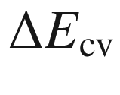

, the energy separation of the highest valence-band state and the lowest conduction-band state. The energy splitting

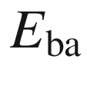

is the energy separation between the centers of the valence and conduction bands. Mostly, the term



is used for



.

© Springer Nature Switzerland AG 2021

M. Grundmann

The Physics of Semiconductors

Graduate Texts in Physics

<https://doi.org/10.1007/978-3-030-51569-0_3>

## 3. Crystals

Marius Grundmann[1](#u116076_4_En_3_Chapter-Aff11)

(1)

Felix Bloch Institute for Solid State Physics, Universität Leipzig, Leipzig, Germany

Marius Grundmann

Email:

[grundmann@physik.uni-leipzig.de](mailto:grundmann@physik.uni-leipzig.de)

*La science cristallographique ne consiste donc point à décrire scrupuleusement tous les accidens des formes cristallines; mais à spécifier, en décrivant ces formes, les rapports plus ou moins immédiats qu’elles ont entre elles.*

*Crystallographic science does not consist in the scrupulous description of all the accidental crystalline forms, but in specifying, by the description of these forms, the more or less close relationship they have with each other.*

*J.-B. Romé de l’Isle, 1783 [186]*

## Abstract

A little bit of crystallography. The concepts of the direct and reciprocal lattice, point and space groups, unit and elementary cells and the Wigner- Seitz cell are laid out. The important crystal structures for semiconductors (diamond, sphalerite, wurtzite, chalcopyrite, ...) are discussed in some detail. Also alloys and ordering are covered.

### 3.1 Introduction

The economically most important semiconductors have a relatively simple atomic arrangement and are highly symmetric. The symmetry of the atomic arrangement is the basis for the classification of the various crystal structures. Using group theory [187], basic and important conclusions can be drawn about the physical properties of the crystal, such as its elastic and electronic properties. The presence of highly symmetric planes is obvious from the crystal shape of the minerals and their cleavage behavior.

Polycrystalline semiconductors consist of grains of finite size that are structurally perfect but have various orientations. The grain boundaries are a lattice defect (see also Sect. [4.​4.​3](The_Physics_of_Semiconductors00002.docx#u116076_4_En_4_Chapter)). Amorphous semiconductors are disordered on the atomic scale, see Sect. [3.3.7](The_Physics_of_Semiconductors00002.docx#u116076_4_En_3_Chapter-Sec12).

### 3.2 Crystal Structure

A crystal is built up by the (quasi-) infinite periodic repetition of identical building blocks. This translation lattice [188–190] is generated by the three fundamental *translation* vectors

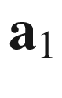

,

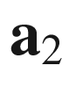

and

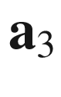

. These three vectors may not lie in a common plane. The lattice (Fig. [3.1](#u116076_4_En_3_Chapter-Fig1)) is the set of all points



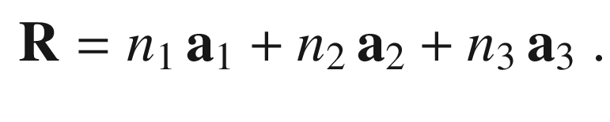

(3.1)

The crystal structure is made up by the lattice and the building block that is attached to each lattice point. This building block is called the *base* (Fig. [3.2](#u116076_4_En_3_Chapter-Fig2)). In the simplest case, e.g. for crystals like Cu, Fe or Al, this is just a single atom (monoatomic base). In the case of C (diamond), Si or Ge, it is a diatomic base with two identical atoms (e.g. Si–Si or Ge–Ge), in the case of zincblende compound semiconductors, such as GaAs or InP, it is a diatomic base with nonidentical atoms such as Ga–As or In–P. For wurtzite crystals such as GaN or ZnO the base has four atoms like Ga–N–Ga–N. There exist far more involved structures, e.g. NaCd



where the smallest cubic cell contains 1192 atoms. In protein crystals, the base of the lattice can contain 10,000 atoms.

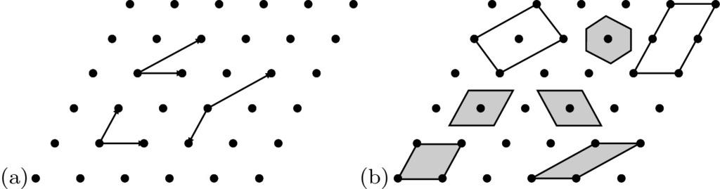

Fig. 3.1

**a** Two-dimensional lattice. It can be generated by various pairs of translation vectors. **b** Elementary cells of the lattice. Primitive elementary cells are shaded

In summary: Crystal structure = Lattice



Base.

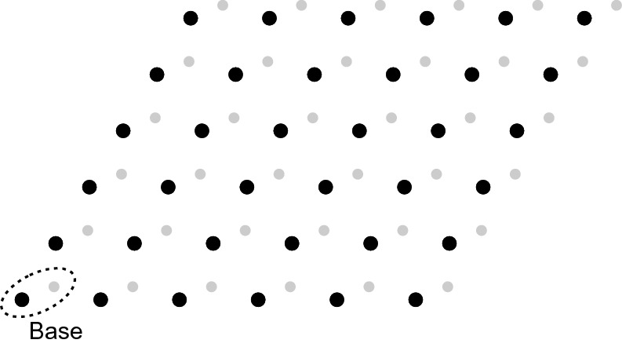

Fig. 3.2

Crystal structure, consisting of a lattice and a base

### 3.3 Lattice

As described in Sect. [3.2](#u116076_4_En_3_Chapter-Sec2) the lattice is spanned by three vectors

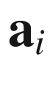

. The lattice symmetry is decisive for the physical properties of the semiconductor. It is described by the appropriate groups of the symmetry operations.

#### 3.3.1 2D Bravais Lattices

There are five two-dimensional (2D) Bravais lattices (Fig. [3.3](#u116076_4_En_3_Chapter-Fig3)) which are distinct and fill all (2D) space. These are very important for the description of symmetries at surfaces. The 2D Bravais lattices are the square, hexagonal, rectangular and centered-rectangular lattice.

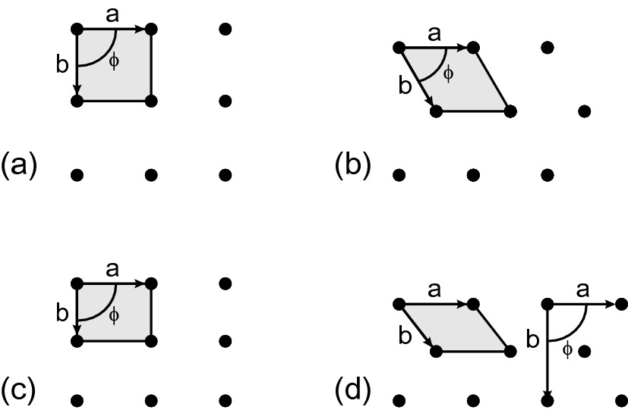

Fig. 3.3

The two-dimensional Bravais lattices with the primitive unit cells: **a** square lattice (

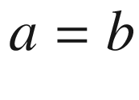

,

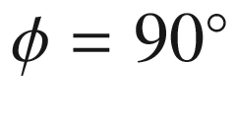

), **b** hexagonal lattice (



,

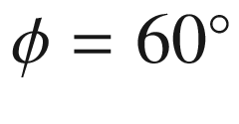

), **c** rectangular lattice (

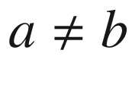

,

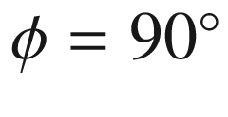

), **d** centered-rectangular lattice (

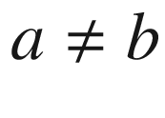

,

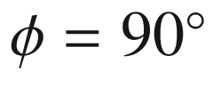

, for the (nonprimitive) rectangular unit cell shown on the right)

#### 3.3.2 3D Bravais Lattices

In three dimensions, the operations of the point group results in fourteen 3D Bravais lattices (Fig. [3.4](#u116076_4_En_3_Chapter-Fig4)), that are categorized into seven crystal classes (trigonal, monoclinic, rhombic, tetragonal, cubic, rhombohedral and hexagonal). These classes are discerned by the conditions for the lengths and the mutual angles of the vectors that span the lattice (Table [3.1](#u116076_4_En_3_Chapter-Tab1)). Some classes have several members. The cubic crystal can have a simple (sc), face-centered (fcc) or body-centered (bcc) lattice.

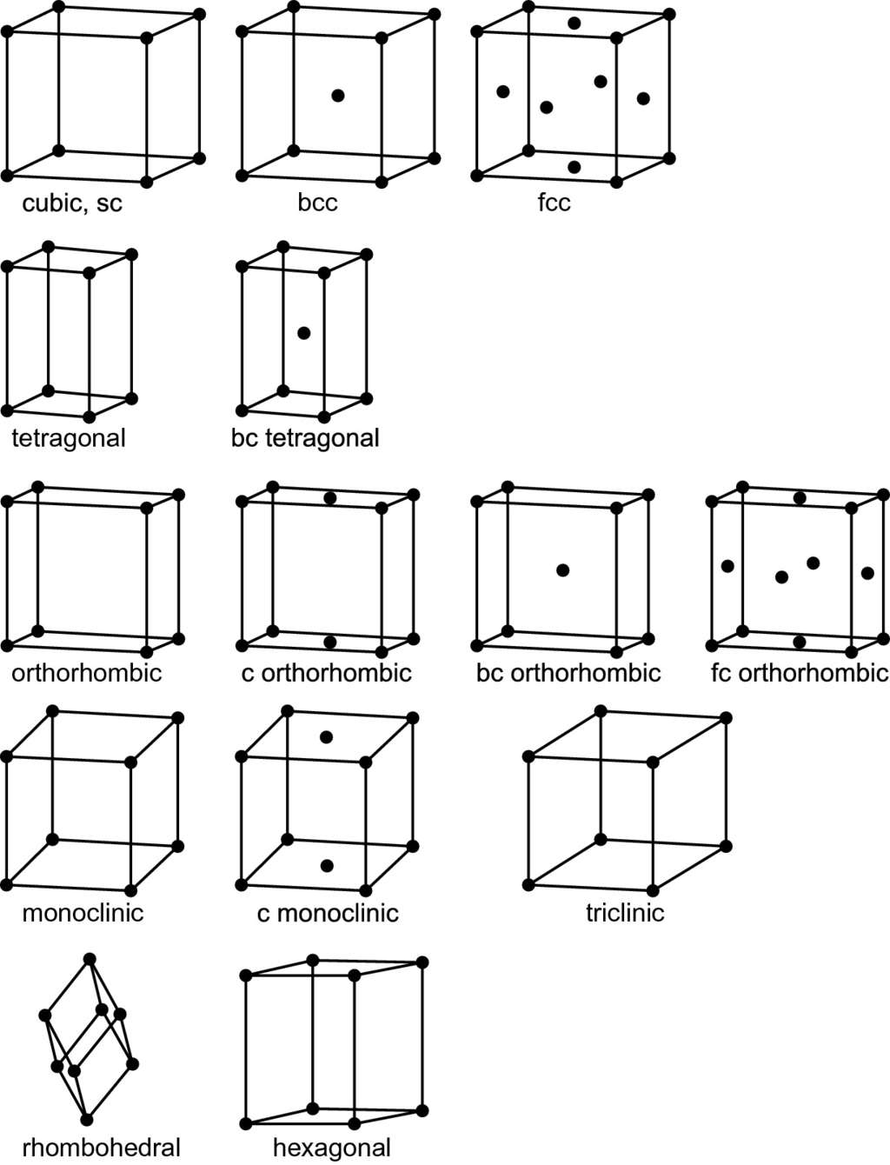

Fig. 3.4

The 14 three-dimensional Bravais lattices: cubic (sc: simple cubic, bcc: body-centered cubic, fcc: face-centered cubic), tetragonal (simple and body-centered), orthorhombic (simple, centered, body-centered and face-centered), monoclinic (simple and centered), triclinic, rhombohedral and hexagonal

Table 3.1

Conditions for lengths and angles for the 7 crystal classes. Note that only the positive conditions are listed. The rhombohedral system is a special case of the trigonal class. Conditions for the trigonal and hexagonal classes are the same, however, trigonal symmetry includes a single

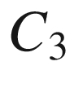

or

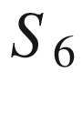

axis, while hexagonal symmetry includes a single

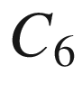

or

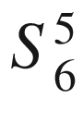

axis

| System | # | Lattice | Conditions for the |
| --- | --- | --- | --- |
|  |  | symbol | usual unit cell |
| Triclinic | 1 |  | None |
| Monoclinic | 2 | s, c | $$\alpha = \gamma = 90^{\circ }$$  or  $$\alpha = \beta = 90^{\circ }$$ |
| Orthorhombic | 4 | s, c, bc, fc | $$\alpha = \beta = \gamma = 90^{\circ }$$ |
| Tetragonal | 2 | s, bc | $$a = b$$  ,  $$\alpha \ = \beta = \gamma = 90^{\circ }$$ |
| Cubic | 3 | s, bc, fc | $$a = b = c$$  ,  $$\alpha = \beta = \gamma = 90^{\circ }$$ |
| Trigonal | 1 |  | $$a = b$$  ,  $$\alpha = \beta = 90^{\circ }$$  ,  $$\gamma = 120^{\circ }$$ |
| (Rhombohedral) | 1 |  | $$a = b = c$$  ,  $$\alpha = \beta = \gamma $$ |
| Hexagonal | 1 |  | $$a = b$$  ,  $$\alpha = \beta = 90^{\circ }$$  ,  $$\gamma = 120^{\circ }$$ |

In the following, some of the most important lattices, in particular those most relevant to semiconductors, will be treated in some more detail.

##### 3.3.2.1 Cubic fcc and bcc Lattices

The primitive translation vectors for the cubic face-centered (fcc) and the cubic body-centered (bcc) lattice are shown in Fig. [3.5](#u116076_4_En_3_Chapter-Fig5) and Fig. [3.6](#u116076_4_En_3_Chapter-Fig6), respectively. Many metals crystallize in these lattices, e.g. copper (fcc) and tungsten (bcc).

In the fcc lattice, one lattice point sits in the center of each of the six faces of the usual cubic unit cell. The vectors spanning the primitive unit cell are

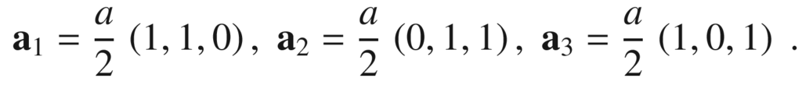

(3.2)

In the bcc lattice, one extra lattice point sits at the intersection of the three body diagonals at

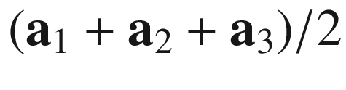

. The vectors spanning the primitive unit cell are

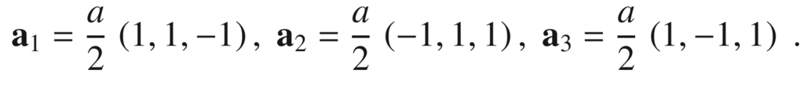

(3.3)

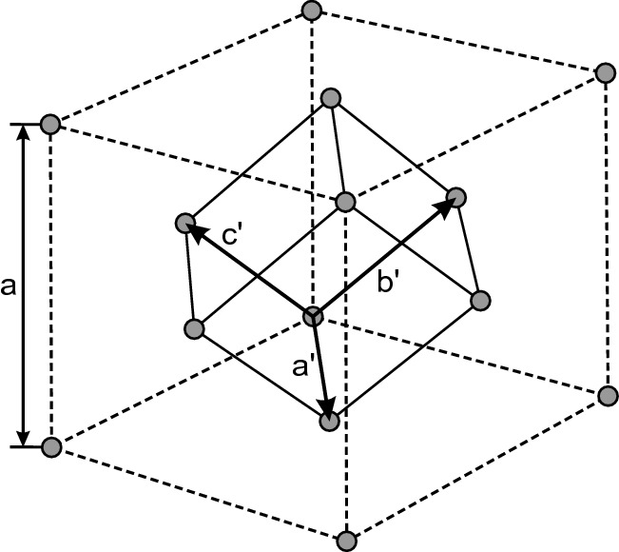

Fig. 3.5

Primitive translations of the fcc lattice. These vectors connect the origin with the face-center points. The primitive unit cell is the rhombohedron spanned by these vectors. The primitive translations



,



and



are given in ([3.2](#u116076_4_En_3_Chapter-Equ2)). The angle between the vectors is 60



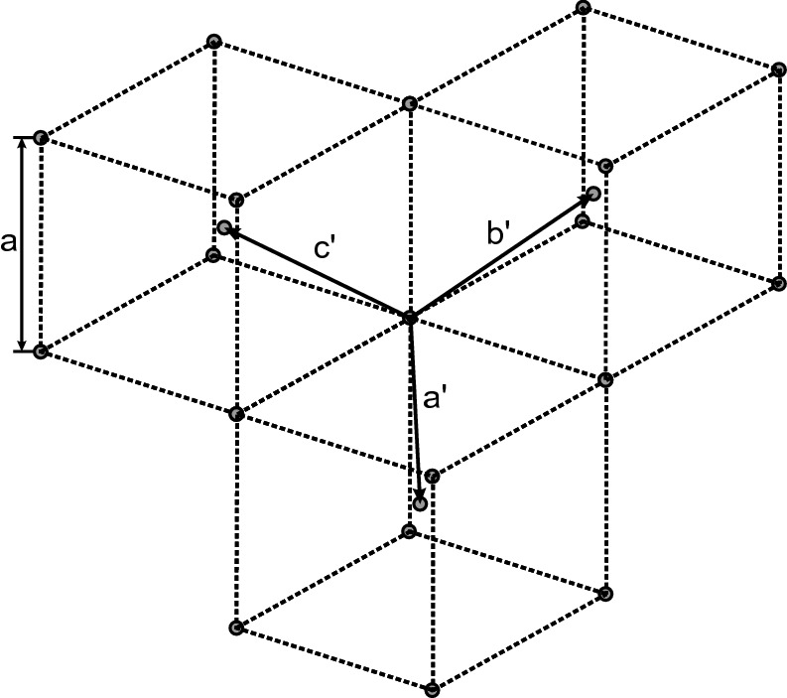

Fig. 3.6

Primitive translations of the bcc lattice. These vectors connect the origin with the lattice points in the cube centers. The primitive unit cell is the rhombohedron spanned by these vectors. The primitive translations



,



and



are given in ([3.3](#u116076_4_En_3_Chapter-Equ3)). The angle between the vectors is

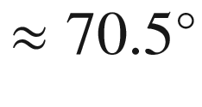

##### 3.3.2.2 Hexagonally Close Packed Structure (hcp)

The 2D hexagonal Bravais lattice fills a plane with spheres (or circles) with maximum filling factor. There are two ways to fill space with spheres and highest filling factor. One is the fcc lattice, the other is the hexagonally close packed (hcp) structure.[1](The_Physics_of_Semiconductors00002.docx#u116076_4_En_3_Chapter-Fn1) Both fcc and hcp have a filling factor of 74%.

For the hcp, we start with a hexagonally arranged layer of spheres (A), see Fig. [3.7](#u116076_4_En_3_Chapter-Fig7). Each sphere has six next-neighbor spheres. This could, e.g., be a plane in the fcc perpendicular to the body diagonal. the next plane B is put on top in such a way that each new sphere touches three spheres of the previous layer. The third plane can now be added in two different ways: If the spheres of the third layer are vertically on top of the spheres of layer A, a plane A’ identical to A has been created that is shifted from A along the stacking direction (normally called the *c*-axis) by

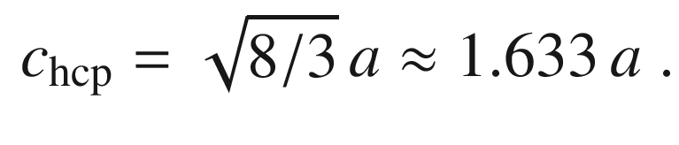

(3.4)

The vectors spanning the primitive unit cell are

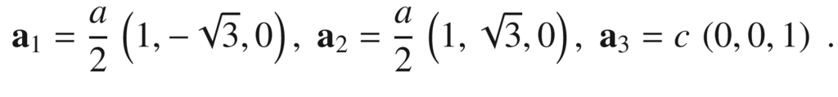

(3.5)

The hcp stacking order is ABABAB



for hcp, the coordination number is 12. In the fcc structure, the third layer is put on the thus far unfilled positions and forms a new layer C. Only the forth layer is again identical to A and is shifted by

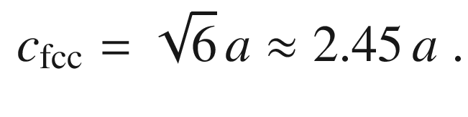

(3.6)

The fcc stacking order is ABCABCABC



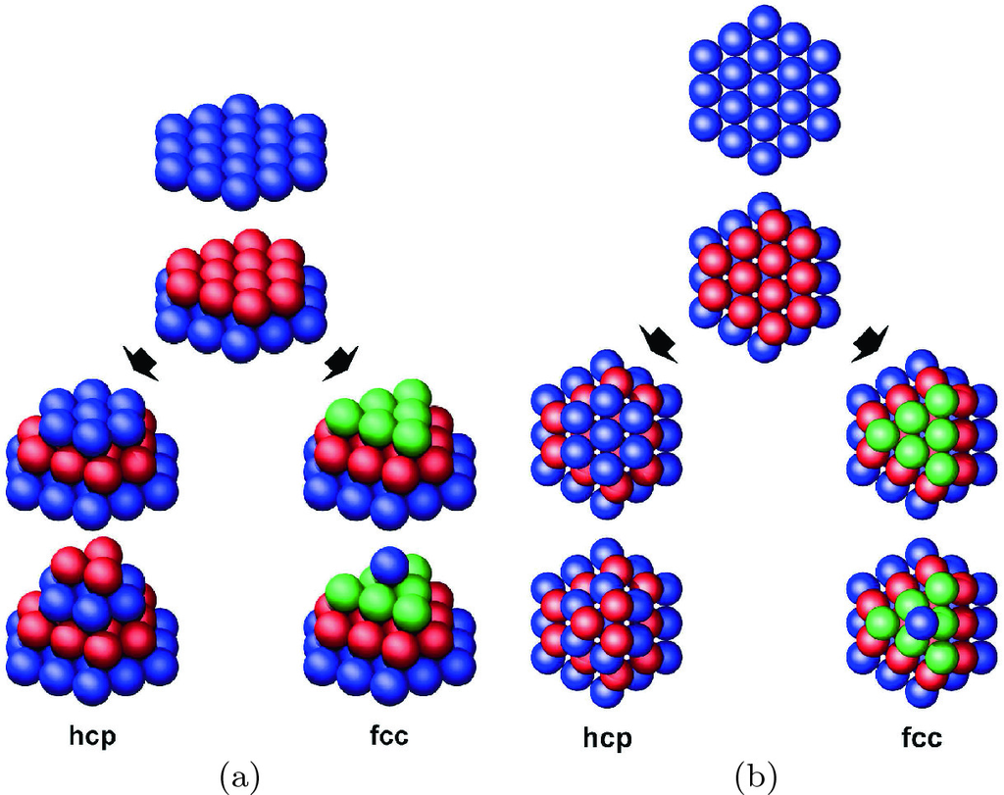

Fig. 3.7

Structure of the **a** hcp and **b** fcc lattice. For hcp the stacking (along the *c*-axis) is ABABAB



, for fcc (along the body diagonal) it is ABCABCABC



In the hexagonal plane of the fcc lattice (which will later be called a

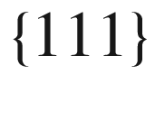

plane) the distance between lattice points is

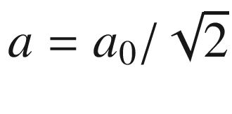

, where

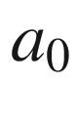

is the cubic lattice constant. Thus

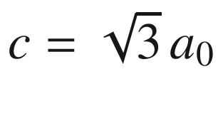

, just what is expected for the body diagonal.

For real materials with hexagonal lattice the ratio *c*/*a* deviates from the ideal value given in ([3.4](#u116076_4_En_3_Chapter-Equ4)). Helium comes very close to the ideal value, for Mg it is 1.623, for Zn 1.861. Many hcp metals exhibit a phase transition to fcc at higher temperatures.